Outline

1. **Background**
2. **Questionnaire main results**
3. **Open Data**
4. **Implementation of the Fundamental Principles: challenges and opportunities**
5. **Concluding remarks**
6. **Annex with survey results (table format)**
7. **Background**

Following a request at the thirty-fourth session of the Statistical Commission, the Statistics Division conducted a first global review of the implementation of the Fundamental Principles of Official Statistics in 2003. The results were reported to the Commission in a report to its thirty-fifth session in 2004, coinciding with the tenth anniversary of the adoption of the Fundamental Principles by the Commission.

At its forty-second session, the UN Statistical Commission “agreed that it was desirable to conduct periodic reviews of the implementation of the Fundamental Principles by Member States and asked the United Nations Statistics Division to undertake such a review and report the results to the Commission before 2014” (Decision 41/111). This request was reaffirmed during the forty-third session in 2012 (Decision 43/111).

The United Nations Statistical Commission, at its 48th session in March 2017, requested the Friends of the Chair Group on the Implementation of the Fundamental Principles of Official Statistics (FOC-FPOS)[1] to work on selected dimensions of the implementation of the Fundamental Principles within the context of the preparation for the twenty-fifth anniversary of their adoption, in 2019. Specifically, the Group was mandated to conduct a global review of the implementation of the Fundamental Principles of Official Statistics[2] and to prepare a report to be discussed at the Commission’s 50th session in March 2019.

The present assessment of the implementation of the Fundamental Principles of Official Statistics is largely an updated version of an earlier the questionnaires sent to countries by the UN Statistics Division in 2003 and 2012.[3] It has been prepared with the contribution of PARIS21, with the aim to modernize and improve on previous assessments, while maintaining comparability on a set of core items from the 2012 questionnaire to allow for the review of progress. Notable differences include revised and expanded options for each answer based on the FPOS implementation guide and the results of previous questionnaires. The wording of some questions was also revised with a view to improve consistency in the responses, since the 2012 report highlighted some contradictions across the answers provided by some respondents. The 2018 questionnaire also included new questions related to open data and the application of the Fundamental Principles to non-official and non-traditional sources of data, to better reflect the current situation of national statistical offices and their use of information from an expanded data ecosystem.

There were **73 questions included in the 2018 questionnaire**, compared to 78 in the 2012 version. Many of the questions in the 2012 assessment were yes/no, and the answers to those questions were included as options in 2018 questionnaire in order to better pinpoint trends in implementation activities.

**Ninety-three countries responded to the 2018 questionnaire** with a regional breakdown as follows:



Figure 1. Distribution of responses, by region

Approximately 86 percent of the 93 country responses in the 2018 survey were provided on behalf of the national statistical office (NSO), while about 12 percent were for the national statistical system (NSS). This response rate per NSO and NSS is consistent with the 2012 survey. To fully understand the impact of implementation of the FPOS within the broader NSS, future questionnaires may delve into more specific questions on NSS activities and the FPOS.

1. **FPOS awareness and integration into institutional framework**

In line with the results of past questionnaires, **heads of NSOs** were generally considered to be aware of the existence of the FPOS. However, at present, only 74 percent of the responses indicate that the **heads or senior management of other agencies of the National Statistical System** are aware of the fundamental principles. Moreover, only 57 percent of countries informed that the **line ministry or department to which the NSO reports** is aware of the UNFPOS. In most countries, the UNFPOS are mentioned in reports, strategy and policy papers and publications (82 percent) or discussed in meetings and events such as the World Statistics Day (67 percent).

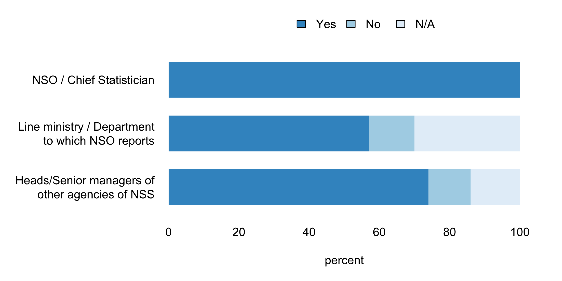

Figure 2. Awareness of existence of UNFPOS

Although the 2012 questionnaire made reference to the extent to which UNFPOS are integrated into the NSS legal framework, the 2018 questionnaire included this more explicitly. This now allows to establish that **arethe of over 60 percent of responding countries**and 8 reported and no integration, respectively At the regional level, more than 80 percent of respondents from African countries indicated full integration of FPOS into the statistical law or legal framework, while more than half of those from the Americas indicated only partial integration.[4]

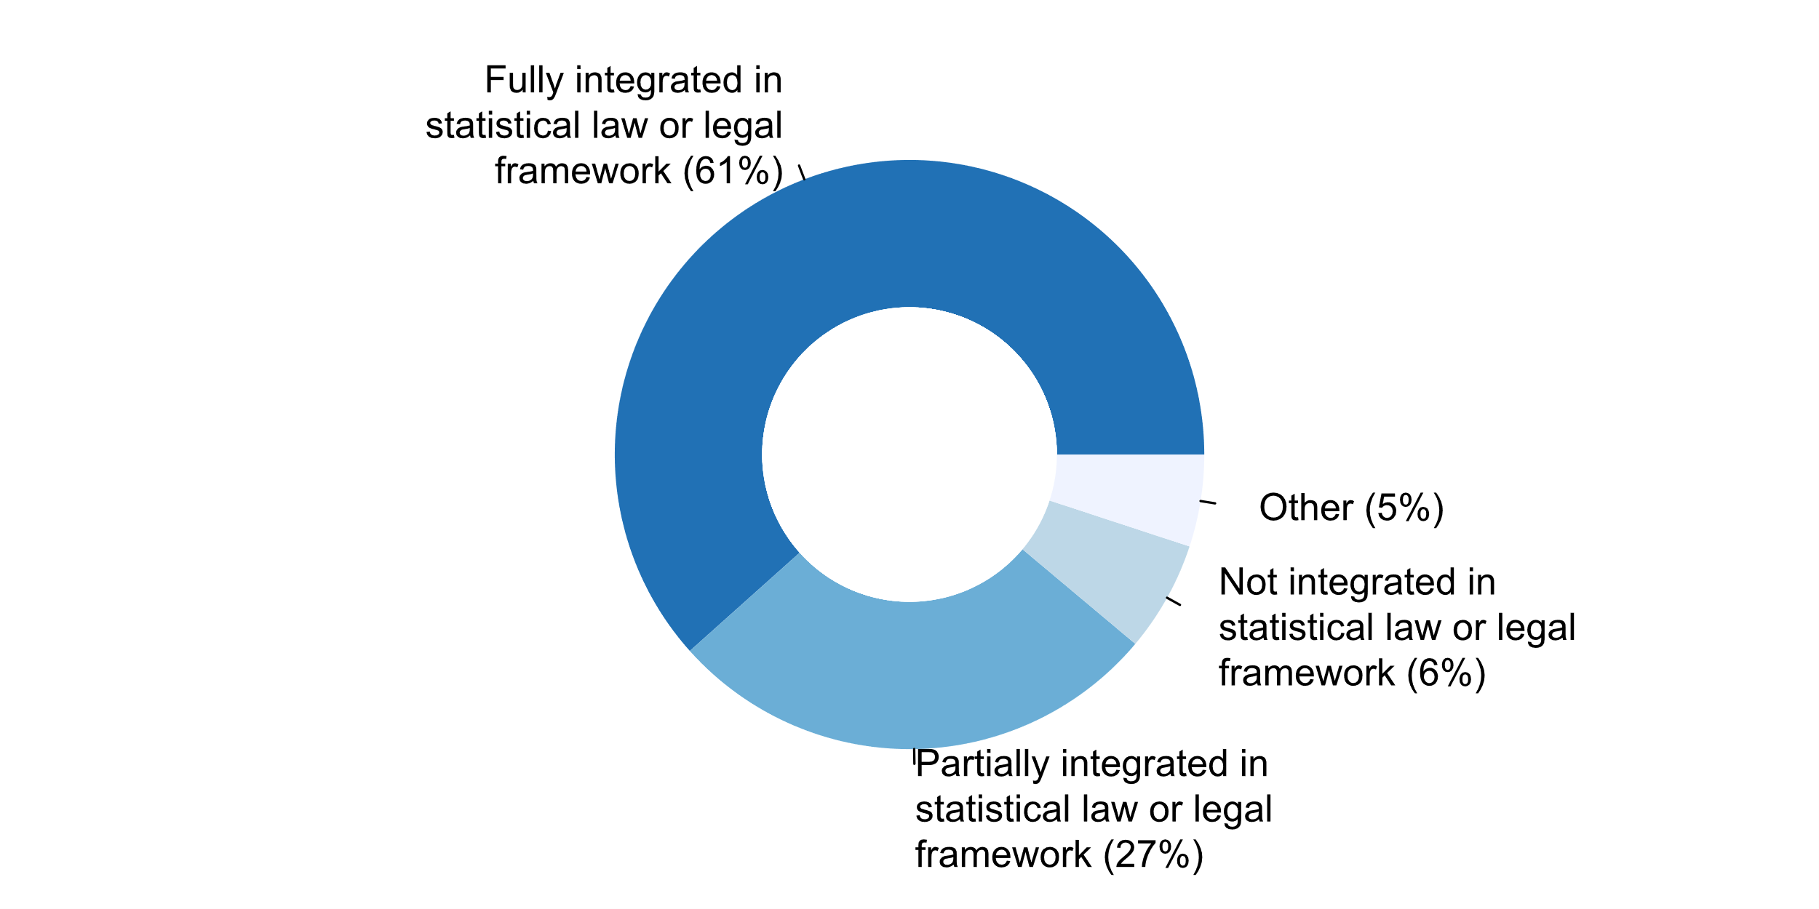

Figure 3. Extent to which UNFPOS are integrated into the NSS institutional framework

**Results for relating to specific principles**

**Principle 1: Relevance, Impartiality and Equal Access**

Previous surveys on the implementation of the UNFPOS show that the proportion of countries that report the existence of established user councils and organized user groups for specific surveys and/or to ensure user-producer dialogues had increased from 66 percent in 2003 to 72 percent in 2012. The 2018 questionnaire also showed that approximately three out of each five countries relying on **user councils or organized user groups** as a source of user feedback on their statistical products and services over the last five years (such groups were mentioned by 86 percent European countries).

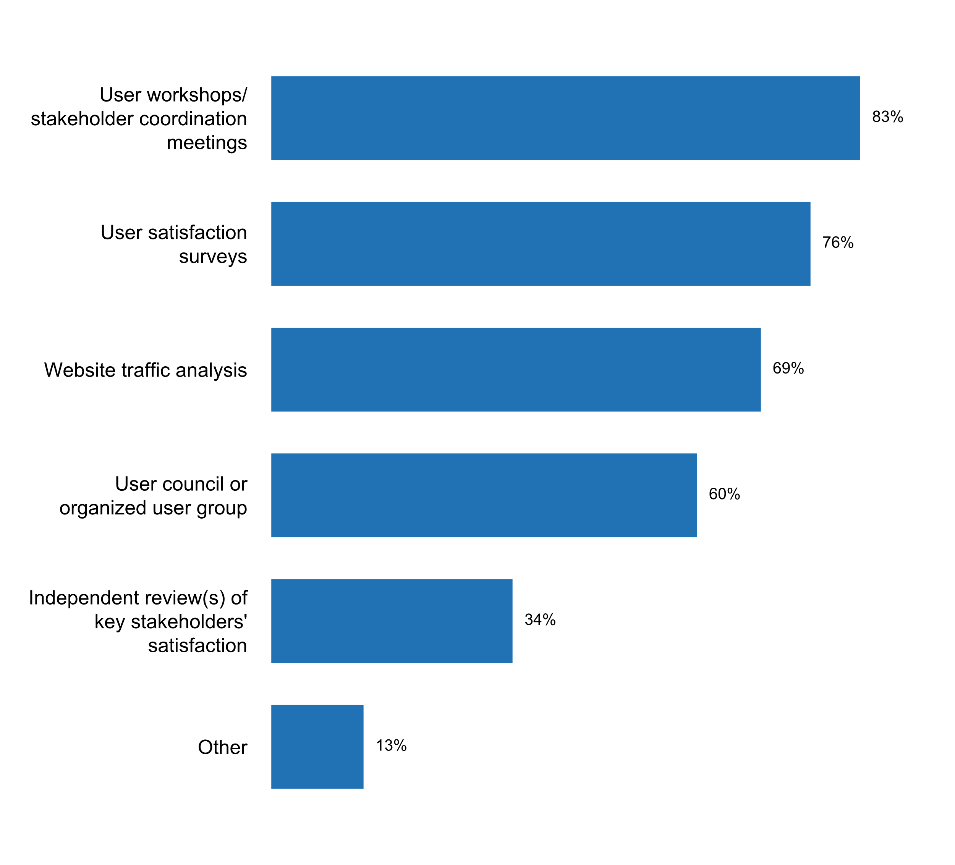

Figure 4. Source of feedback from users on statistical products and services over the last five years

Moreover, 75 percent of those countries that rely on user councils or organized user groups for feedback on their statistical outputs indicated that the mandate of this groups includes the **provision of strategic advice on statistical policy and priorities**, followed by **coordination of statistical activities** (66 percent) and provision of **technical advice** (61 percent). Also, most countries where a user council or user group exists indicated that such group includes **government employees** (96 percent) and **academic and professional associations** (93 percent), with representatives of the **business sector, policy makers, and civil society organizations** being also frequently members of such user groups. In contrast, less than half of the countries where a statistics user group exists indicated the participation of workers’ unions, international organizations, and the general public in them.

The 2018 questionnaire also shows that, over the past five years, 83 percent of countries sought feedback from users on statistical products and services through **user workshops or stakeholder coordination meetings**. In addition, **user satisfaction surveys** were cited by 3 of every 4 countries as a means of obtaining feedback from users, followed by **website traffic analysis** (69 percent of countries).

Wirth respect to planning instruments currently being used by NSOs and across the National Statistical System, most countries (88 percent) highlighted **annual or multiannual work programmes**. In contrast, only three out of each five countries indicated the use of a **National Strategy for the Development of Statistics** as a planning instrument for their statistical activities.

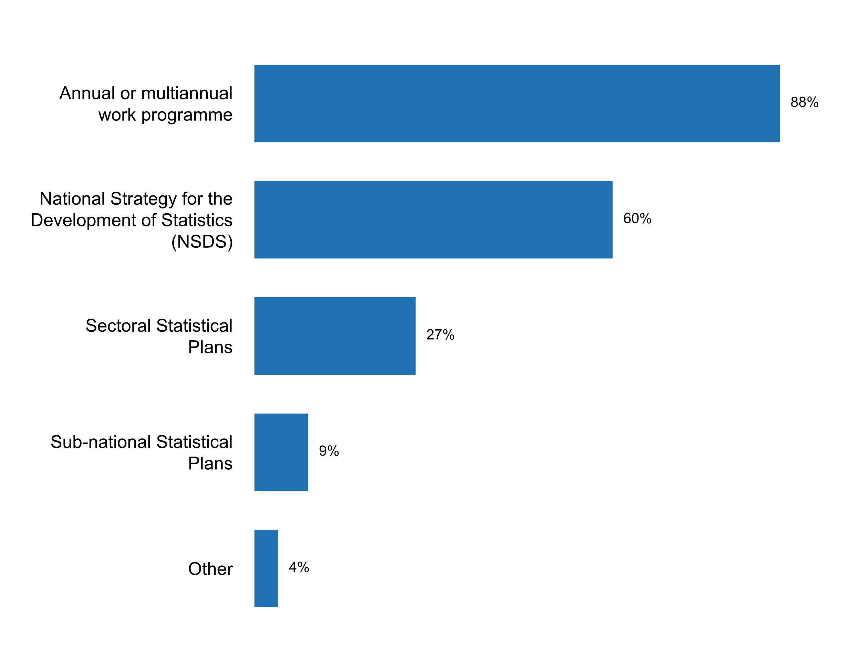

Figure 5. Planning instruments currently being used by the NSS / NSO

In past questionnaires (2012 and 2003), almost 90 percent of countries reported having a systematic dissemination policy. Looking into the measures that are in place for the dissemination of statistics, the 2018 questionnaire shows that almost all of the 93 respondent countries use various traditional **dissemination media, such as print publications, online pdf files**, etc. A vast majority (90 percent) also have appointed a **specialized unit responsible for dissemination** or provide **user support via email, etc.**

An **advanced release calendar** was frequently mentioned in responses to previous questionnaires as was an element of a dissemination strategy. While this is still relevant for a majority of countries (83 percent), it is clear from the responses that many other measures are frequently used for disseminating statistics.[5]

The accessibility of data for all users and under free circumstances is crucial to any open data initiative. In relation to the state of openness and interoperability of the disseminated data, it is worth nothing that the provision of **data downloads in proprietary formats** is still more frequent (74%) than data downloads in **open machine-readable formats** (58 percent) or via **online Application Programming Interfaces (APIs)** (38%).



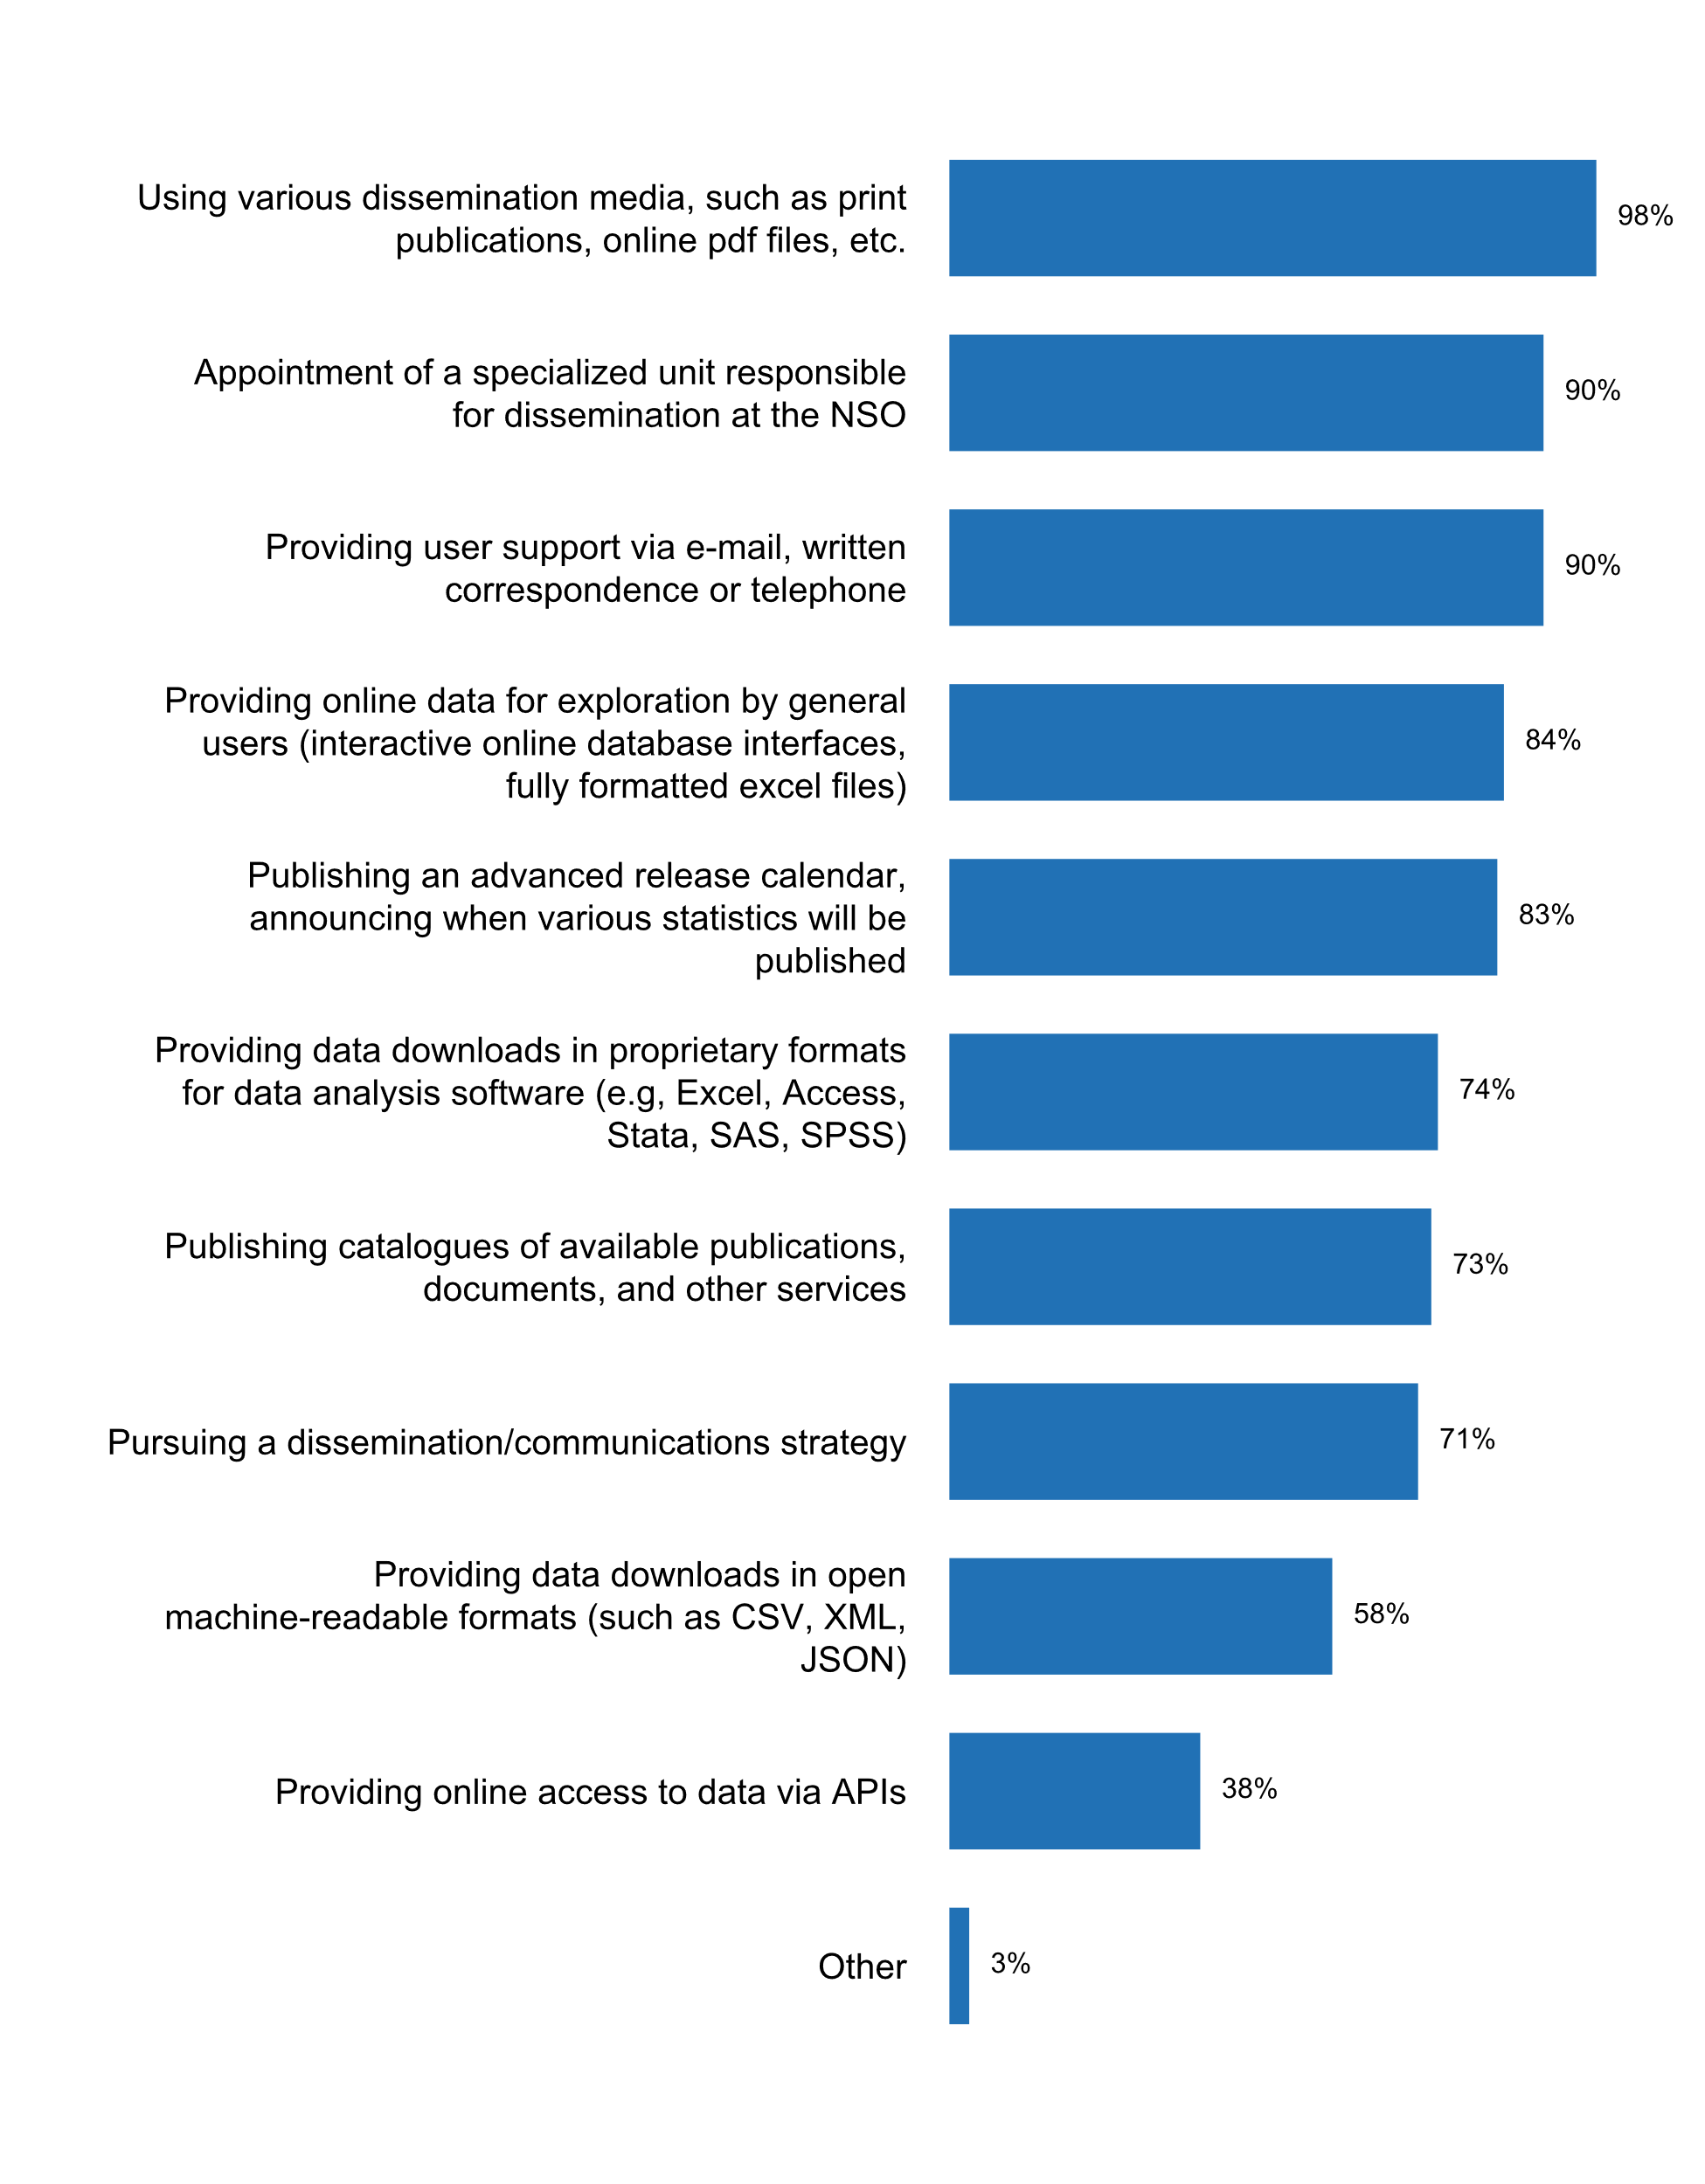

Figure 6. Measures currently in place for disseminating statistics

The **pre-release of statistics** to certain user groups was not granted to any of the groups listed for 47 percent of the respondent countries. However, 44 percent of respondents noted that government departments or policy-makers are given access to statistics prior to their public release. In 53 percent of such cases, the users who have prior access to the statistics are always **publicly identified**. Comments provided on this question note that for a number of countries specific **policies regarding pre-release** are established and found online. In general, those that receive the pre-release access to data do so **24 hours or less** time before its publication.[6]

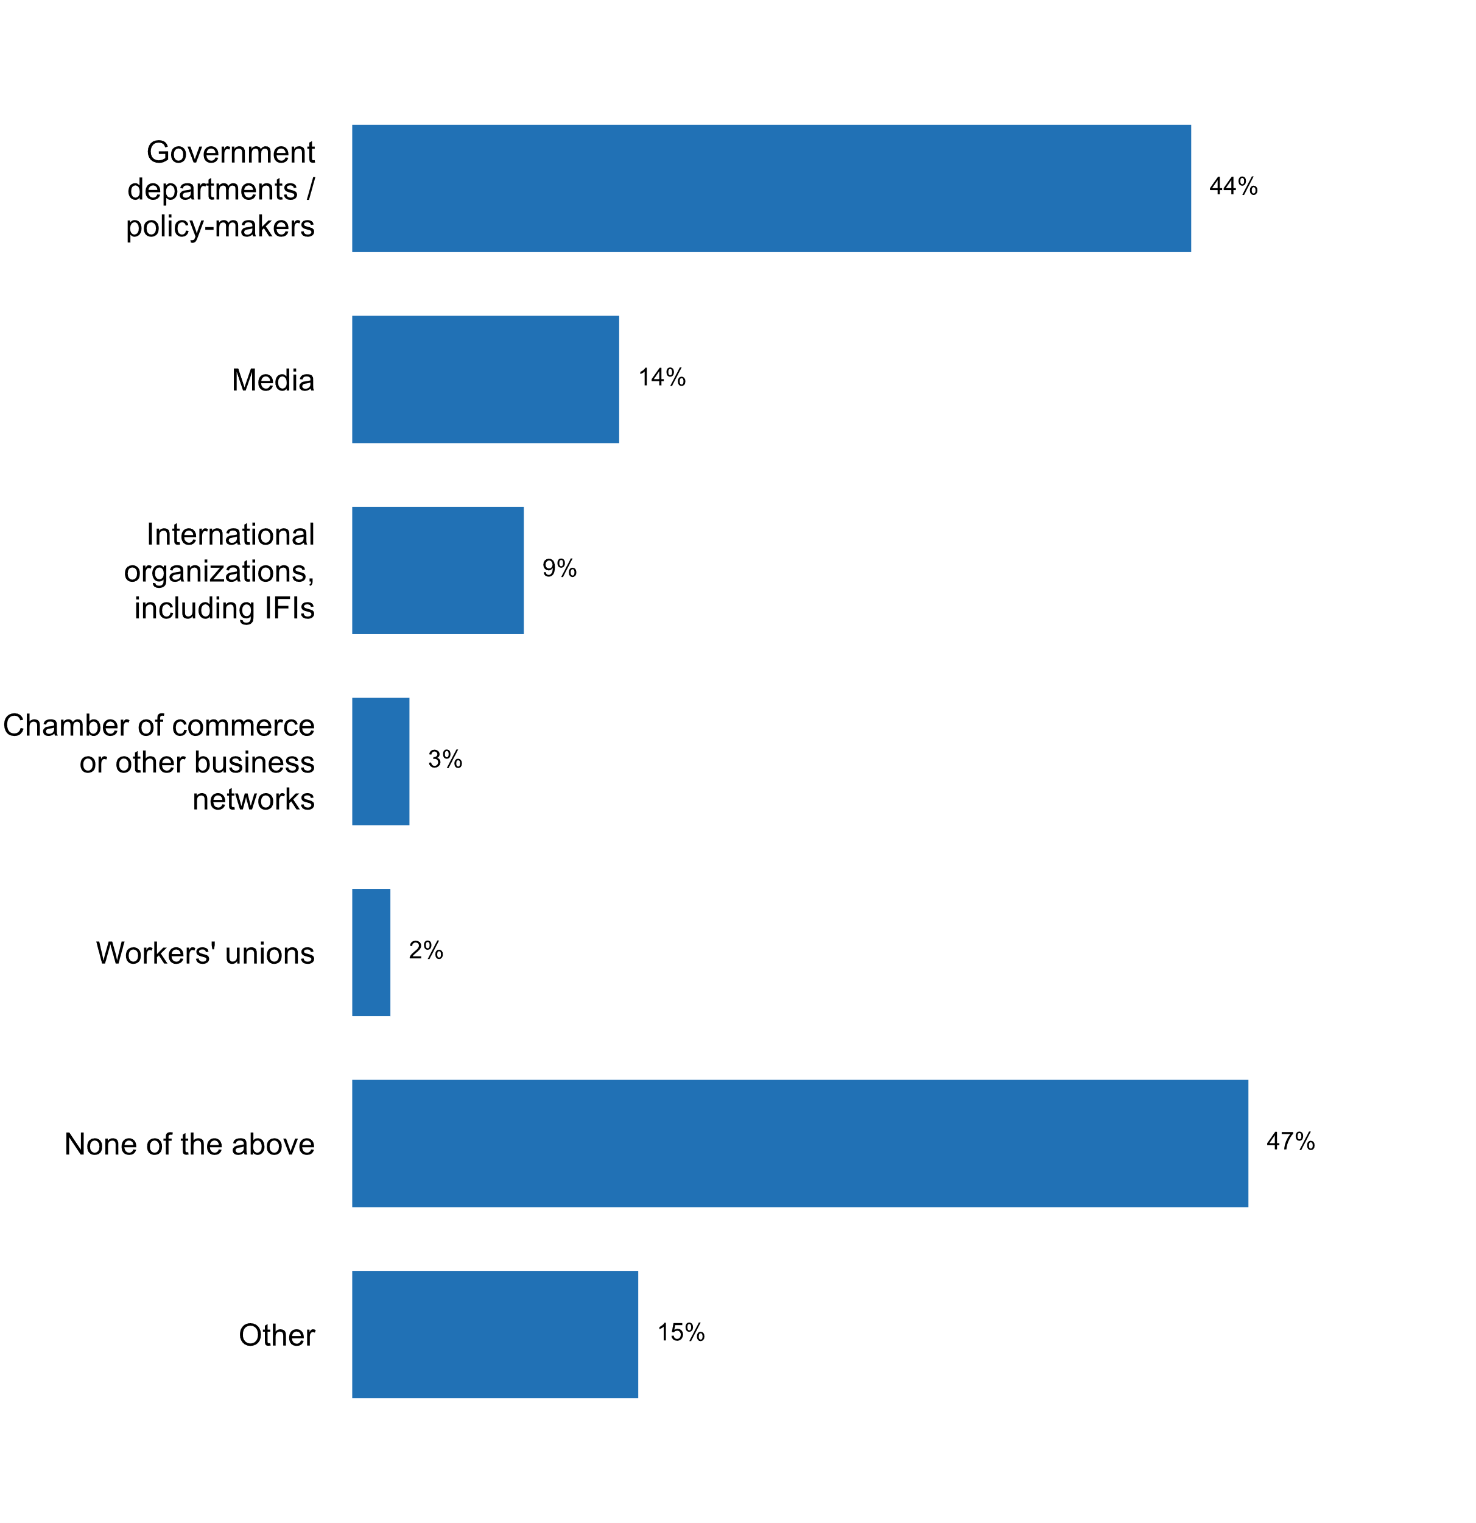

Figure 7. Groups of users given access to statistics prior to their public release in the past five years

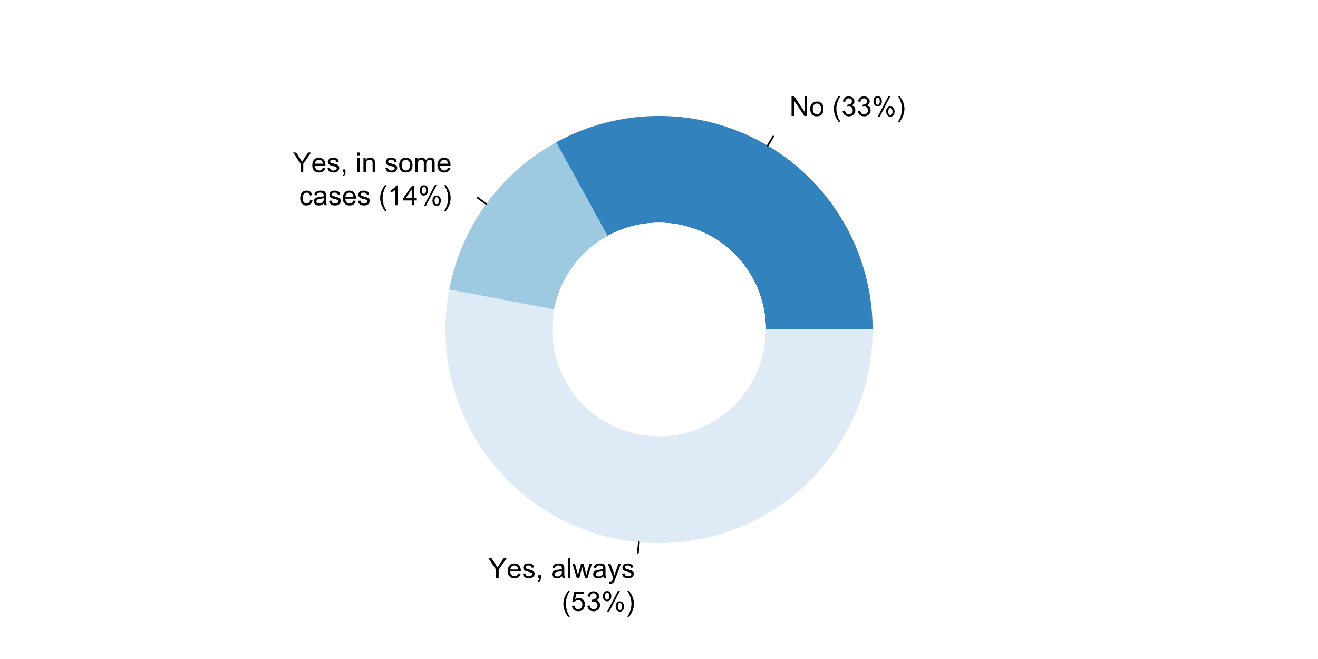

Figure 8. If any user has access to a pre-release, is this publicly identified?

The 2018 questionnaire also inquired about the conditions under which national statistical offices provide access to aggregates and/or microdata. About 60 percent of respondents indicated that they provide **online access to at least some data sets under publicly available terms of use**, while dissemination after signing a **licensing agreement** or for a **fee** is reported by 29 and 23 percent of the respondents, respectively. Almost 1 in every five countries (18 percent) report the dissemination of some datasets after **registration** of the users on the website.

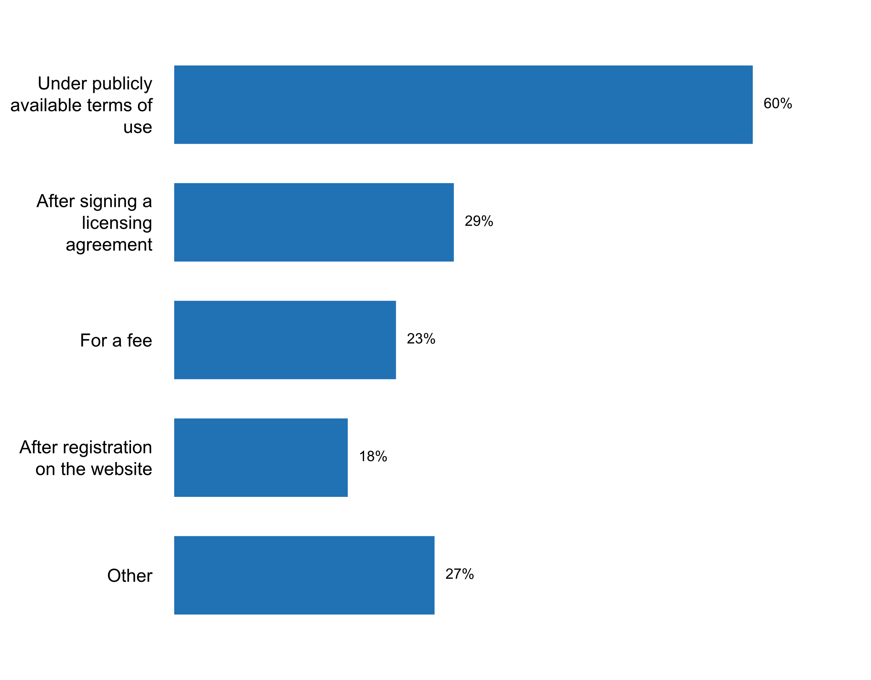

Figure 9. Conditions for online access to aggregates and/or microdata

In 58 percent of the responding countries, anonymized data and aggregates can be re-distributed under condition of **attribution of the source**, and 41 percent allow such re-distribution **for non-commercial purposes**. Only 19 percent report allowing the re-distribution of anonymized microdata and aggregates **for commercial purposes**, and only 15 require a fee. Results are very similar with respect to the further distribution of derivative works based on aggregates and/or microdata that are available online (see Figure 11).

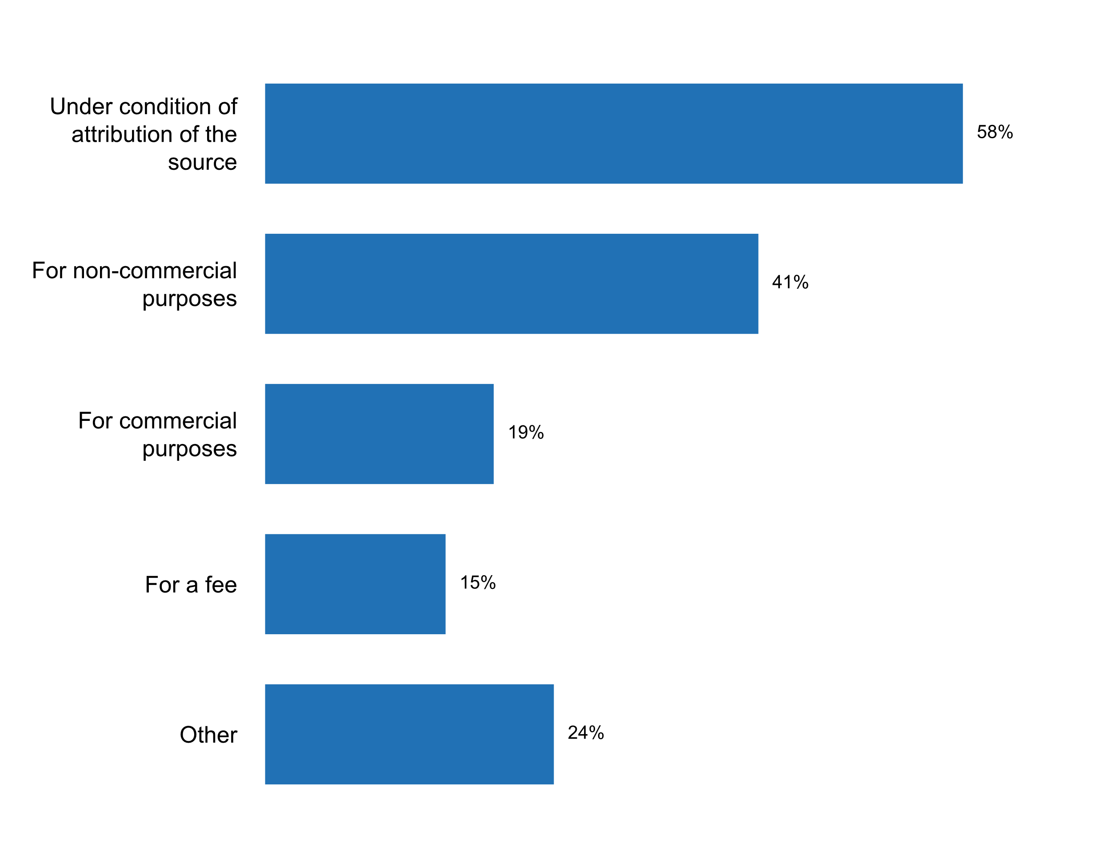

Figure 10. Conditions for re-distribution of anonymized microdata and aggregates

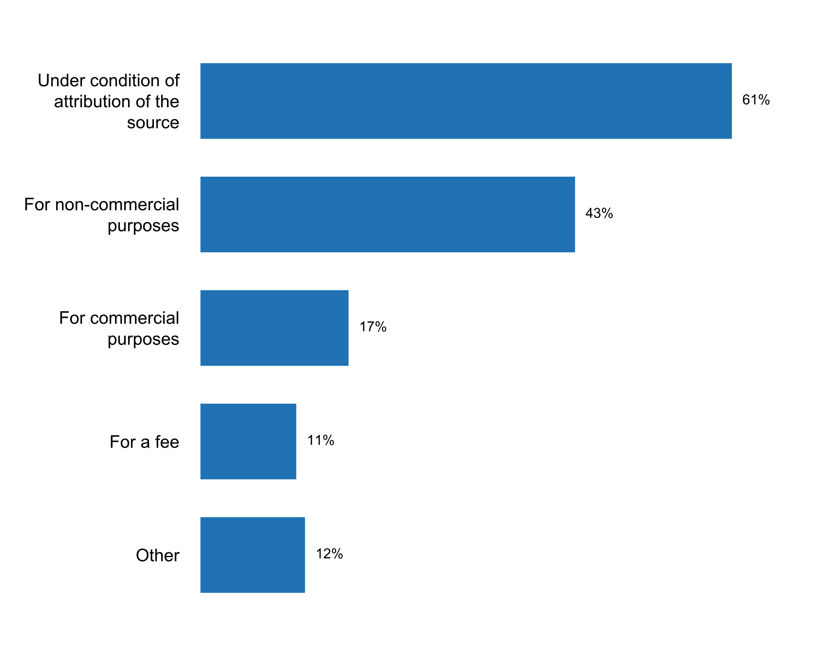

Figure 11. conditions for distribution of derivative works based on the aggregates   
and/or microdata that are available online

In general, some of the main challenges identified by respondents for the implementation of Principle 1 included: (1) ensuring equal access to statistical information; (2) the inclusion or exclusion of microdata and ensuring that aggregates do not identify people or groups; (3) harmonizing legal frameworks with the statistical framework in the short and medium term; as well as (4) harmonizing administrative records for statistical and geographical purposes to increase timeliness of dissemination and reduce costs of data capture, the generation of information and lessen the burden of the system’s informants.

**Principle 2: Professional Standards, Scientific Principles and Professional Ethics**

“To retain trust in official statistics, the statistical agencies need to decide according to strictly professional considerations, including scientific principles and professional ethics, on the methods and procedures for the collection, processing, storage and presentation of statistical data.”

Principle 2 is closely related to the ability of National Statistical Offices to make decisions based on strict professional considerations. A crucial determinant of this independence is the nature of the communication between the Chief Statistician and policy making authorities. The 2018 questionnaire shows that the vast majority (95 percent) of chief statisticians have direct access to policy-making authorities. This access, notably, is most frequently through meetings with ministers and/or deputy ministers, while only 42 percent of the respondents report attending upper/lower house parliamentary hearings.

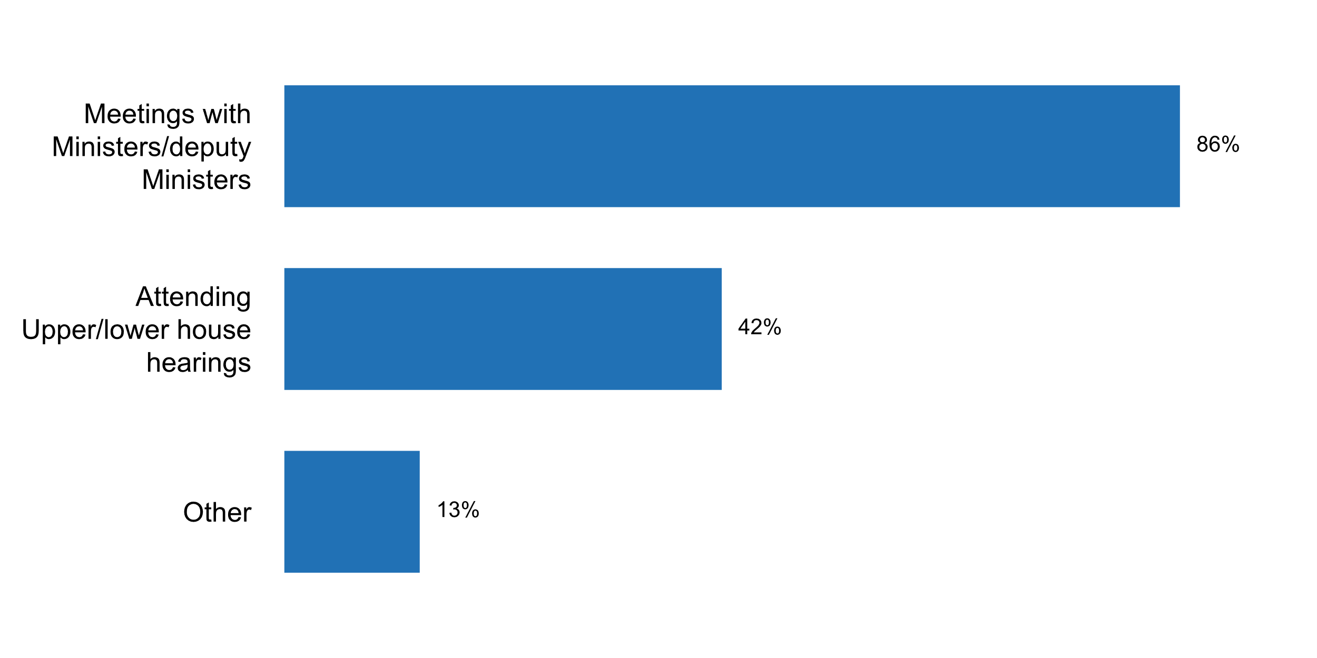

Figure 12. Modalities of communication between chief statistician and policy-making authorities

In 2018, 86 percent of countries responding to the questionnaire reported to have clear rules for the appointment and dismissal of the head of the NSO – a welcome increase from approximately 75 percent in 2012.



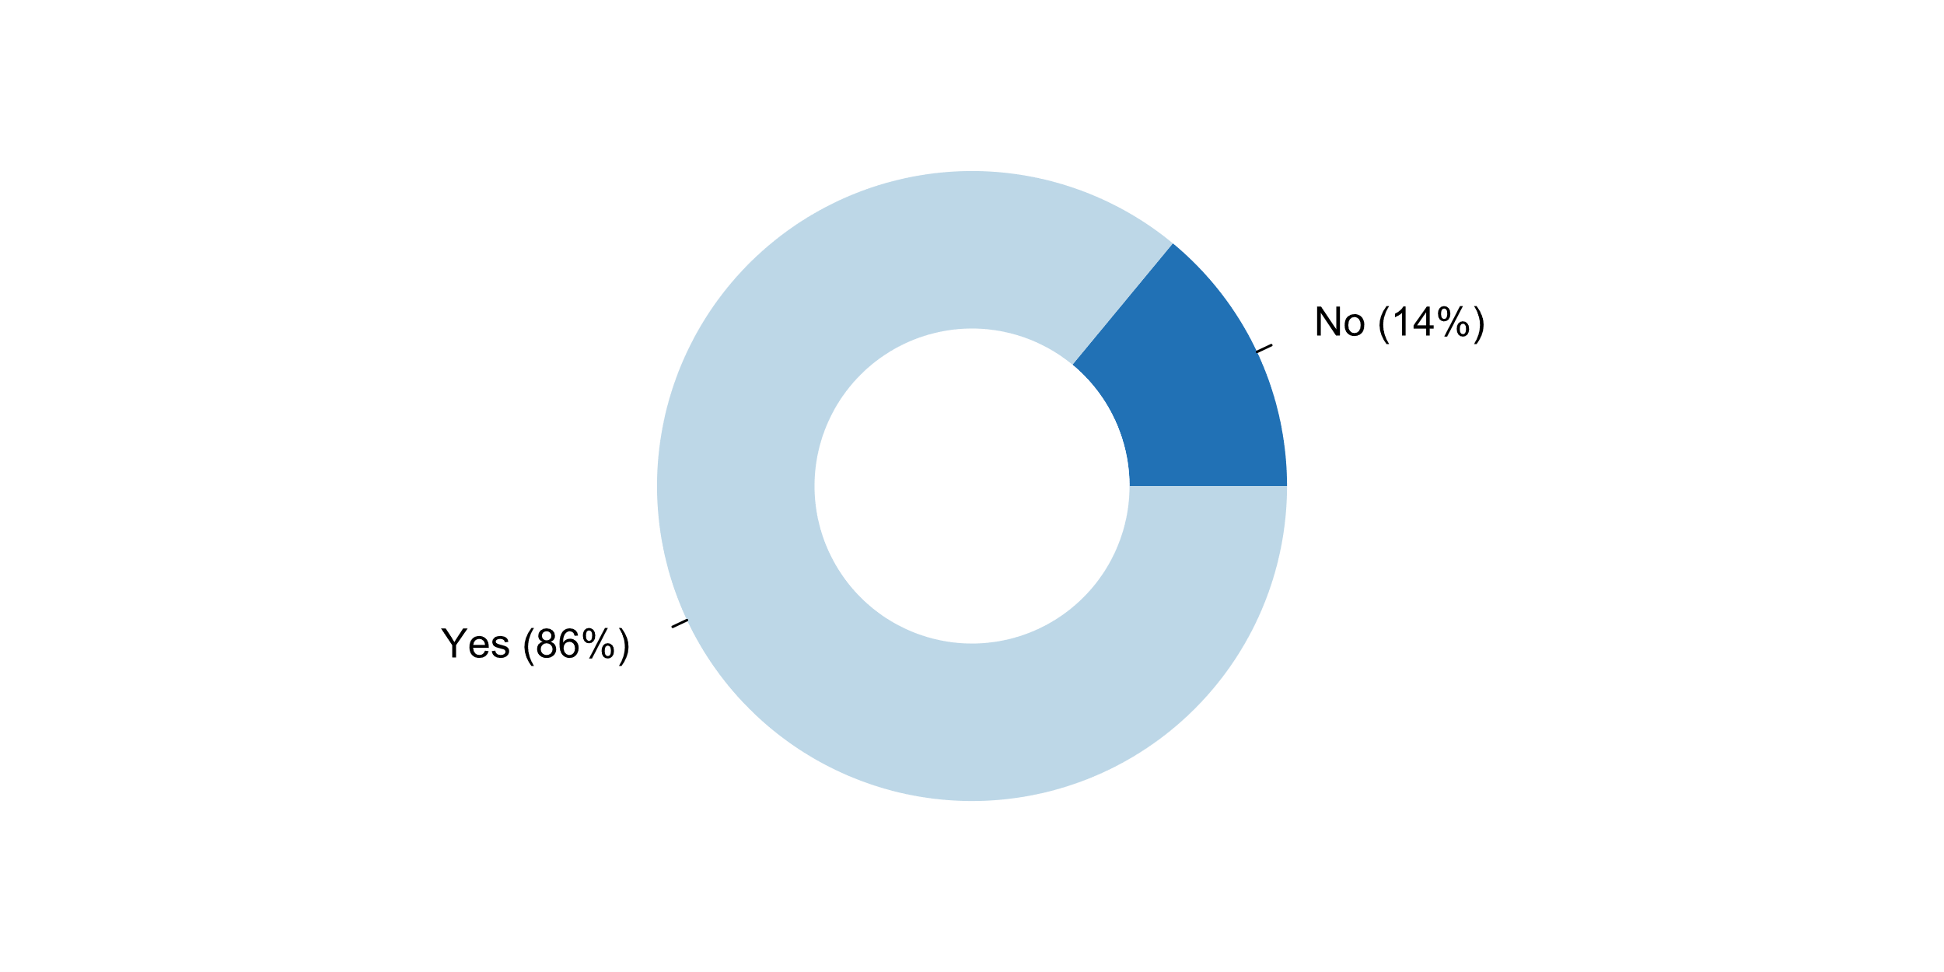

Figure 13. Existence of clear rules for appointment and dismissal of the head of the NSO

More specifically, in almost 7 out of every 10 countries responding to the questionnaire, these rules cover the **qualifications and the selection procedure of the Chief Statistician**. Other aspects frequently included in such regulations are the length of the **appointment period** (56 percent) and the **reasons for dismissal** (49 percent). In fewer cases (24 and 35 percent of respondents, respectively) the rules regulate **age and office-term limits** of the chef statistician. small numberpercent

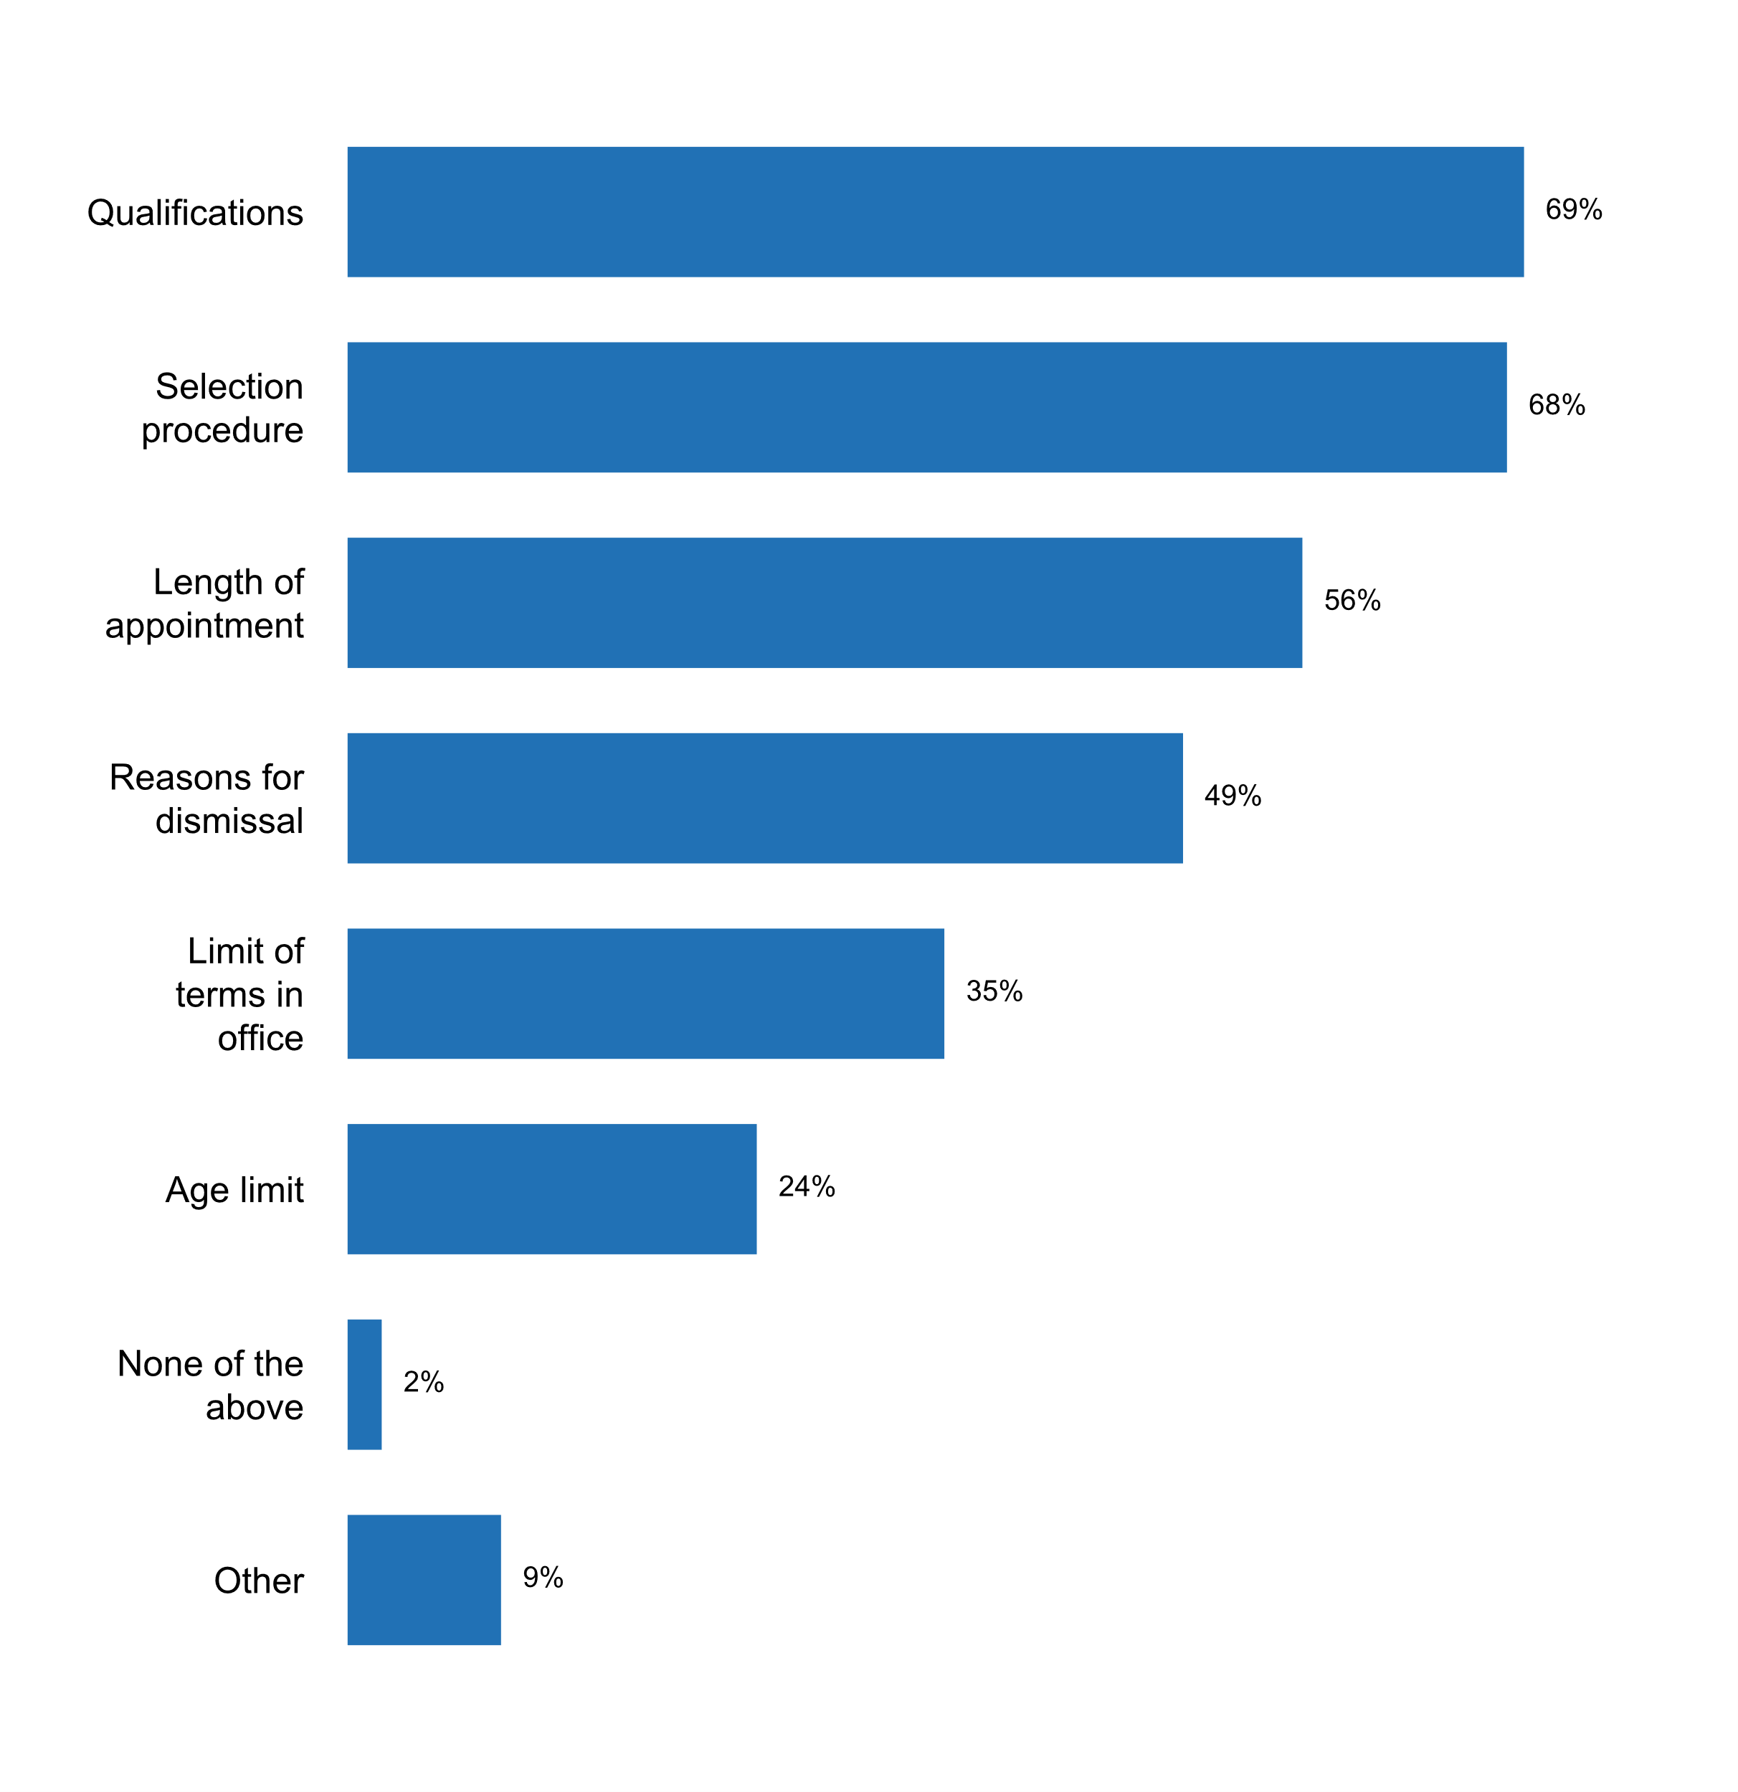

Figure 14. Aspects regulated in rules for appointment and dismissal of the head of NSO

Principle 2 also refers to the methods and procedures for the collection, processing, storage and presentation of statistical data. In this connection, the 2018 survey shows that almost all (96 percent) of countries support their methodologies with the **use of internationally recommended standards and methods**. Other common practices to obtain external endorsement of the methodologies employed by national statistical systems include **peer or expert reviews** (68 percent), **full disclosure of methodologies** applied (63 percent), as well as the p**ublication of revision policies and other procedural manuals** (59 percent). Less frequent are the reliance on **statistical or methodological councils** to make formal decisions on methodology issues (32 percent) and the participation in **external monitoring or auditing of the NSS practices** (20 percent).

With respect to the **coordination of the use of standards and classifications across the NSS**, most countries (86 percent) indicate that the NSO compiles, publishes and promotes the consistent use of standards and classifications, and 57 percent report that it monitors compliance with classifications and standards across the NSS. A similar proportion of countries (56 percent) report the existence of legislation establishing common standards and/or specifying which agency in the NSS is responsible for doing so. In this connection, in almost half of the responding countries the NSO has a role to play in reviewing and approving statistical questionnaires and methodologies employed across the NSS; whereas in 40 percent of the countries there are committees responsible for the coordination of standards in specific field.

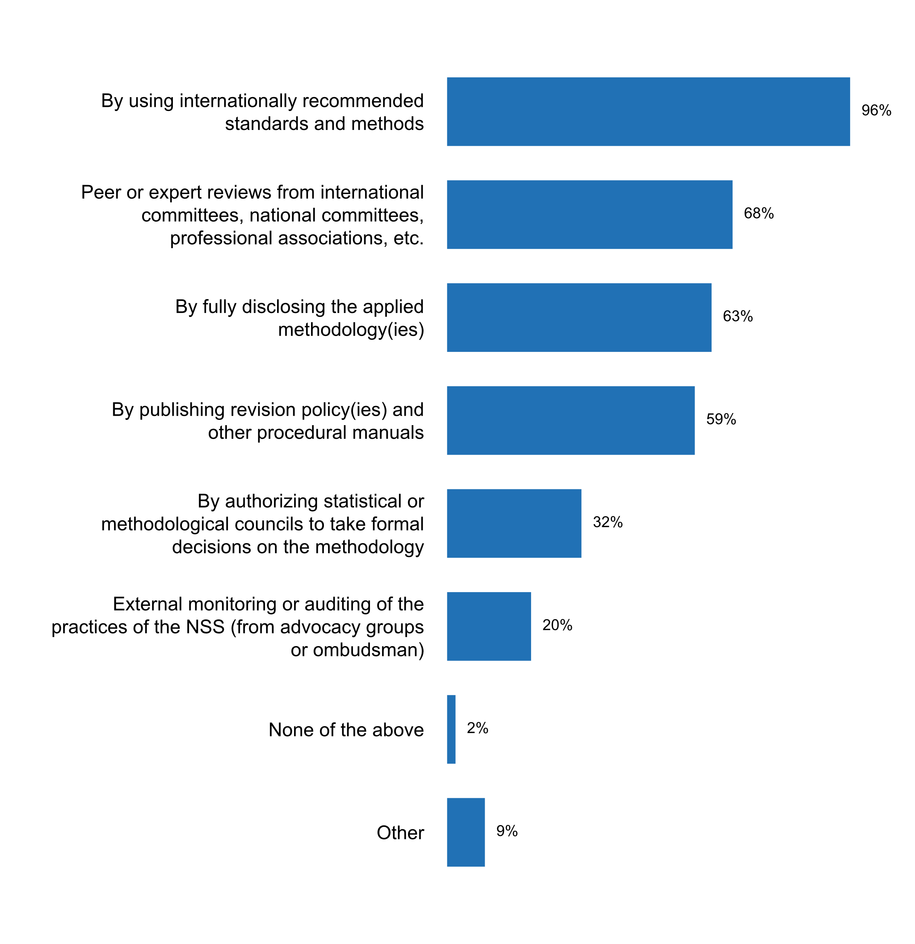

Figure 15. How NSS sought external endorsement of its methodologies   
and survey designs in the past five years

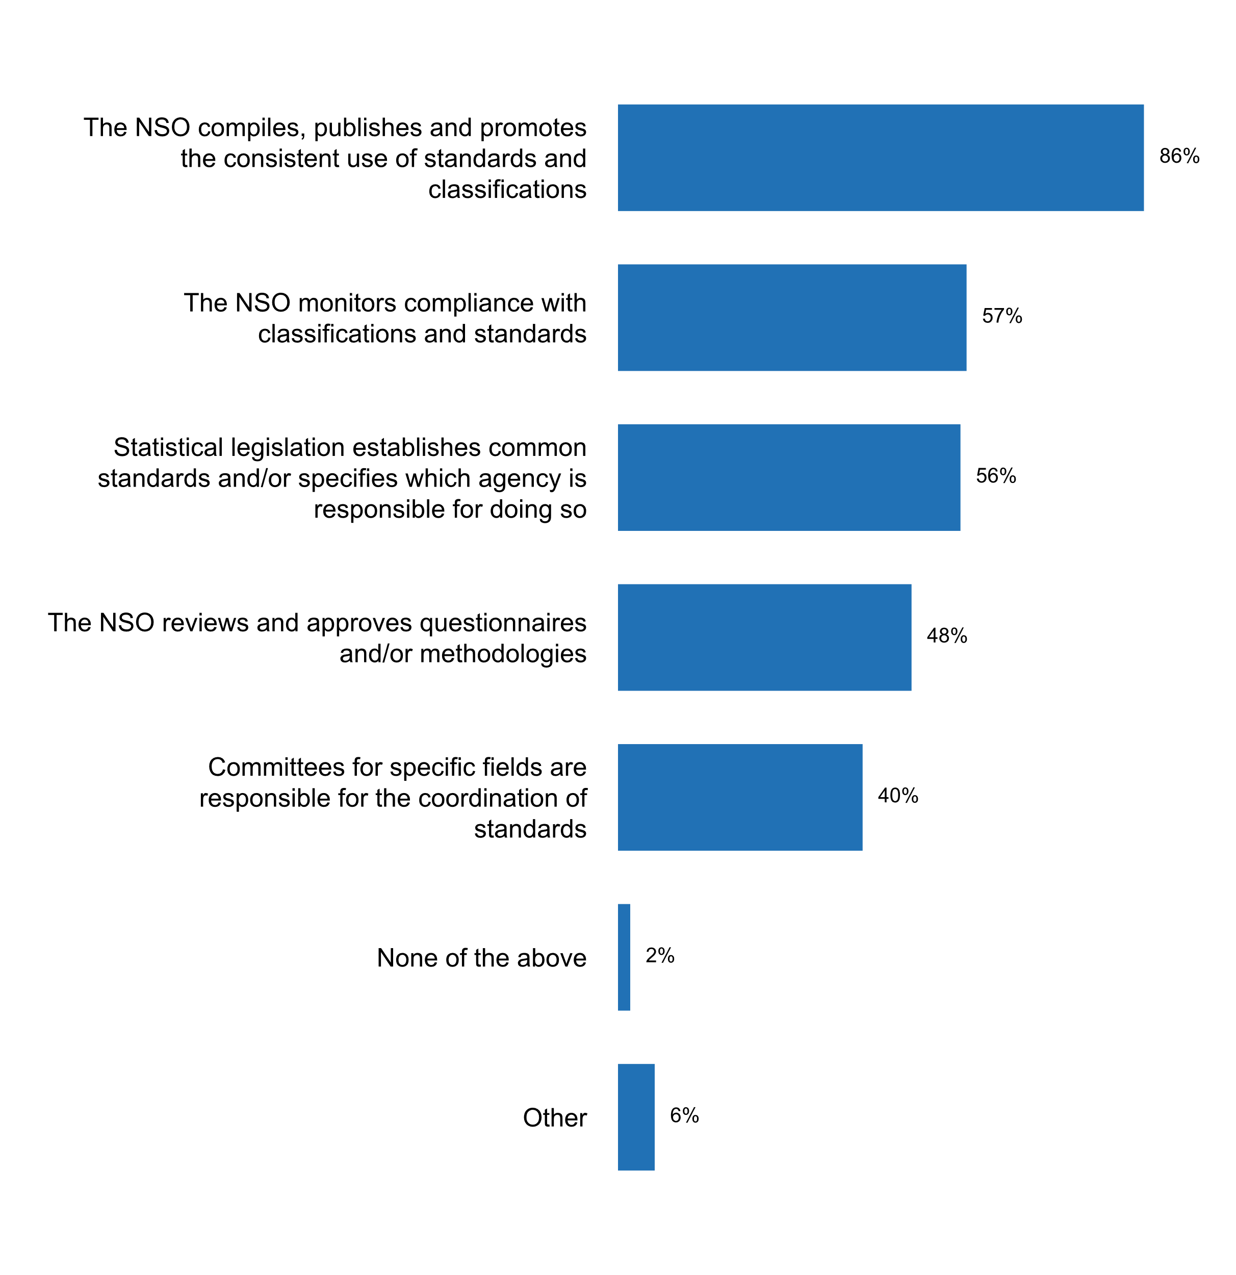

Figure 16. Measures currently being undertaken for coordinating   
standards and classifications across the NSS

All countries reported the existence of documents that provide **guidelines on professional ethics**, with a majority mentioning the statistical law and internal regulations and staff rules as the primary guidance documents. This is an improvement with respect to the 2012 results, when only 80 percent of statistical offices reported having written guidelines for professional ethics. 10 percent also identified other documents that provide guidelines other than existing codifications.

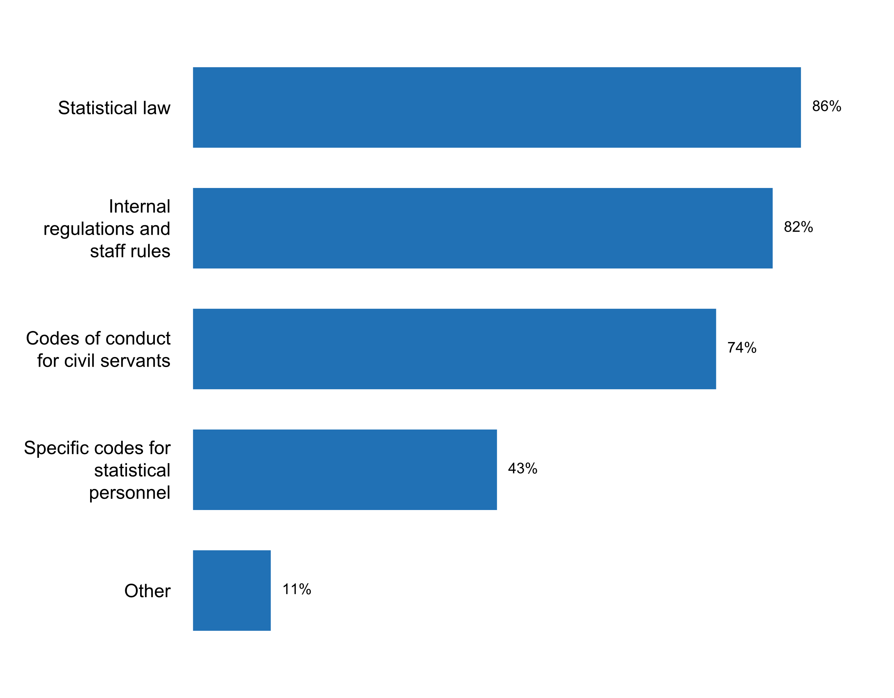

Figure 17. Document(s) providing guidance on professional ethics for staff

In all but one of the countries, measures were taken in the past five years to inform and remind staff about professional ethics. More that three-quarters conduct orientation and training programmes and seminars, and about 67 percent rely on handbooks, booklets, poster, and intranet communication to inform and remind staff of existing codes of conduct. New staff from six out of every ten countries get sworn in and receive relevant laws and guidelines.

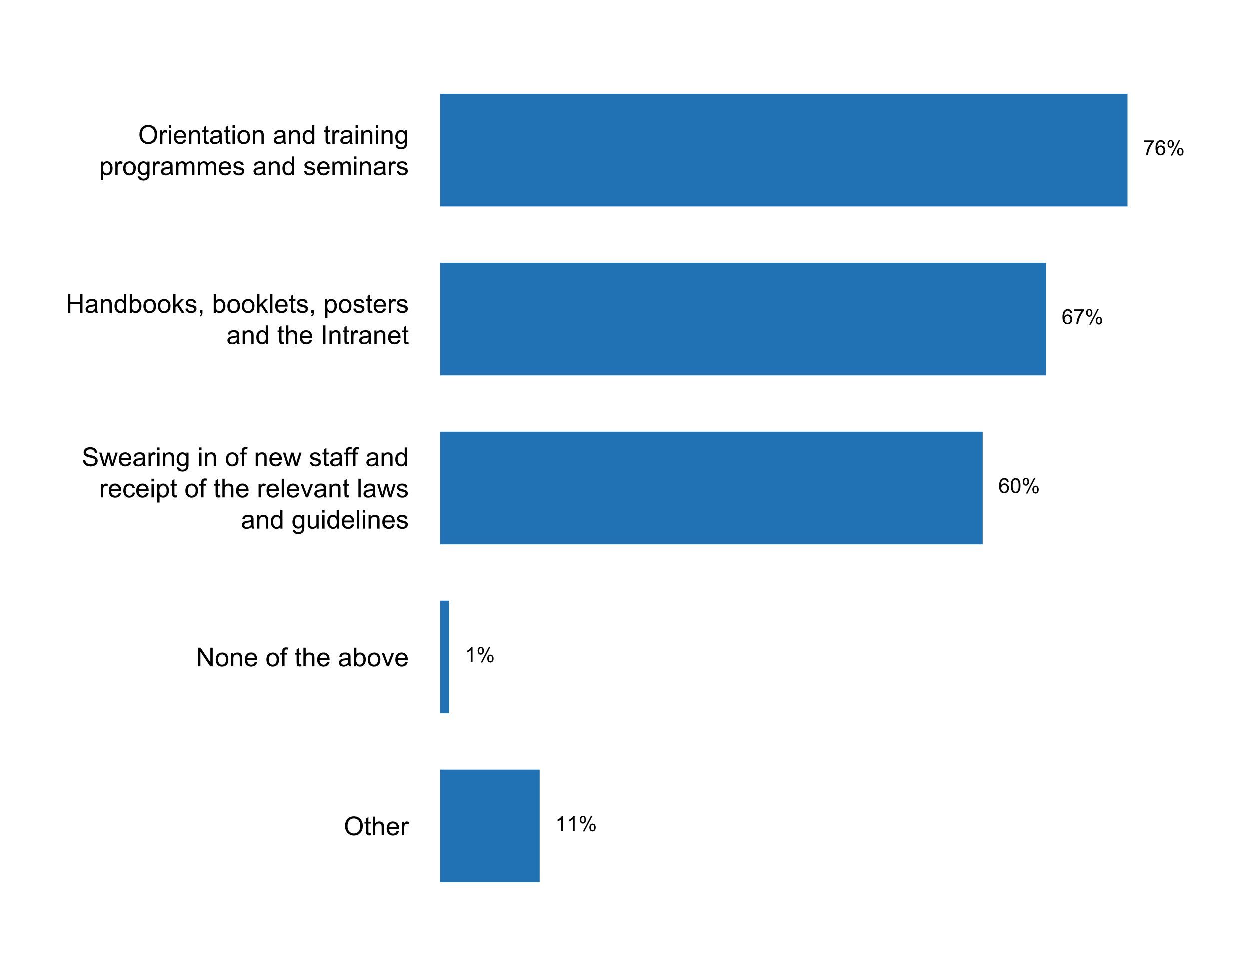

Figure 18. Ways in which staff have been informed and reminded   
of existing codes of conduct, in the past five years

In the 2018 questionnaire, 91 percent of the responses report that NSO staff has received **training concerning open data, data privacy or access to information policies and principles**. However, this figure is only 69 percent for staff on other agencies in the NSS. For those that have not received training, the reasons include limited finances, lack of personnel and capacity, and the fact that an open data policy is not yet part of their regular operations.



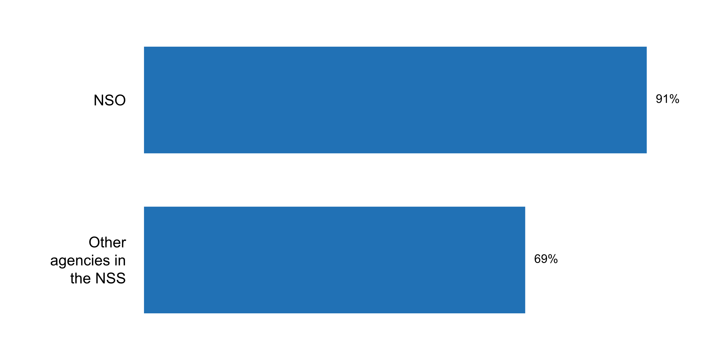

Figure 19. Training concerning open data, data privacy   
or access to information policies and principles

In general, the **main challenges identified by respondents for the implementation of Principle 2** included: (1) the need to update/reform the statistical law to guarantee professional and technical independence and code of ethics; (2) lack of training and lack of knowledge in this area by line ministries; areas of data governance; (3) inadequate human and financial resources in this area; and (4) the need to improve transparency and accountability by statistical agencies.

**Principle 3: Accountability and Transparency**

“To facilitate a correct interpretation of the data, the statistical agencies are to present information according to scientific standards on the sources, methods and procedures of the statistics.”

Ensuring that users have easy access to statistical data along with sufficient information to make proper use of it is critical for the implementation of Principle 3. Eighty-six percent of respondents provide **information on the quality of published data** through methodological notes, and 82 percent have quality information as part of metadata delivered with the data. This is in line with a growing trend found in the 2012 results of a shift to more routine and standardized formats for reference metadata informing users about the quality of published data.

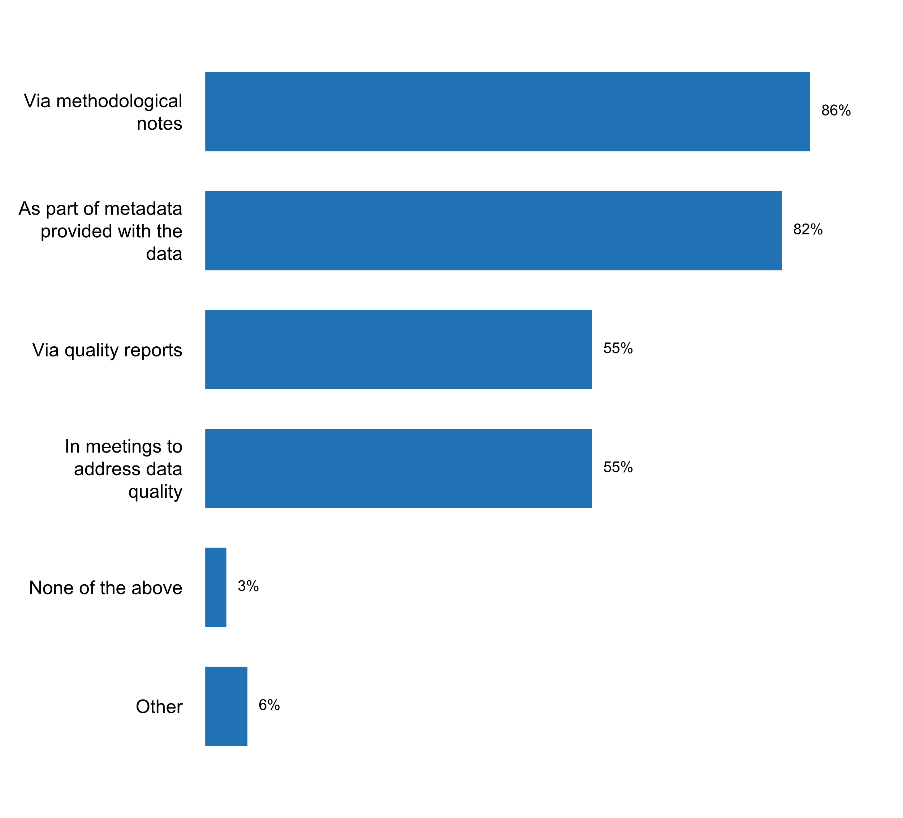

Figure 20. How users are informed of the quality of published data



**Published data of all the national statistical offices responding to the 2018 questionnaire are frequently accompanied by explanatory texts**. Eighty-three percent of the respondents indicate that metadata is associated with each dataset. Four in every five countries (80 percent) notify their users of major methodological changes, and 61 percent provide errata or other forms of error correction. Moreover, approximately one half of all countries publish the manual and protocols used by the NSS (53 percent) or guides to assist users in the interpretation of data and estimates (47 percent).

**Among countries that present metadata with published data, almost 90 percent noted that the datasets released in the last two years included metadata at least half of the time**. However, overall, less than half of the total number of respondents indicate that manuals on concepts and definitions (40 percent) or manuals on data collection, editing, processing, analysis and visualization (37 percent) are made available along with published data.



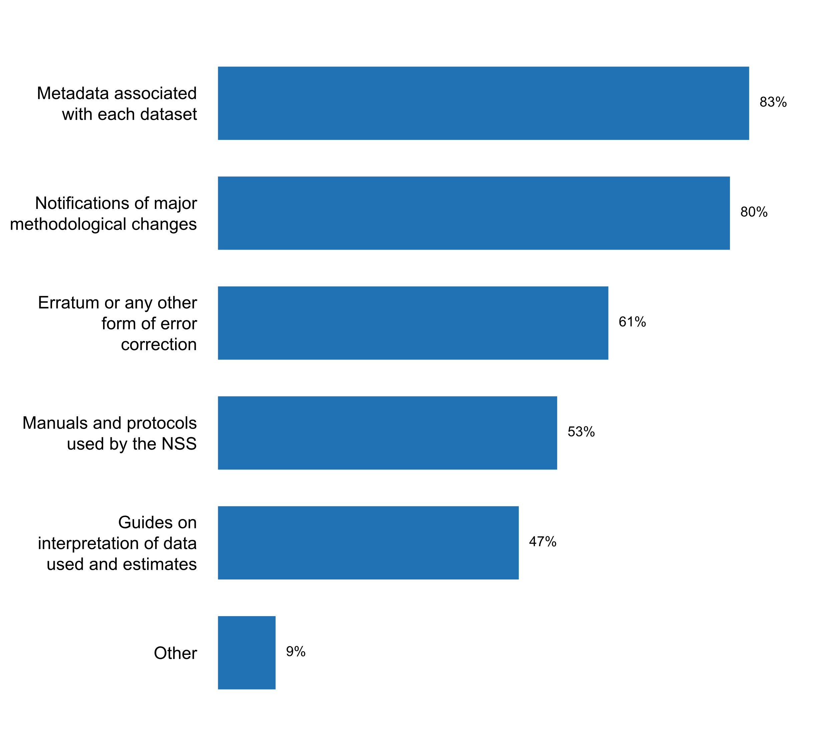

Figure 21. Types of explanatory texts that accompany published data

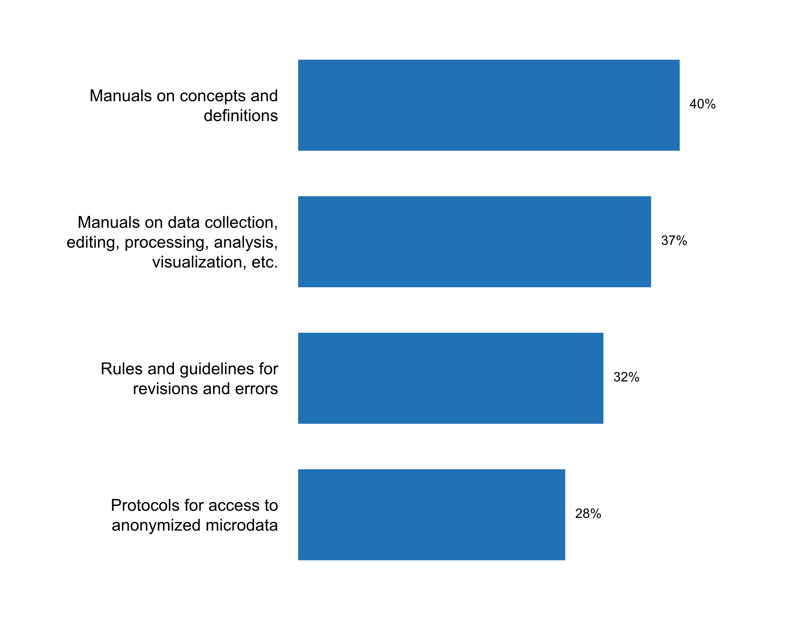

Figure 22. Types of manuals and protocols made available with published data

Almost 97 percent of the countries use at least one data platform to disseminate statistical data. Forty-three percent indicated that they use custom-developed data platforms. Overall, there is a wide variety of platforms being used (see Figure 23), and most countries use a combination of two or more platforms. Almost one third of all countries report the use of ArcGIS, a platform specialized in the dissemination of geospatially-enabled statistical data. The Eurostat web portal and OECD.Stat platforms are also widely used, as reported by 27 and 25 percent of all questionnaire respondents, respectively. Many questionnaire respondents, particularly from developing countries, also report the use of the NADA platform, a microdata cataloguing tool which uses the Data Documentation Initiative (DDI) metadata standard. It is worth noting that almost one in every five country reports the use of DevInfo, although this tool is being phased as technical support is no longer provided. On the other hand, CountryStat, supported by FAO, and the African Information Highway platform, supported by the African Development Bank, are used by a relatively large proportion of countries, especially in Africa. Other platforms commonly mentioned by respondents as being used for data dissemination include PX-Web and Redatam.



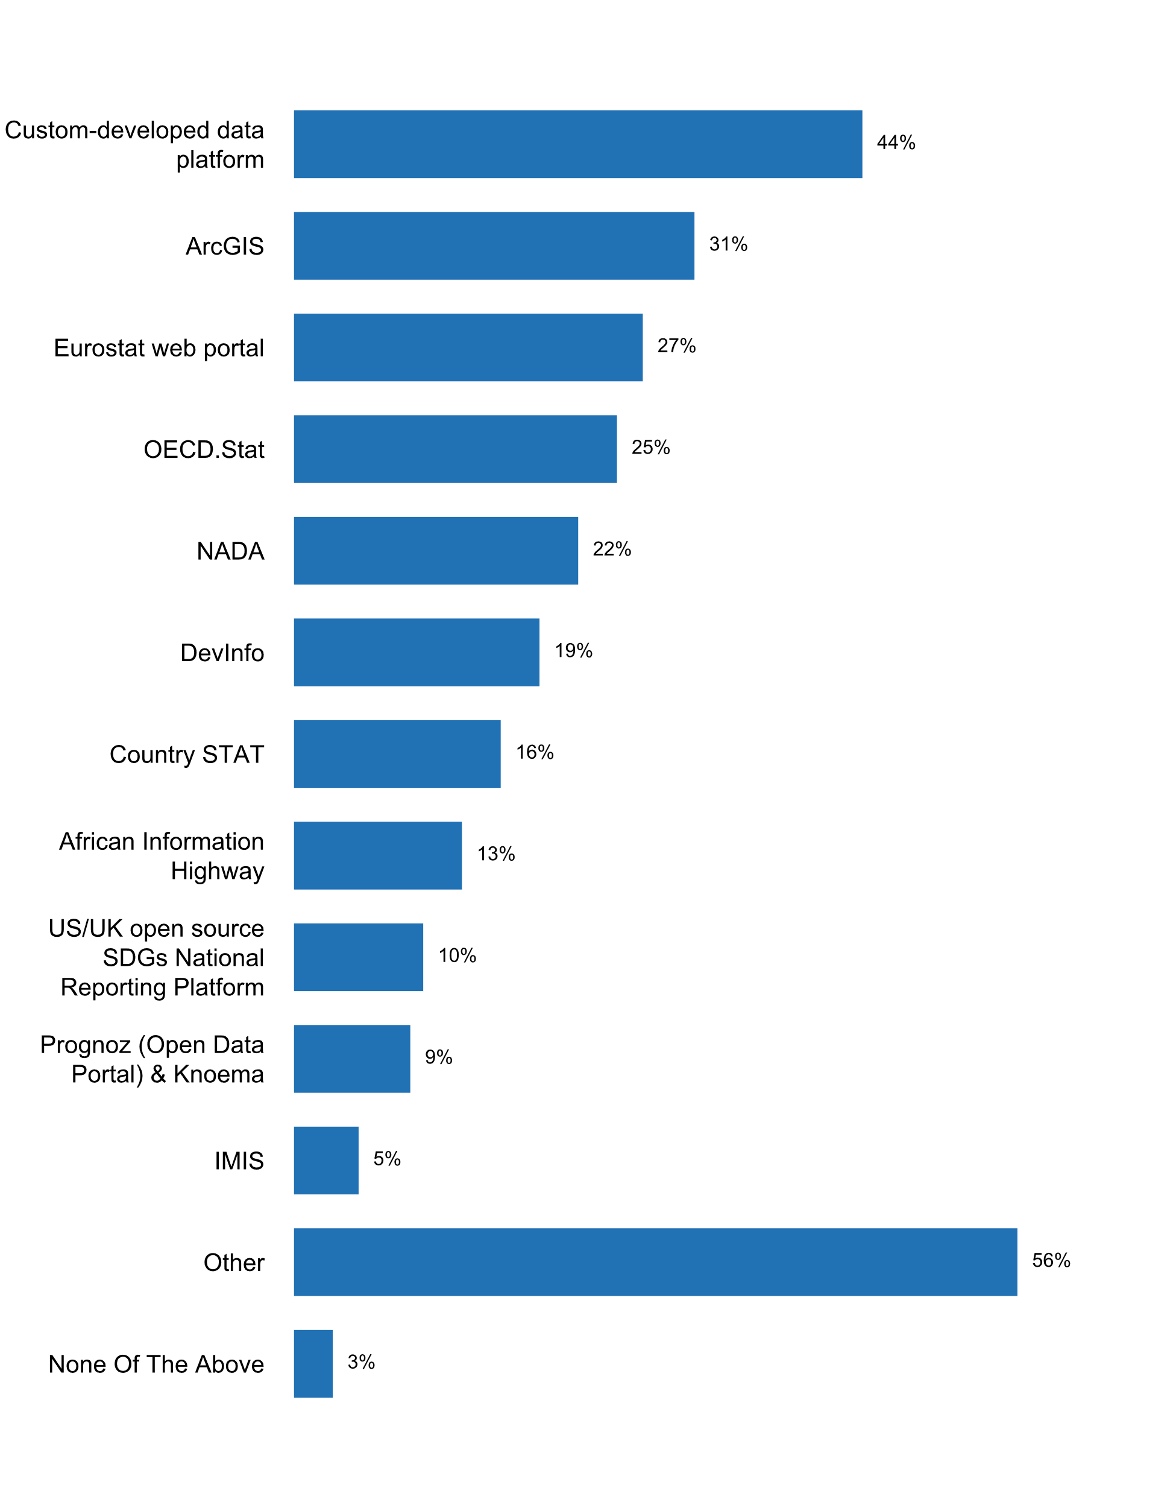

Figure 23. Data platform(s) currently used by NSS/NSO to disseminate statistical data

In general, the main challenges identified by respondents for the implementation of Principle 3 included: (1) lack of resources to produce recommended quality reports and metadata; and (2) lack of metadata from other agencies in the NSS.

**Principle 4: Prevention of Misuse**

“The statistical agencies are entitled to comment on erroneous interpretation and misuse of statistics..”

Over three-quarters of country respondents to the 2018 questionnaire indicate that the NSO and/or the NSS have reacted to the erroneous interpretation and misuse of statistics during the past five years, primarily through sending letters to the editors of newspapers or advertorials (60 percent), publishing articles through webpages or social media (57 percent) or holding press conferences or issues press releases (52 percent). Other means employed by NSOs and NSSs to comment on erroneous interpretation and misuse of statistics include television appearances and email communication.







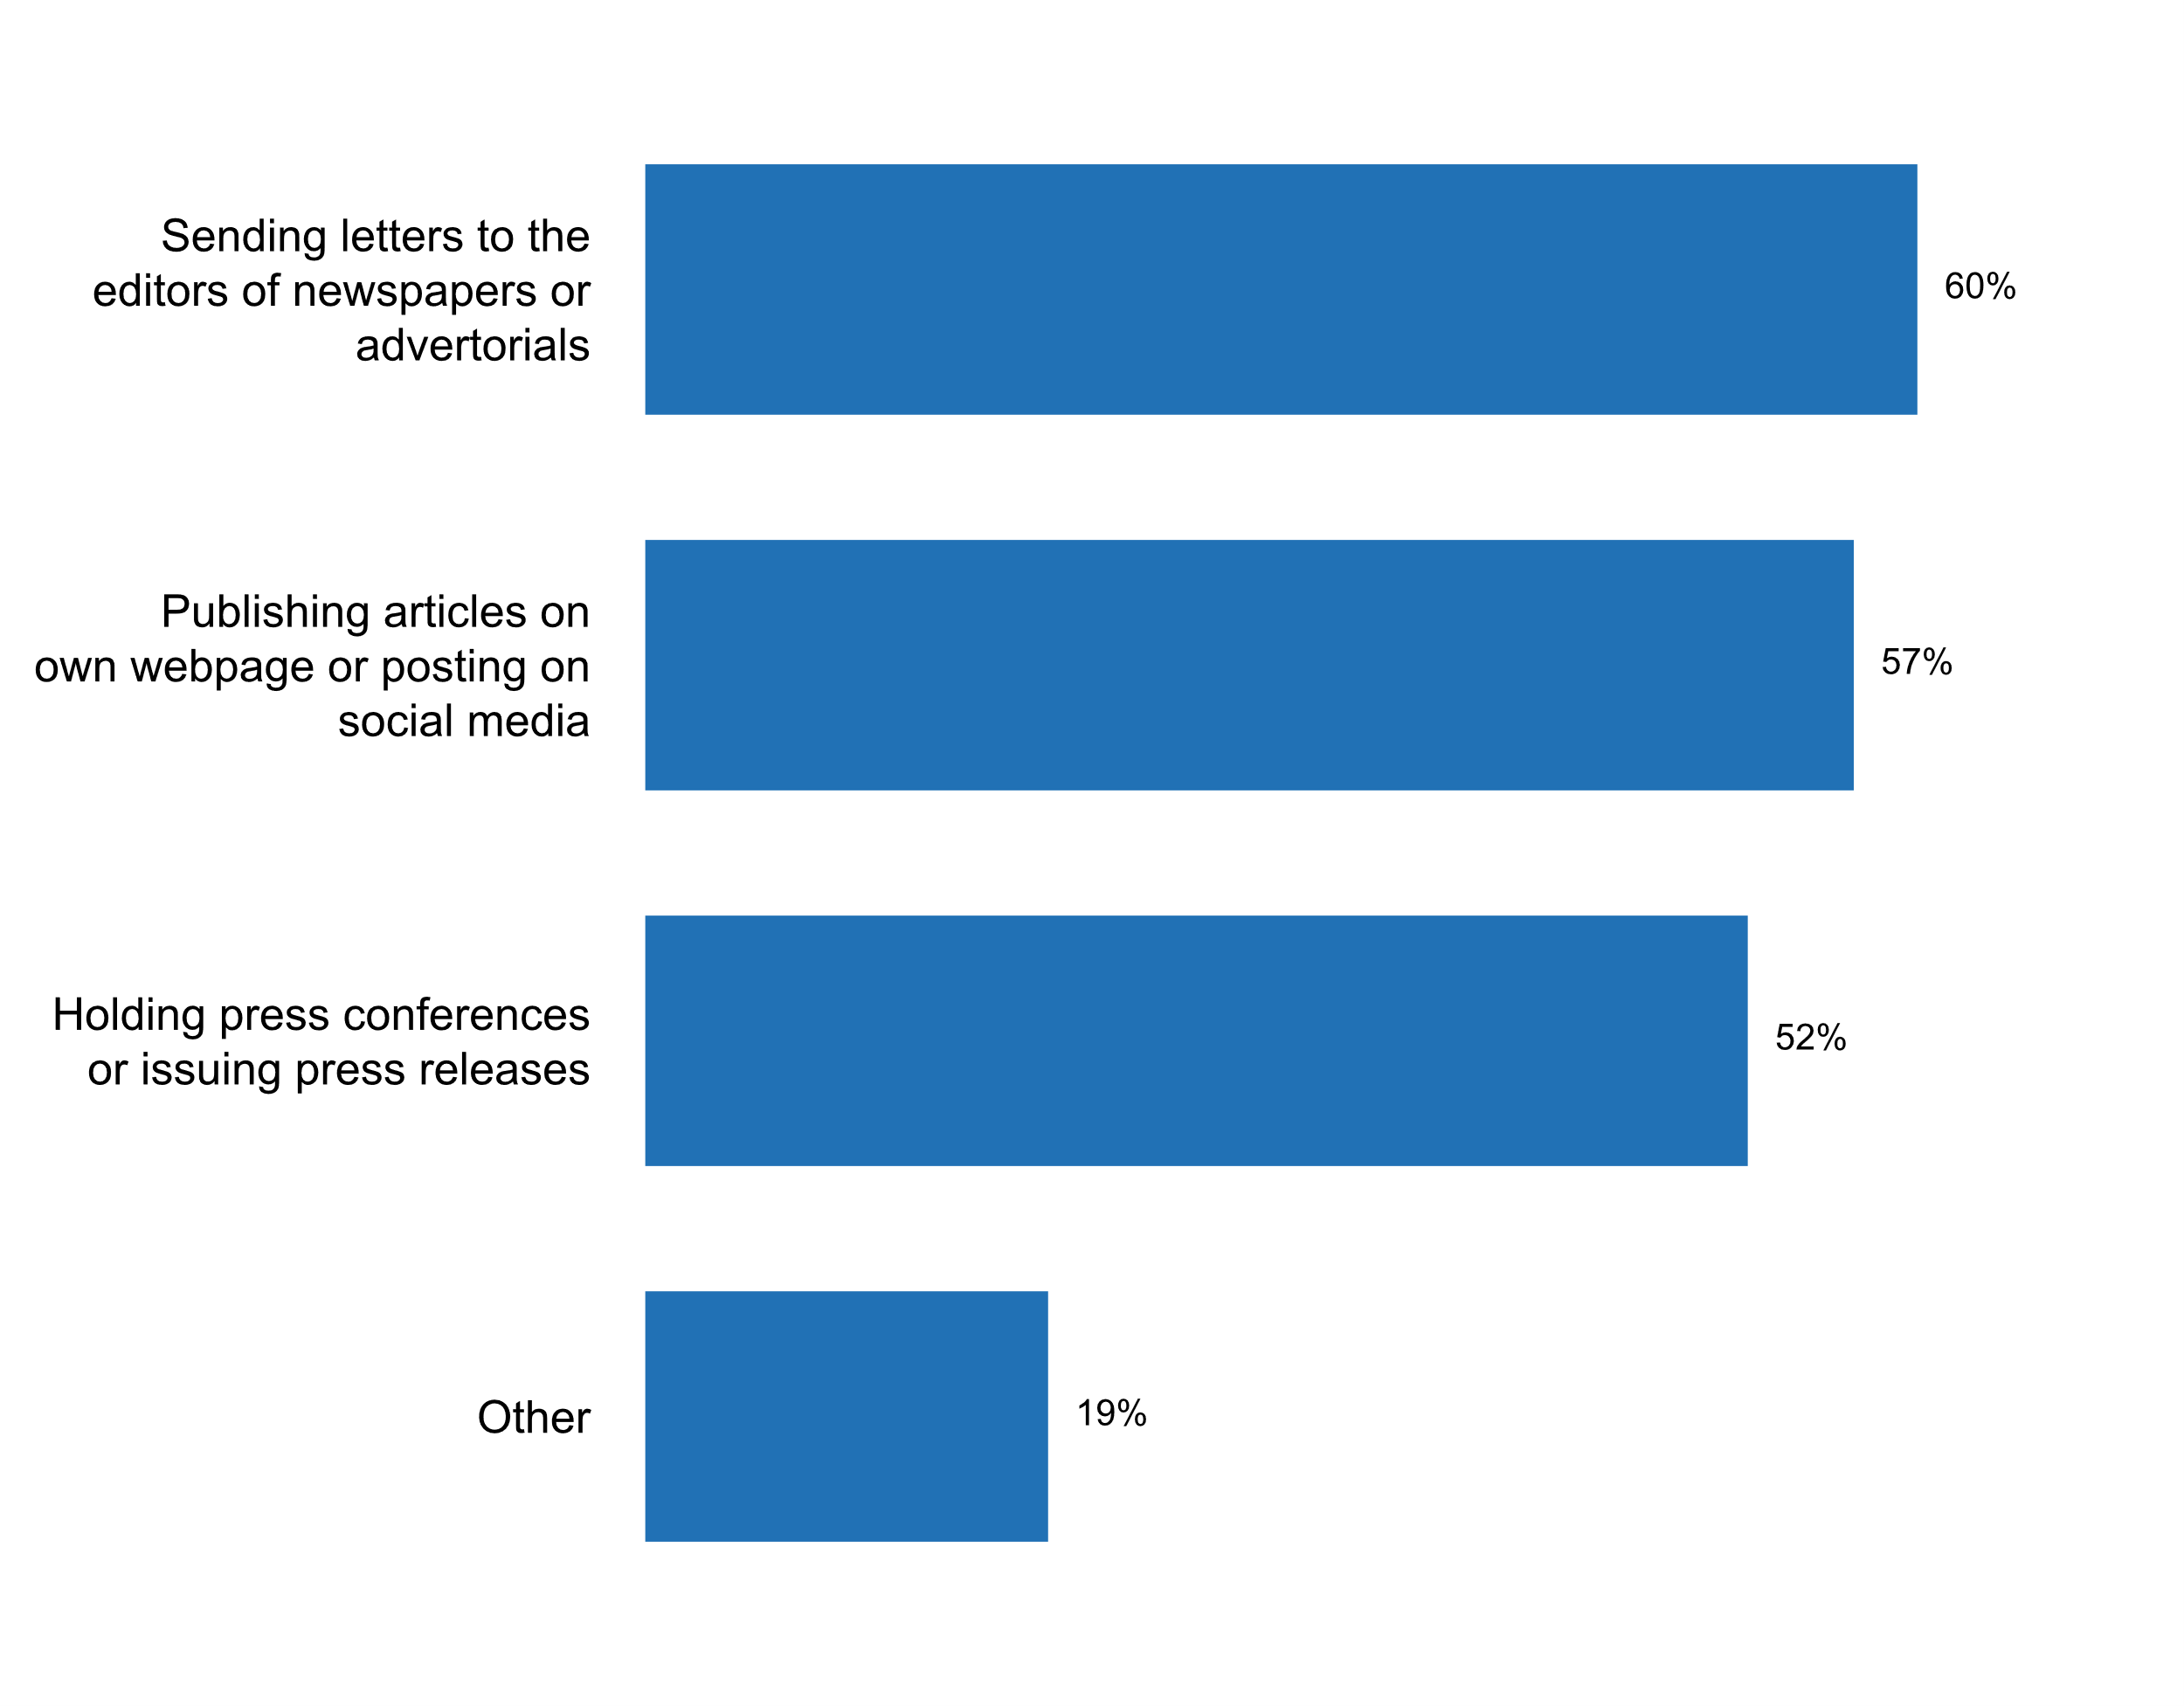

Figure 24. How NSO/NSS reacted to erroneous interpretations   
and misuse of statistics during the past five years

Moreover, almost half of the countries responding to the 2018 questionnaire indicate that the NSO and/or NSS has commented on erroneous interpretation and misuse of statistics at least once every year over the last past years, and 1 in every 3 respondents has done so twice or more per year.

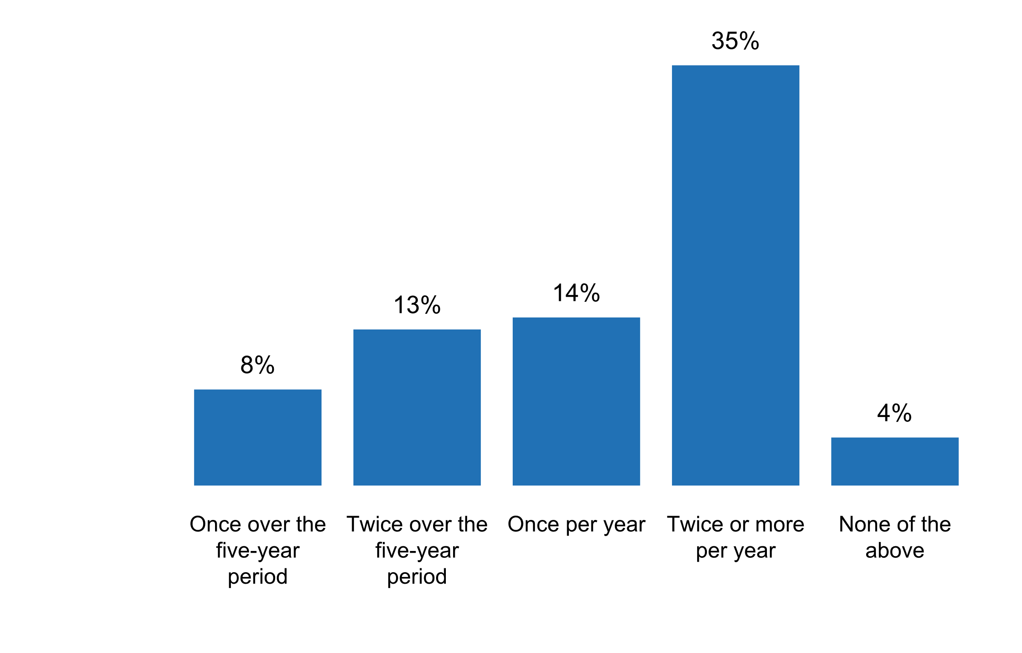

Figure 25. Number of times the NSO/NSS commented on erroneous   
interpretation and misuse of statistics in the past five years

The most commonly identified type of misuse over the past two years was the misreporting of findings (62 percent). Other issues frequently reported include over-generalizations, selective reporting of findings, and suggestions of false causality.

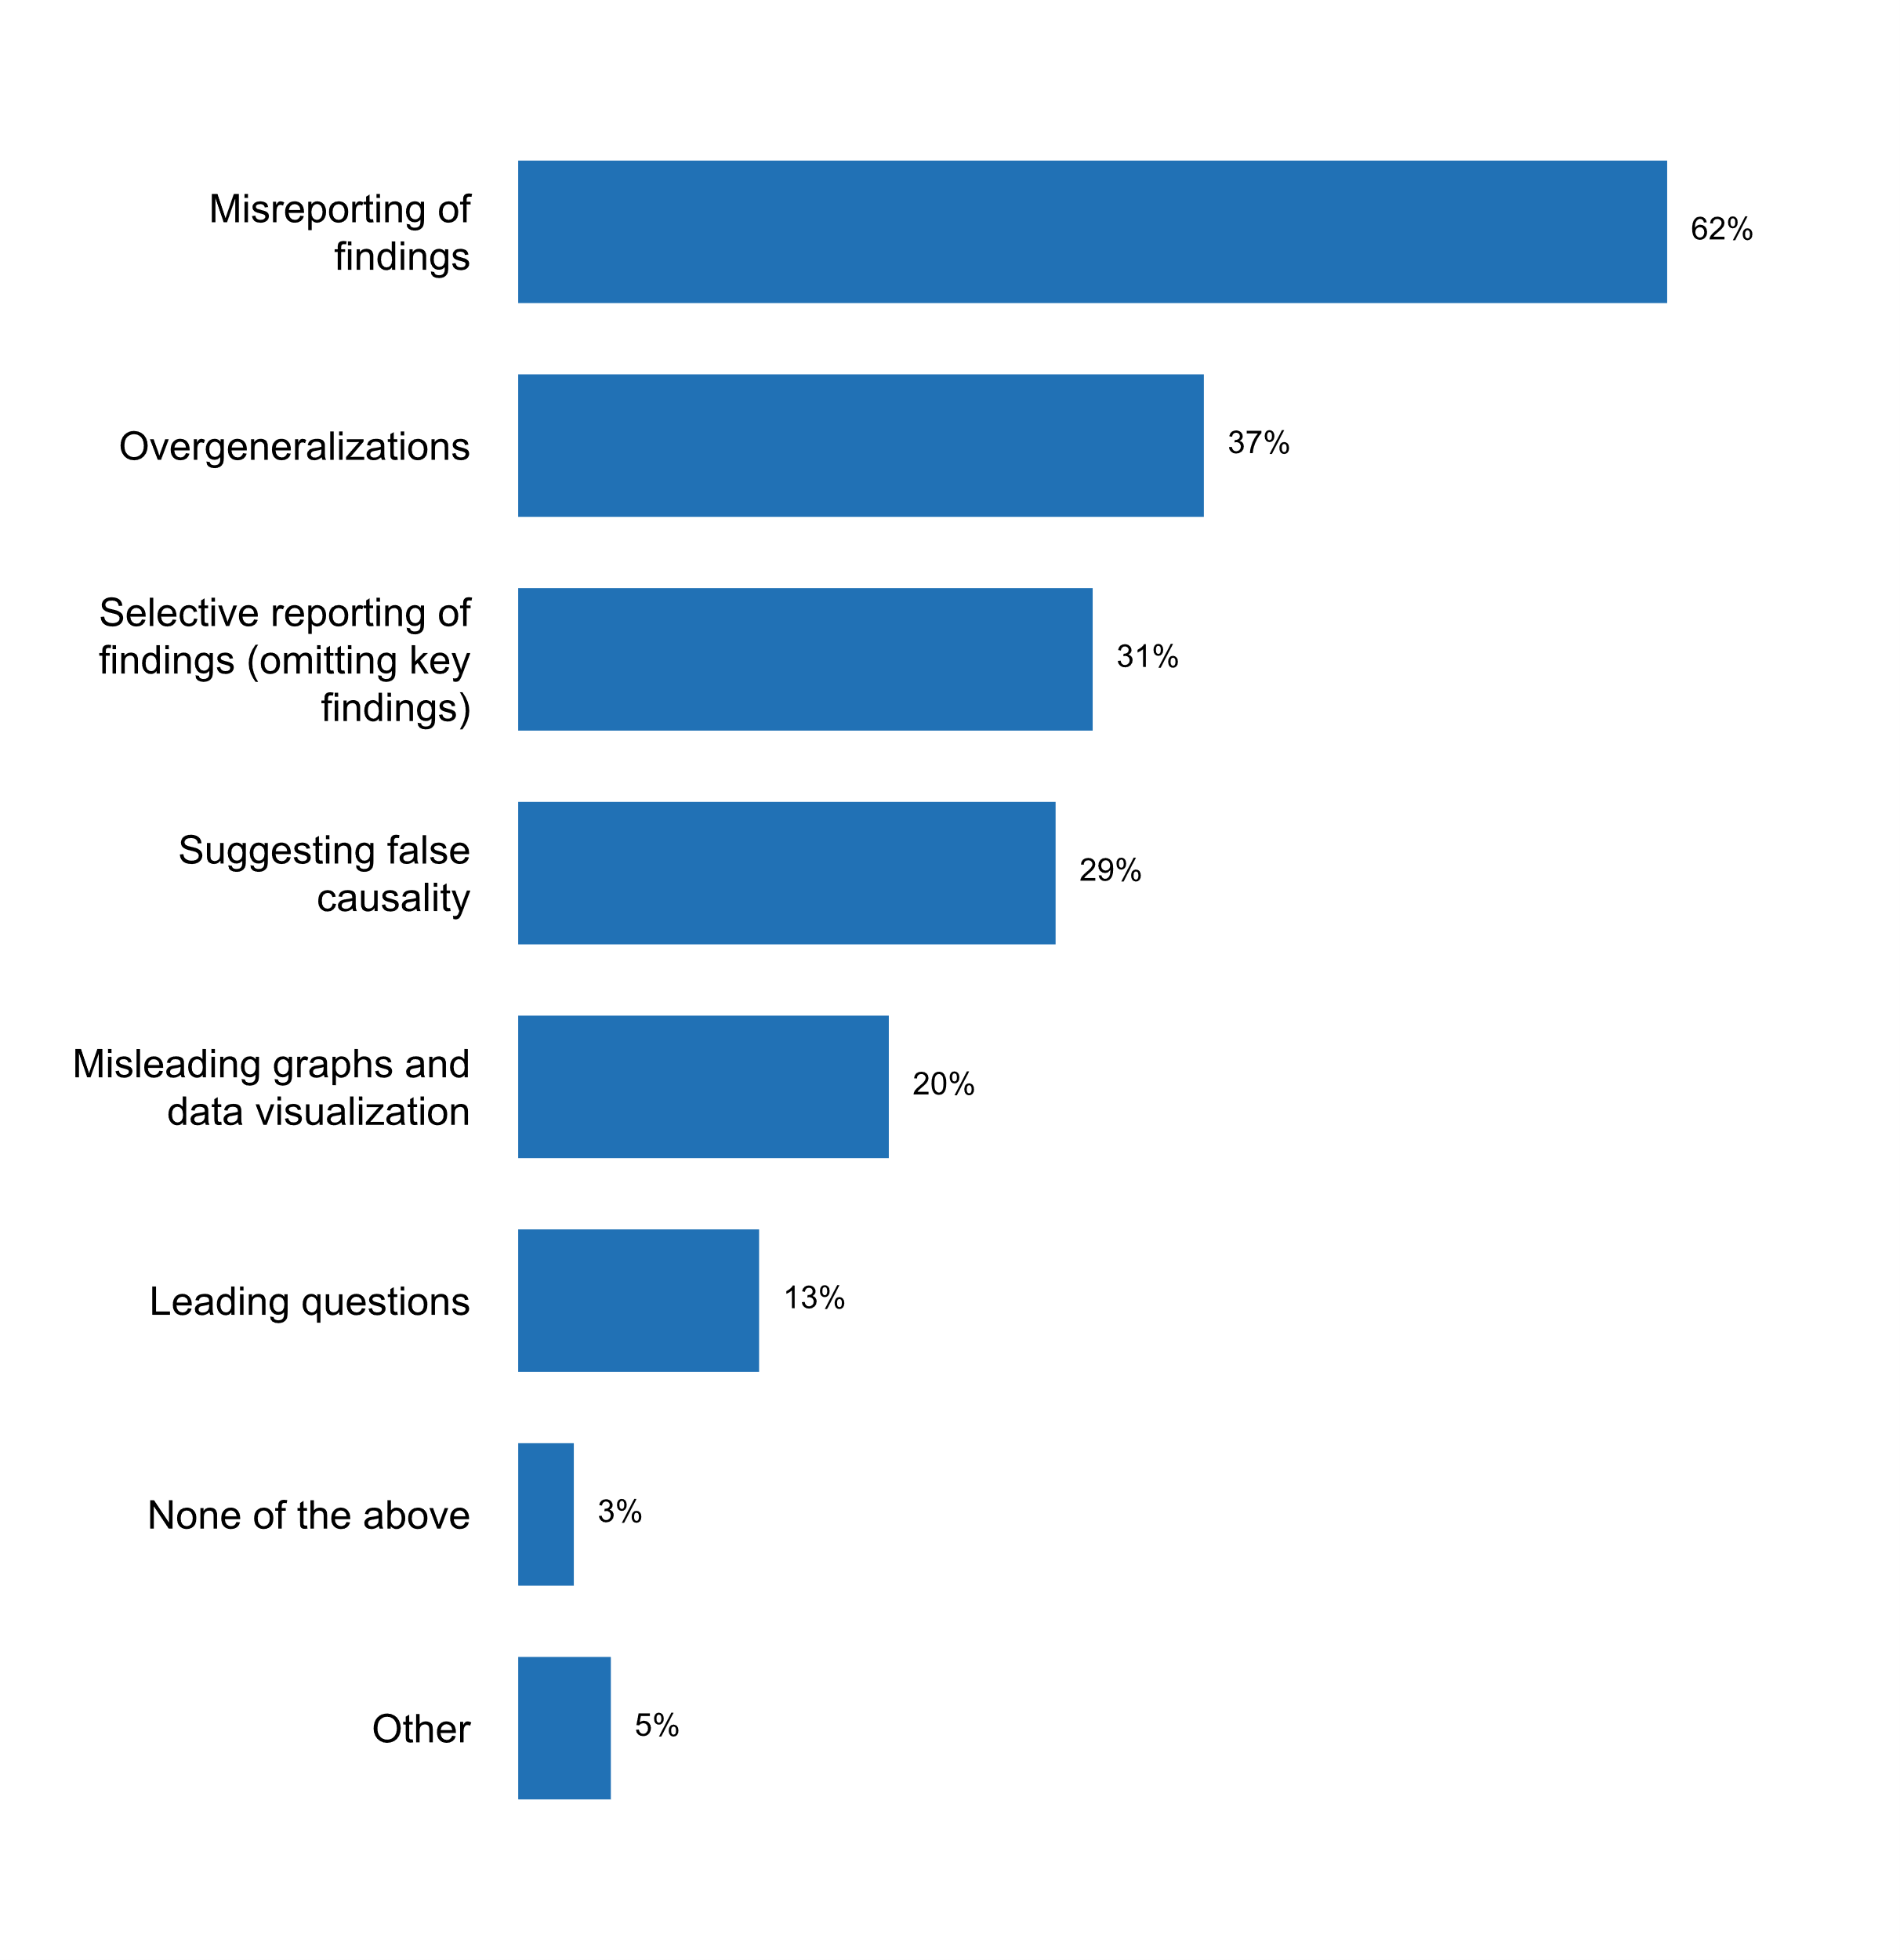

Figure 26. Types of misuse identified in the past two years

Similar to the results in 2012, problems of misinterpretation often are attributed to users’ lack of methodological knowledge, statistical literacy and awareness. These issues were also identified as the most challenging for countries when implementing this Principle.



In this context, countries are engaging in a wide array of activities to educate data users, in line with results found also in the 2003 and 2012 questionnaires. In addition to the activities noted in the answer choices, countries also pointed out other activities such as: quizzes for users, hackathons, self-learning videos and statistical Olympics for high school students. Generally, seminars, participation in external events, and/or appearance in mass media activities were held twice or more per year by the majority of respondents.

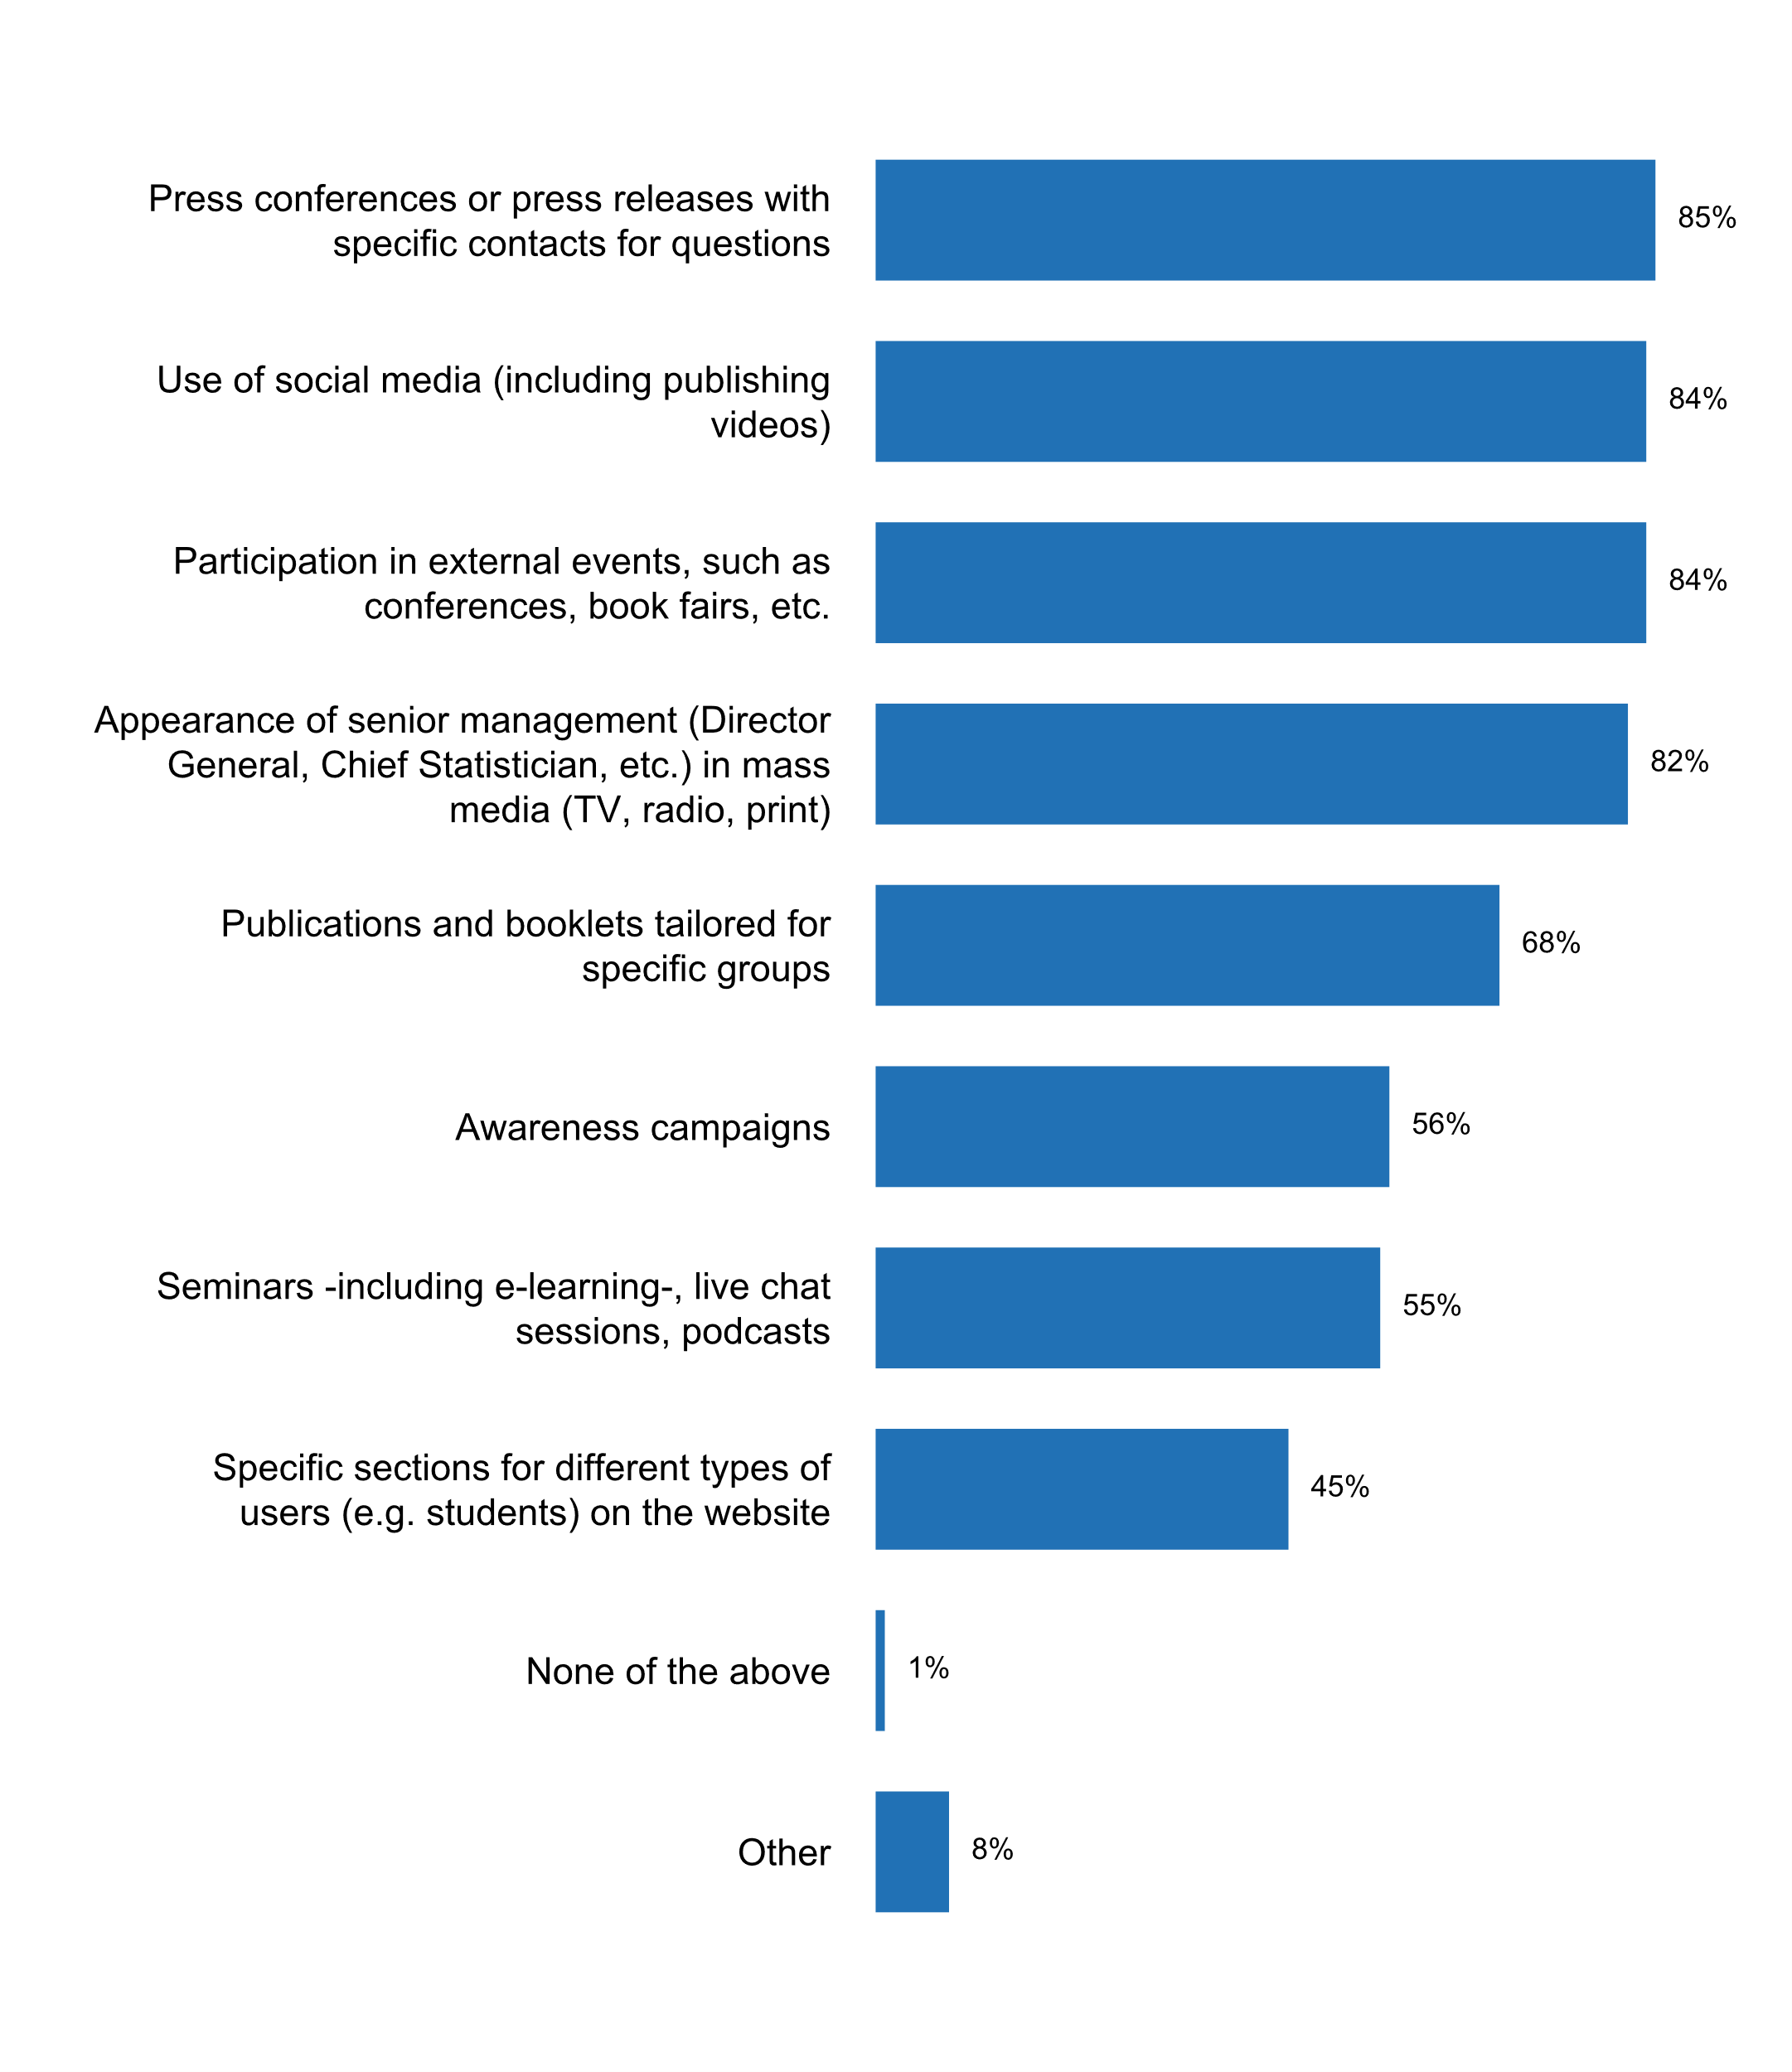

Figure 27. Activities carried out by the NSO/NSS to educate data users   
in the past five years, including the media

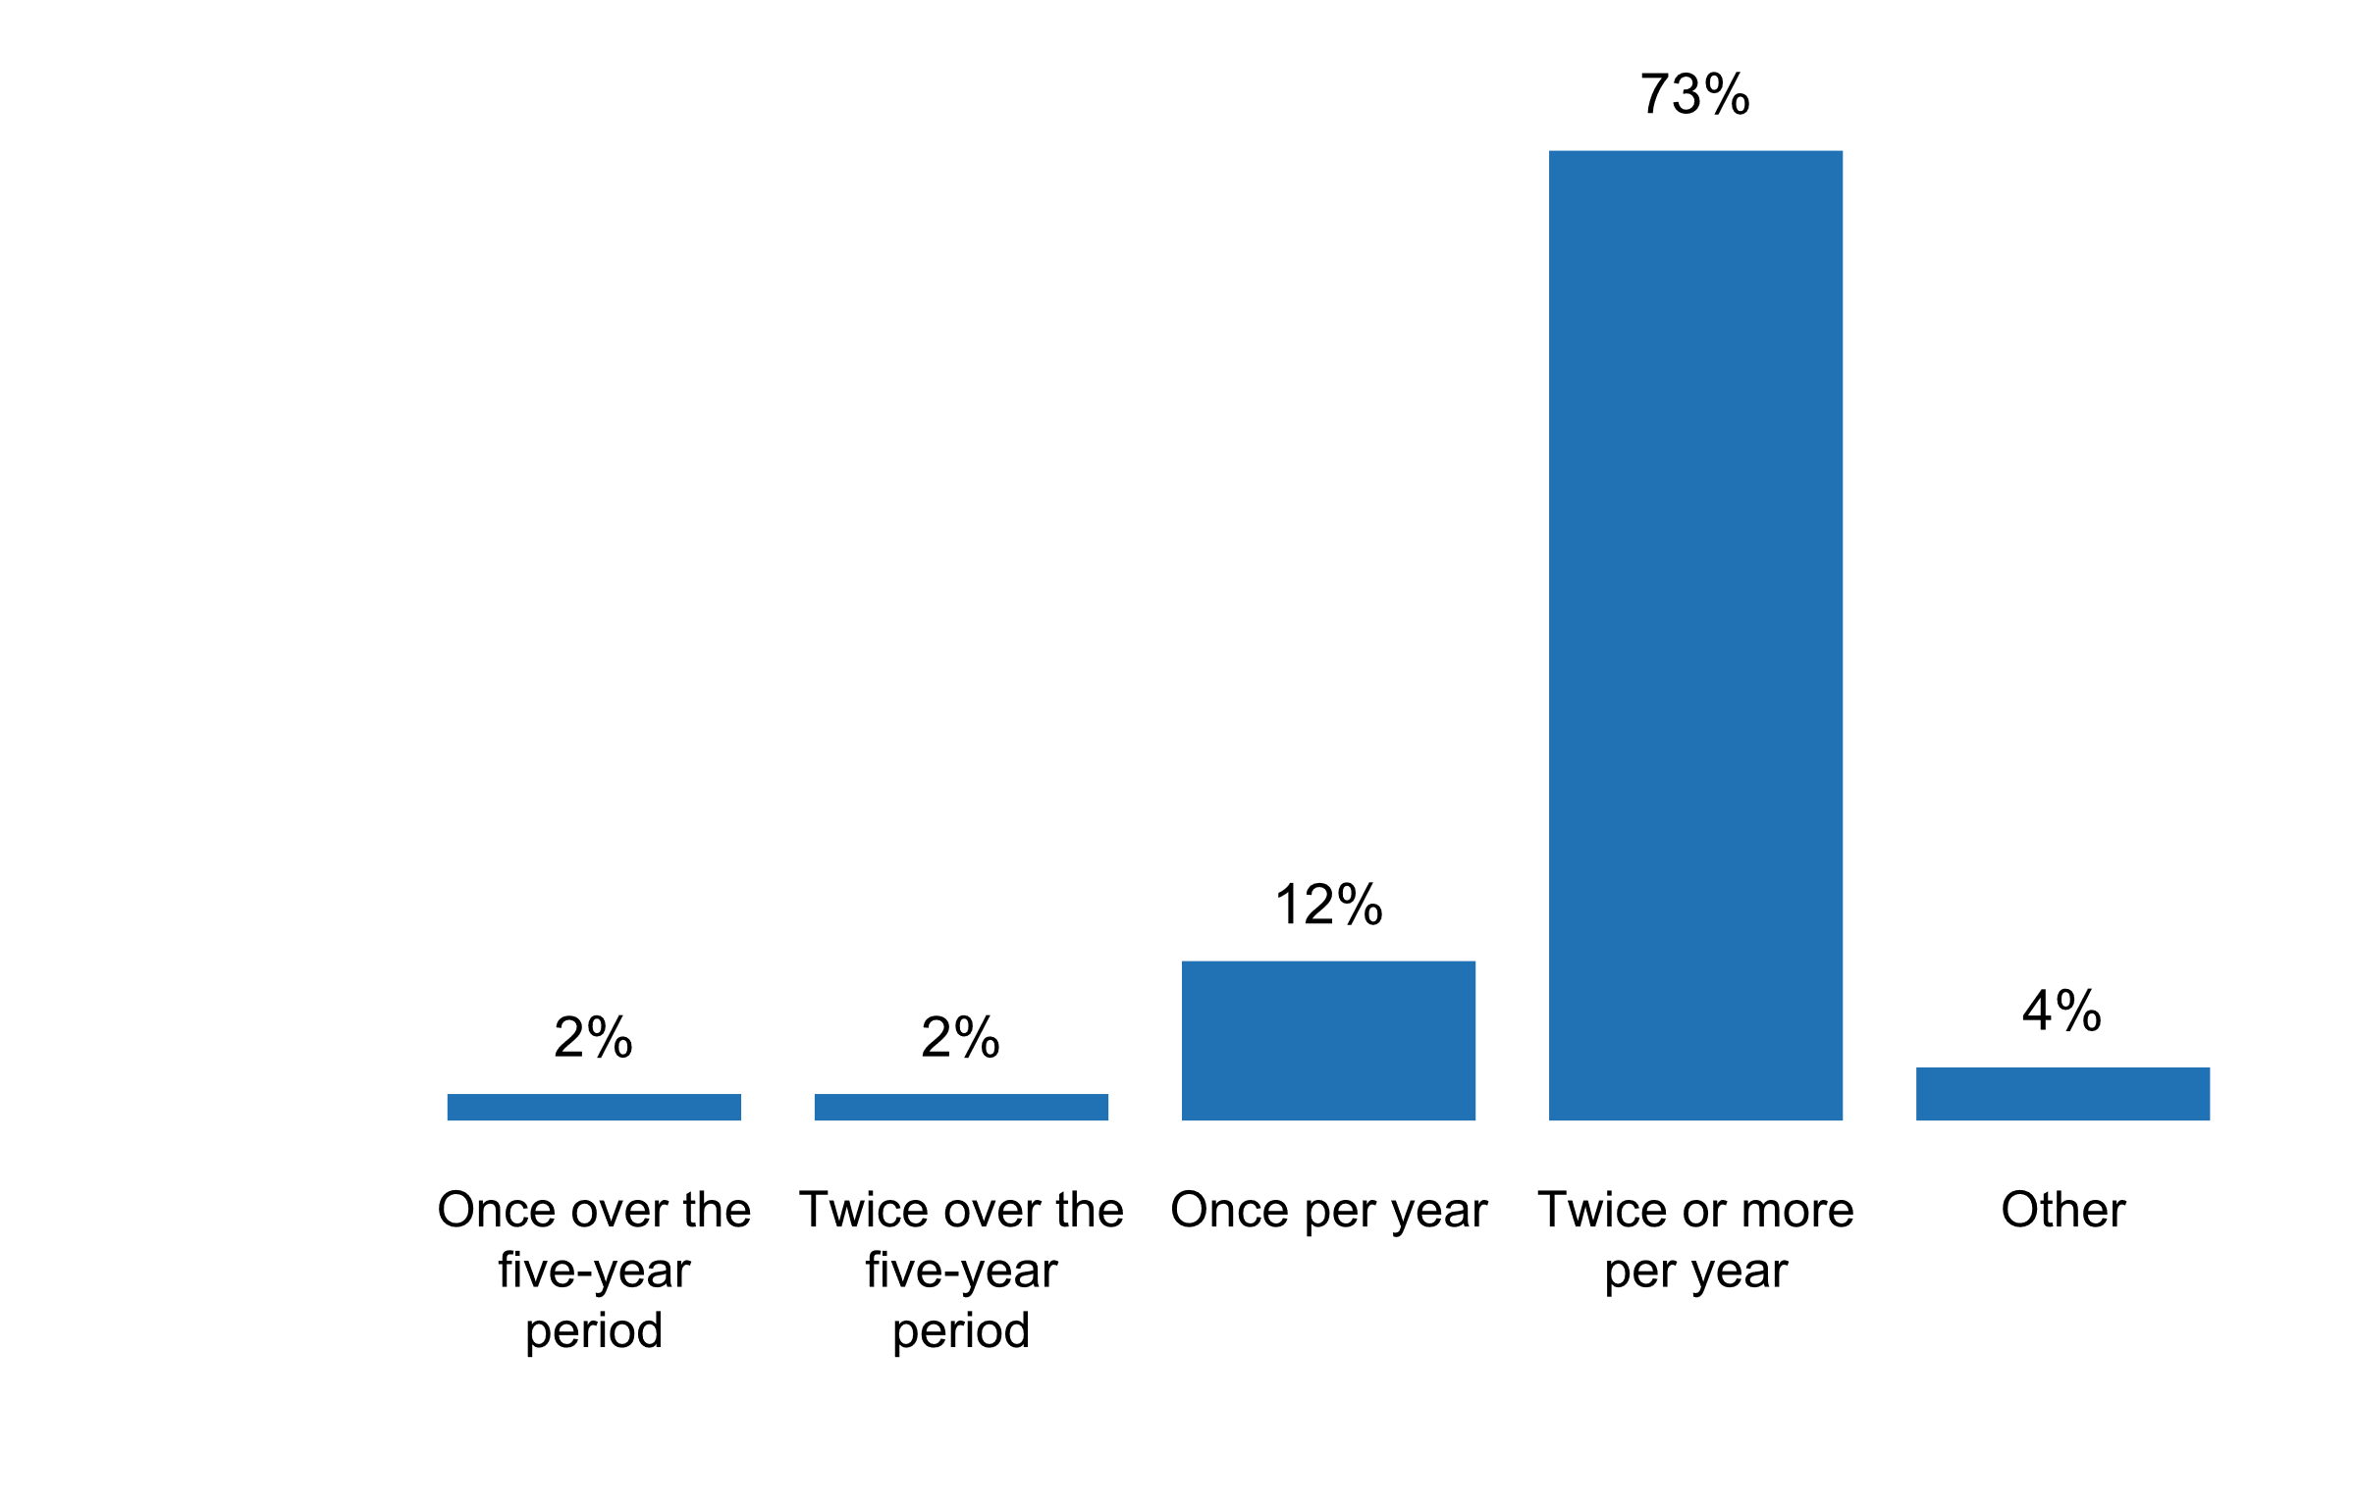

Figure 28. Number of times "seminars, participation in external events, and/or   
appearances in mass media" took place to educate users in the past five years

In general, the main challenge identified by respondents for the implementation of Principle 4 focused on the need to improve statistical literacy and awareness, an issue that has been recently addressed in many international statistical fora and has become a priority for many national statistical offices.

**Principle 5: Sources for Official Statistics**

“Data for statistical purposes may be drawn from all types of sources, be they statistical surveys or administrative records. Statistical agencies are to choose the source with regard to quality, timeliness, costs and the burden on respondents”

Practically every national statistical office uses sample surveys (99 percent) and/or administrative records (98 percent) as data sources for the compilation of official statistics. Not surprisingly, census data is also cited as one of the most common sources of data (94 percent) used by NSOs. However, non-traditional sources of data for the compilation of official statistics are increasingly employed by NSOs and NSS. For instance, 37 percent of respondents indicated that they use currently web scrapped data, while 31 and 29 percent use privately-owned datasets and satellite imagery for the compilation of official statistics, respectively. On the other hand, only 6 percent of respondents to the questionnaire report the use of citizen-generated data from civil society organizations.

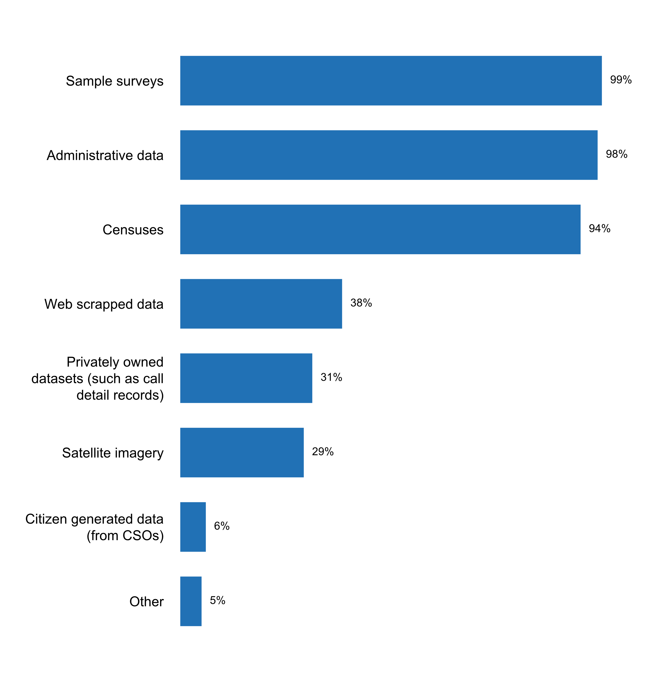

Figure 29. Sources of data currently used by the NSO

In recent years, there has been renewed interest in the use of administrative sources of data to improve timeliness, manage costs and reduce burden on data providers. In this connection, it is worth noting that the use of **administrative records as a direct source of data** (without linking or drawing of inferences) is reported by 9 in every 10 countries. However, around 8 in every 10 countries also use **administrative data for correcting input errors, imputing values, and calibrating sample weights** in census and sample survey data, and as a means for estimation by combining multiple records to derive variables. The use of **administrative data as a means to develop sampling frames and to add information to what is collected in survey or census interviews** is somewhat less frequent (70 percent). Almost one half of respondents also indicate that administrative data is used as a means to assess non-response rates in surveys, which is an important quality indicator.



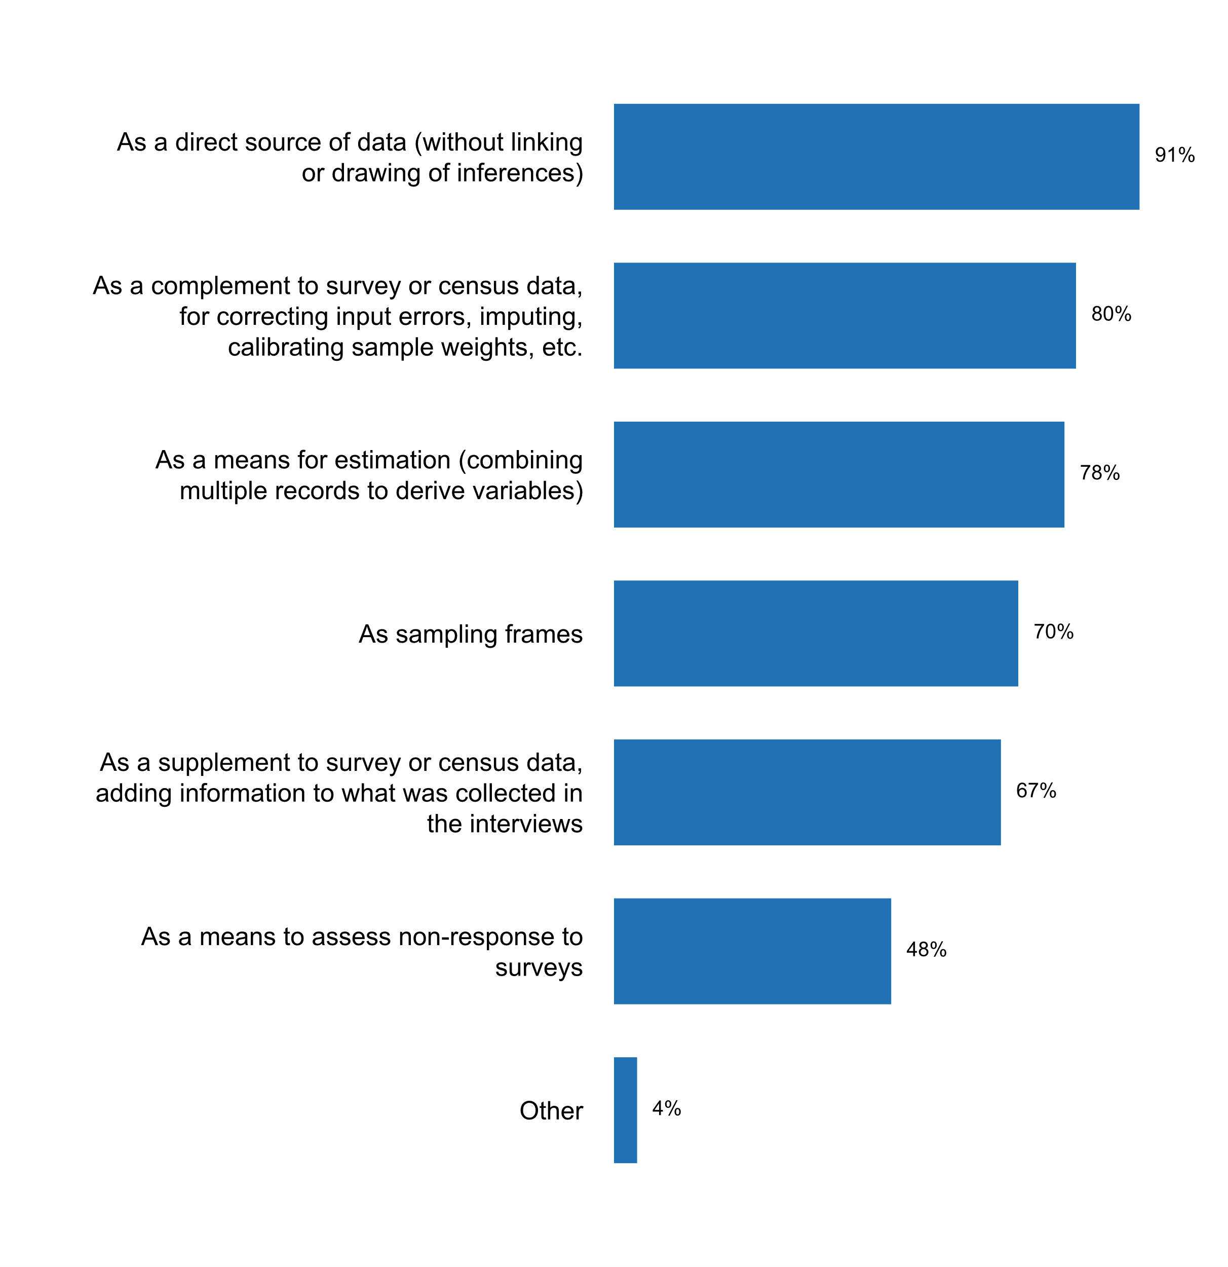

Figure 30. How administrative records are currently used

The majority of countries take action for adapting data from administrative records to statistical purposes. For instance, 85 percent cooperate with the custodians at the stage of design or modernization of information systems; 80 percent provide advice to the custodians for amending the composition and classification of administrative datasets; and 72 percent give feedback to the data source when errors are detected. However, less than half of countries provide training to custodians of administrative sources, hinting towards an opportunity for stronger cooperation and engagement.

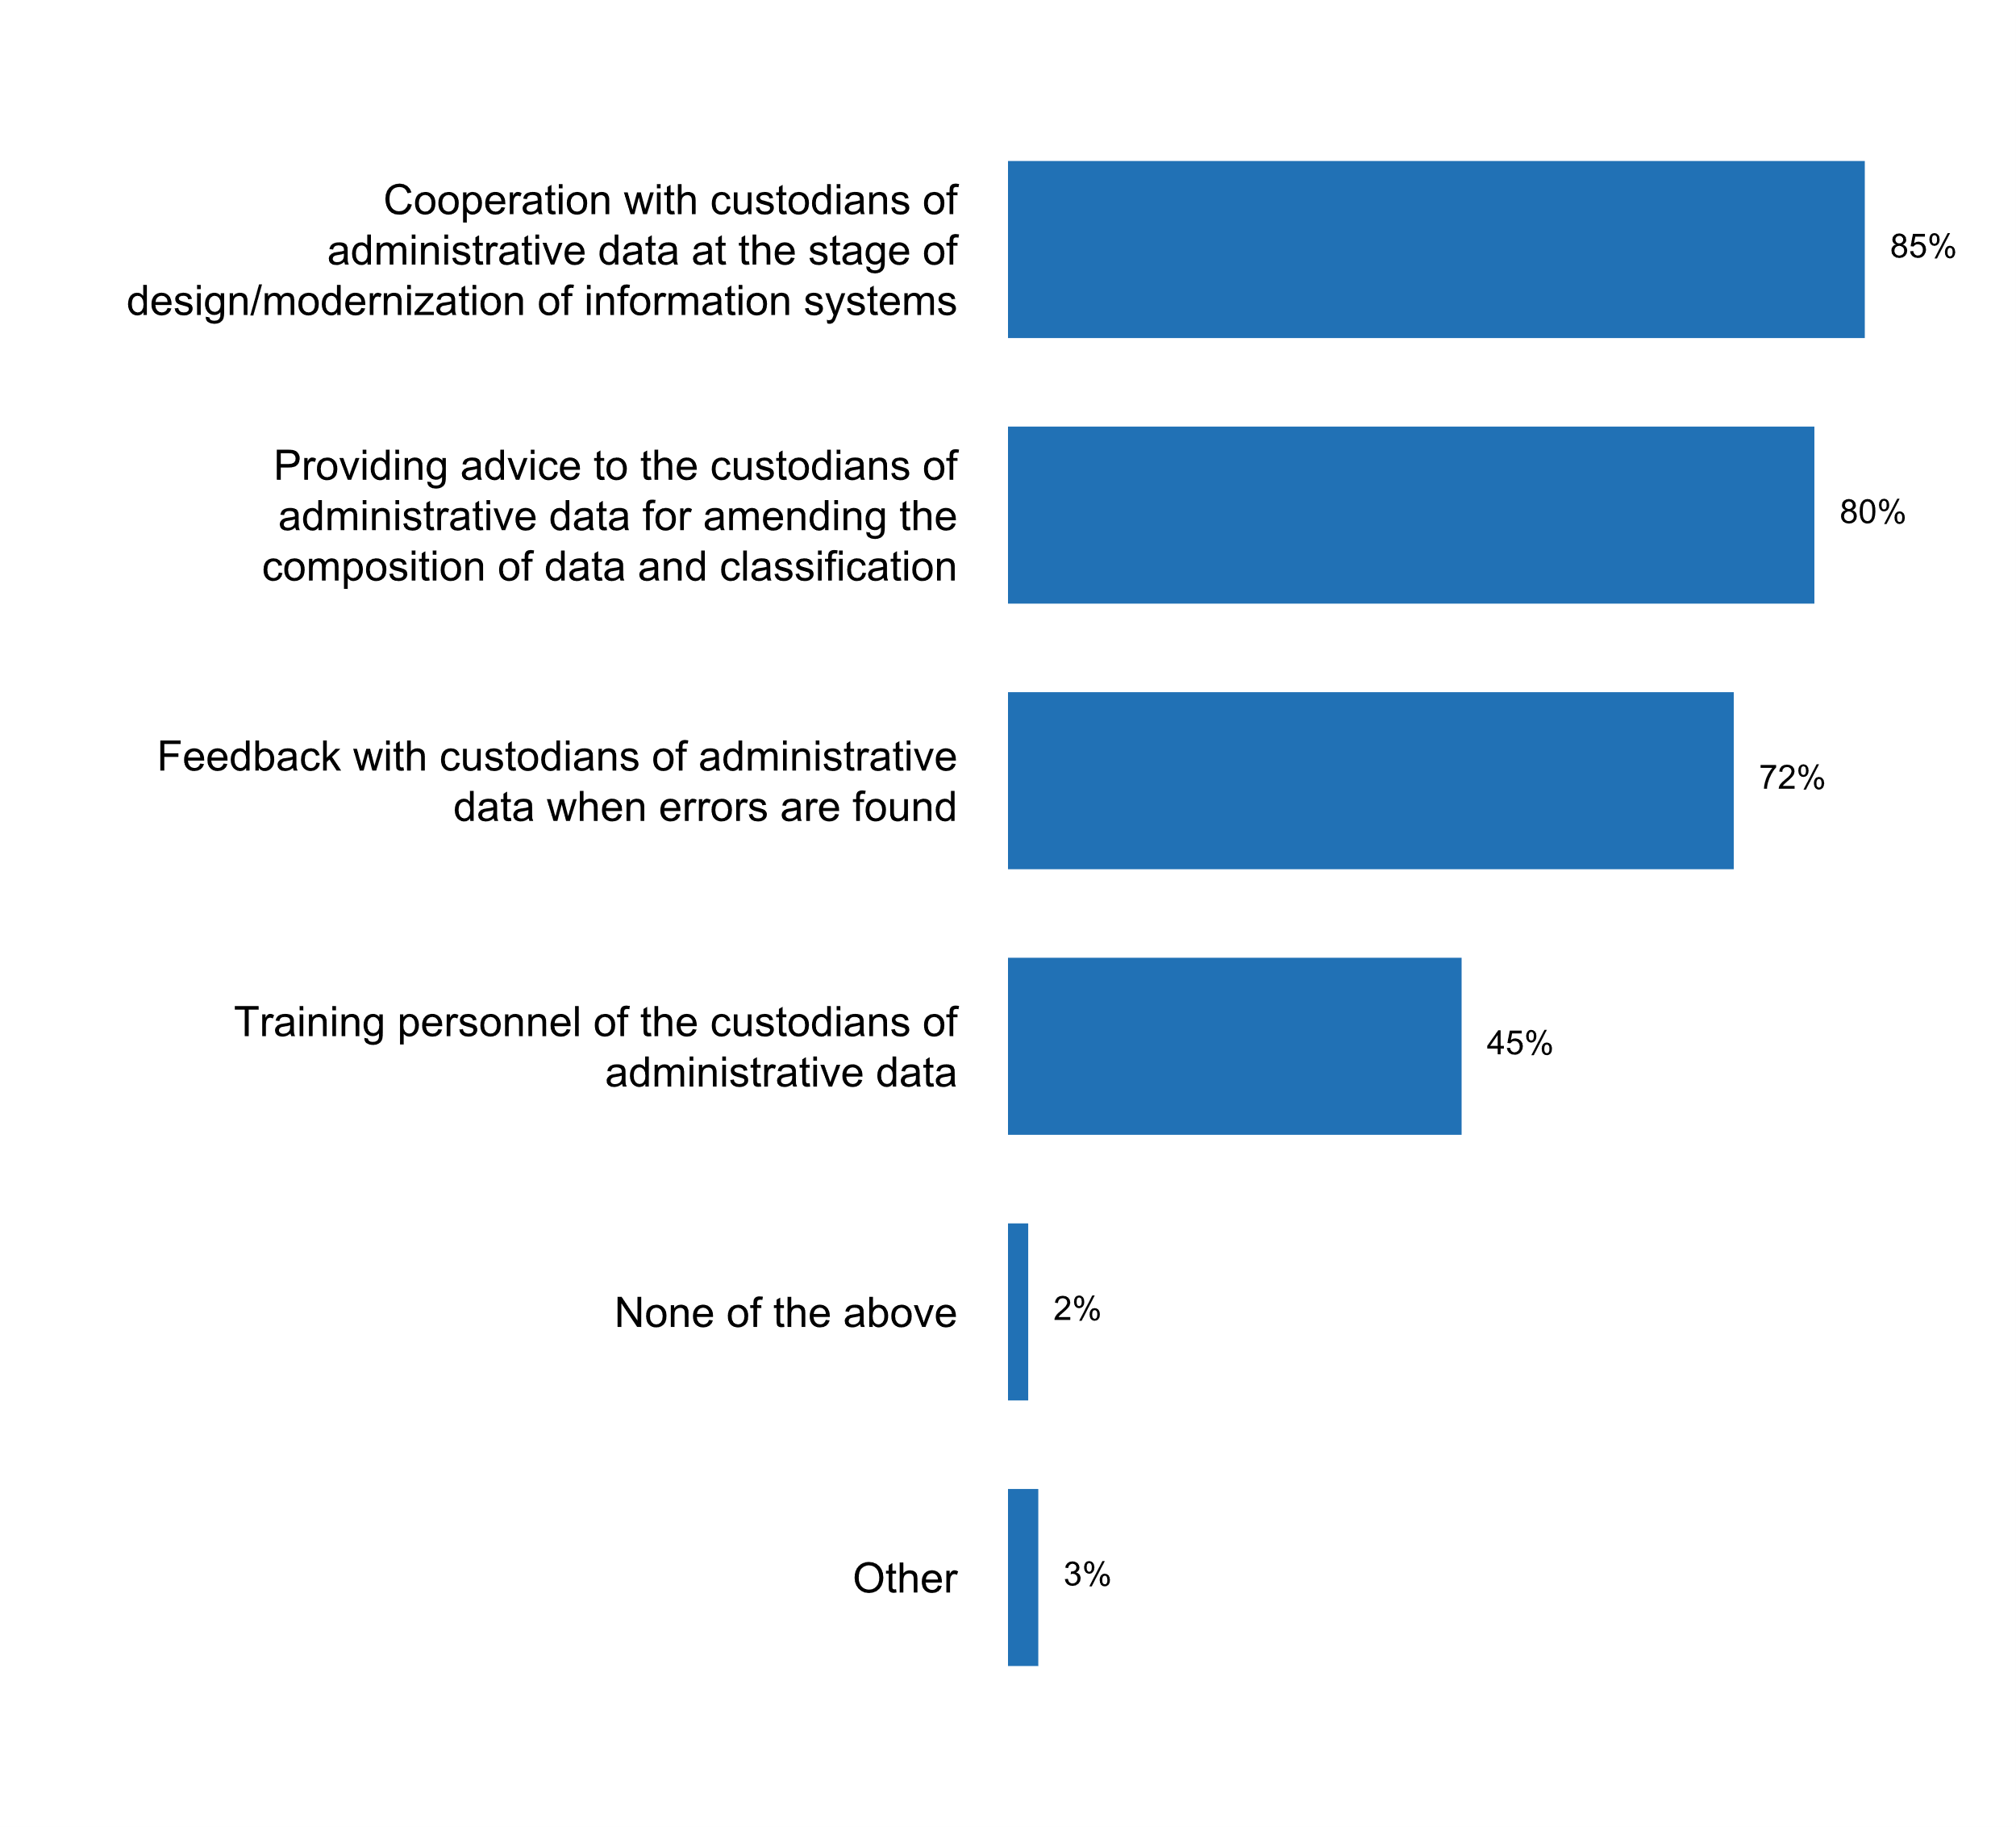

Figure 31. Actions taken for adapting administrative records for statistical purposes

Out of 93 countries that responded to the questionnaire, 55 percent indicated that they use web scrapped data, satellite imagery or privately-owned datasets as a source of data. Of those, over two-thirds (69 percent) have specific rules of access and confidentiality measures to treat the datasets and over half (53 percent) stated that the data provider does not contribute to methodological decisions regarding the use of the data. On the other hand, only 37 percent stated that “consumers/citizens are informed that their data is being used for compiling official statistics”.



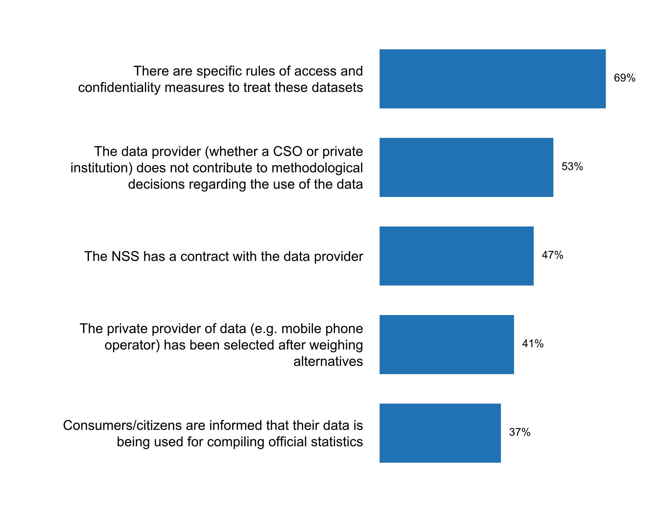

Figure 32. How the NSS accesses and uses big data and citizen-generated data  
(percentage calculated over a total of 51 responses indicating the use of   
web scrapped data, satellite imagery or privately-owned datasets)

According the Principle 5, the choice of data sources should be based on considerations of quality, timeliness, costs and the burden on respondents. With respect to the timeliness *of data sources*, it is worth noting that two-thirds of respondents meet with data providers to agree on deadlines.

In addition, most National Statistical Offices monitor the timeliness of publications against the release calendar (89 percent) and use new technologies for reducing processing times (78 percent). Other measures to ensure the timely release of statistical results include the use of standardized dissemination protocols and the release of preliminary data to users. In terms of resources dedicated to this end, 57 percent of respondents indicate that they use staff overtime or hire temporary staff to ensure timely publication of statistical outputs.

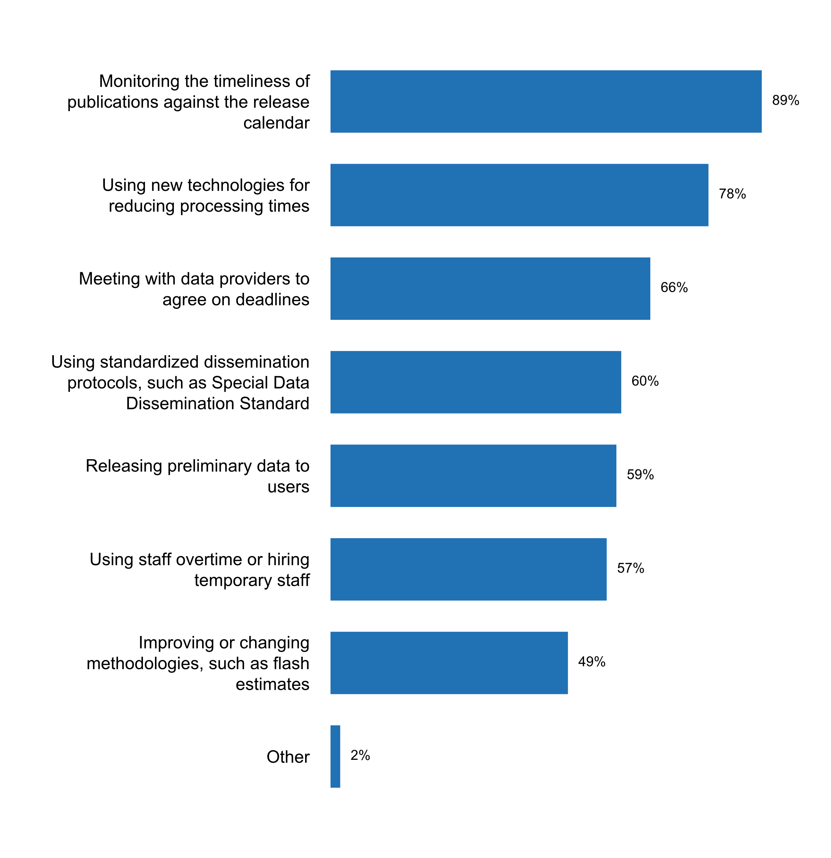

Figure 33. Measures taken to ensure timely release of survey results   
and/or statistical publications or bulletins

As regards to the use of quality management frameworks by National Statistical Offices, 46 percent of respondents indicate that they apply the Data Quality Assessment Framework (DQAF); 43 percent use the European Statistical System Quality Assurance Framework; 38 percent use the General Data Dissemination System, and 23 percent use Total Quality Management. The use of the ISO 9001 and ISO 27001 standards is also used among a number of survey respondents.

In terms strategies for reducing response burden, almost 4 in every 5 statistical offices often report efforts to simplify survey questionnaires, often pre-filling them with data available from existing records, so as to minimize the time that respondents need to spend filling out the questionnaires. The use of administrative records and other data sources (such as big data) has been identified by 70 percent of the respondents as a means of reducing response burden.

Only about one-fourth (24 out of 93) of the countries provided additional comments on challenges to the implementation of Principle 5. Issues with administrative data was a relatively popular theme – their quality and/or the lack of legislative access to them. Some countries also underscored issues with quality of administrative data, including lack of resources for assessing data quality. Access to big data and privately-owned data were also mentioned as common challenges in the implementation of Principle 5.

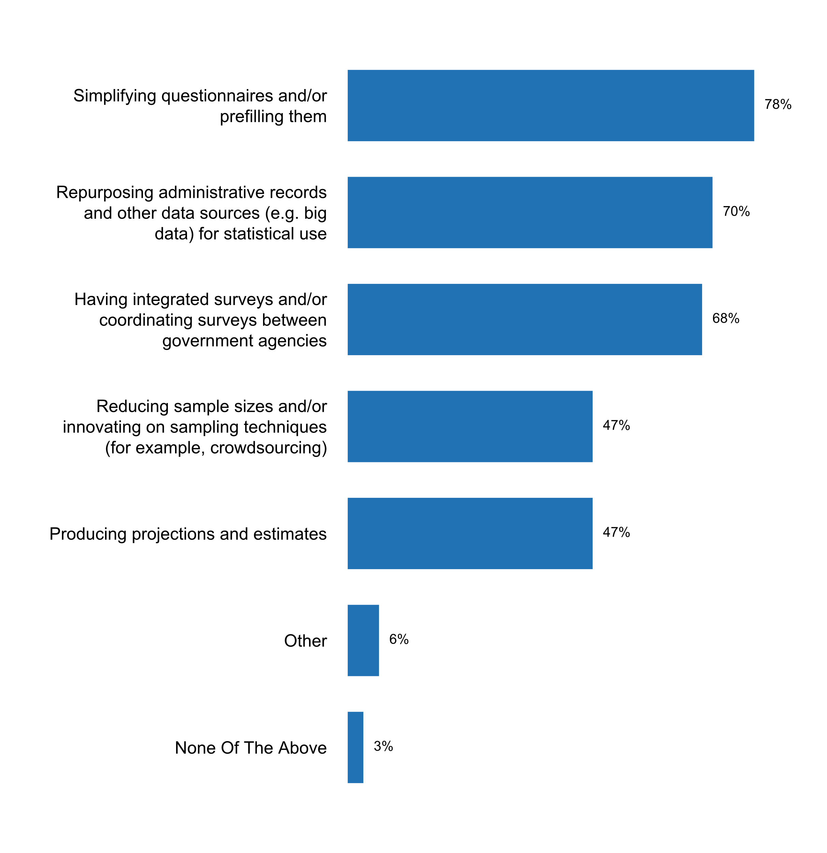

Figure 34. Measures being applied to reduce respondents' burden

**Principle 6: Confidentiality**

“Individual data collected by statistical agencies for statistical compilation, whether they refer to natural or legal persons, are to be strictly confidential and used exclusively for statistical purposes.”

The strategic importance of Principle 6 on for National Statistical Offices is now front and center of the debate on public trust in official statistics. In this context, it is not surprising that all 93 respondents to the 2018 questionnaire indicated the existence of a confidentiality provision in the laws that regulate the NSO/NSS, with 71 percent noting that the confidentiality provision applies to the NSS in general and not just the NSO.

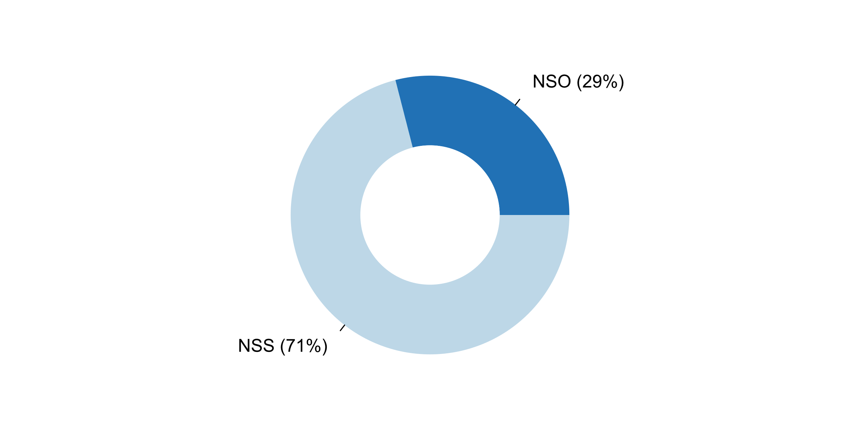

Figure 35. Scope of legal provisions on confidentiality



In most cases, such provisions cover the duty of staff in National Statistical Offices to protect confidentiality, and the training of staff on how to protect individual data. They also cover technical aspects of confidentiality protection, including processes for granting access to microdata, storing and destroying individual records, and checks that need to be conducted before releasing microdata data.

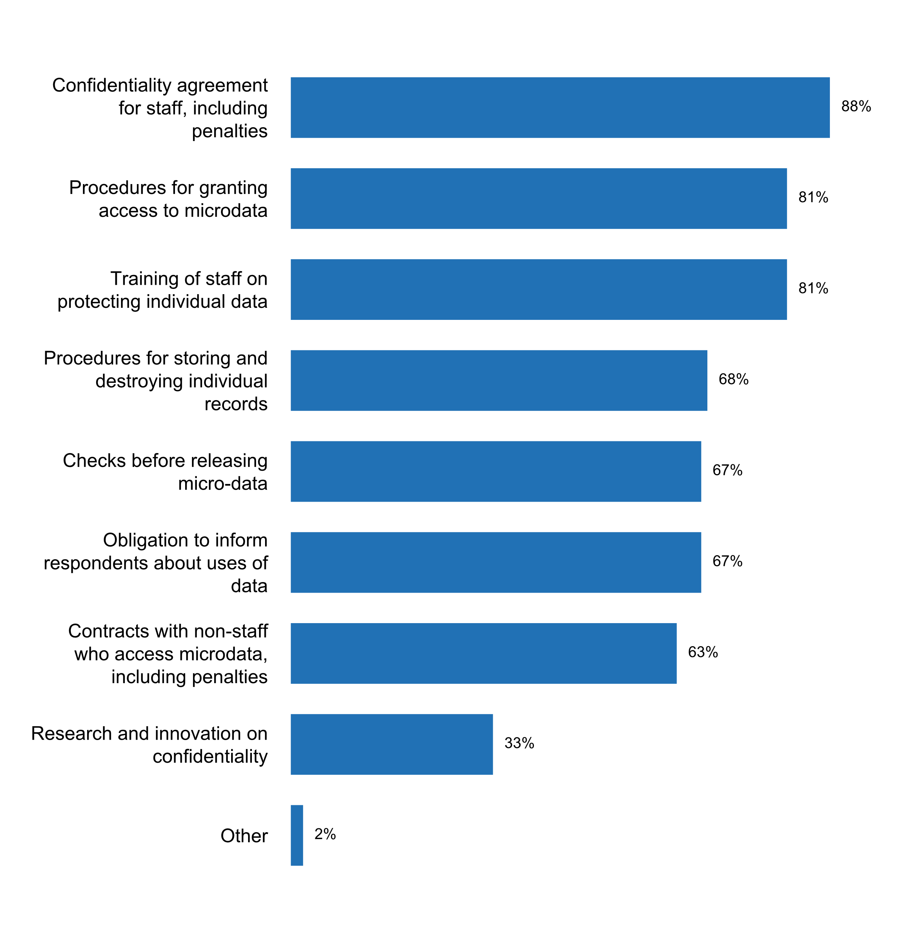

Figure 36. Aspects considered in the confidentiality policy of the NSO

Asked about the most common **practices implemented to anonymize statistical data**, the majority of countries mentioned the **removal of individual names** of persons and enterprises in statistical databases (91 percent), as well as the **suppression of information that allows for re-identification** of respondents. Every 3 out of 4 countries reported conducting **microdata anonymization** prior to release for research purposes, and every 2 out of 3 countries conduct **manual checks** of data being prepared for dissemination. However, only 57% of countries report the **use of specialized software** in order to apply confidentiality checks, and only one third of the respondents **engage specific authorities** to scrutinize applications for accessing confidential data.

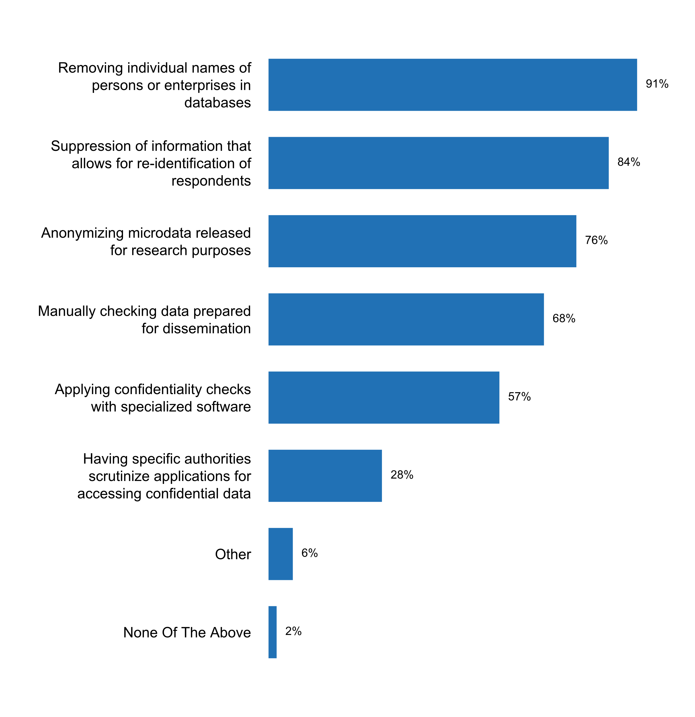

Figure 37. Practices being implemented to anonymize statistical data

Less than two thirds of the respondents identified any **circumstances under which individual data can be disclosed to third parties**. Among those that did, the most frequent was **when the concerned individuals or enterprises have expressed their consent**. Only 1 in 5 respondents of the questionnaires indicated that individual data could be disclosed **when exchanging data with other statistical offices or agencies** in the country. A request **by a court of law or emergency situations** (e.g., a public health crises) where cited as possible circumstances allowing for disclosure of individual data by only 16 percent and 6 percent of the respondents, respectively.

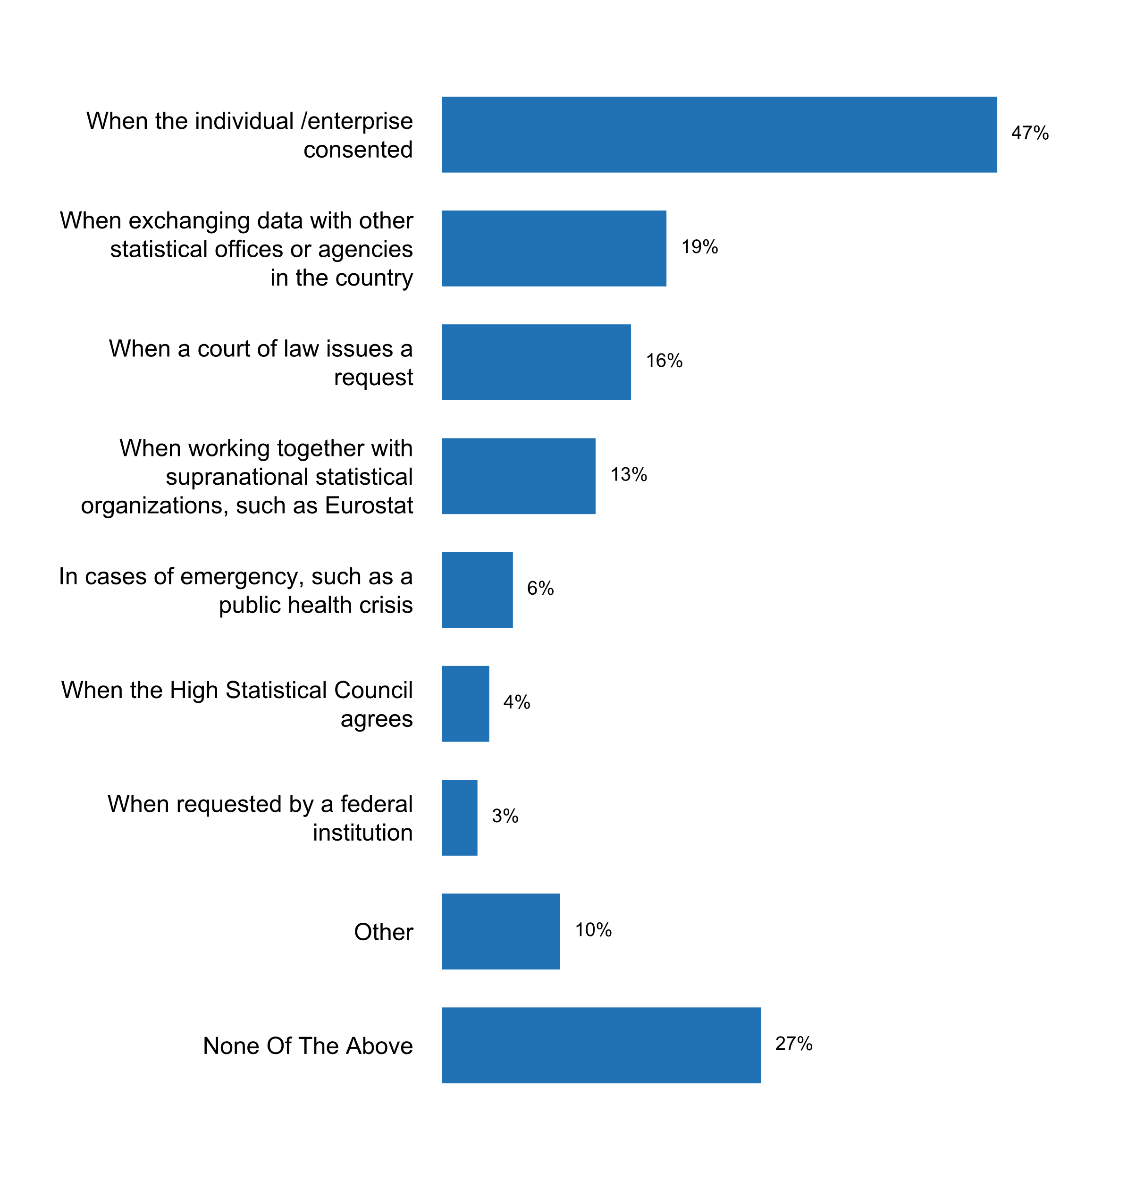

Figure 38. Circumstances under which identifiable individual   
data can be disclosed to third parties

In general, the **main challenges identified by respondents for the implementation of Principle 6** included: (1) Need for more guidance and recommendations on how to handle microdata and open data accessibility, (2) Consideration of the risks relating to equitable access when data is released by multiple sources; (3) Situations when local populations are too small, which results in a high probability of response fatigue by survey respondents and increased probability or re-identification of statistical data; and (4) Contradictions between other laws and the Statistics law.

**Principle 7: Legislation**

“The laws, regulations and measures under which the statistical systems operate are to be made public.”

A **ge**buting countries In 95 percent of the all responding countries, there are regulations that cover the **body responsible for statistics**. Regulations in 91 percent of the countries provide rules on the **status, mandate and functions of the national statistical office**. Approximately 9 in every 10 countries report that statistical regulations cover **secrecy, confidentiality and privacy obligations**.







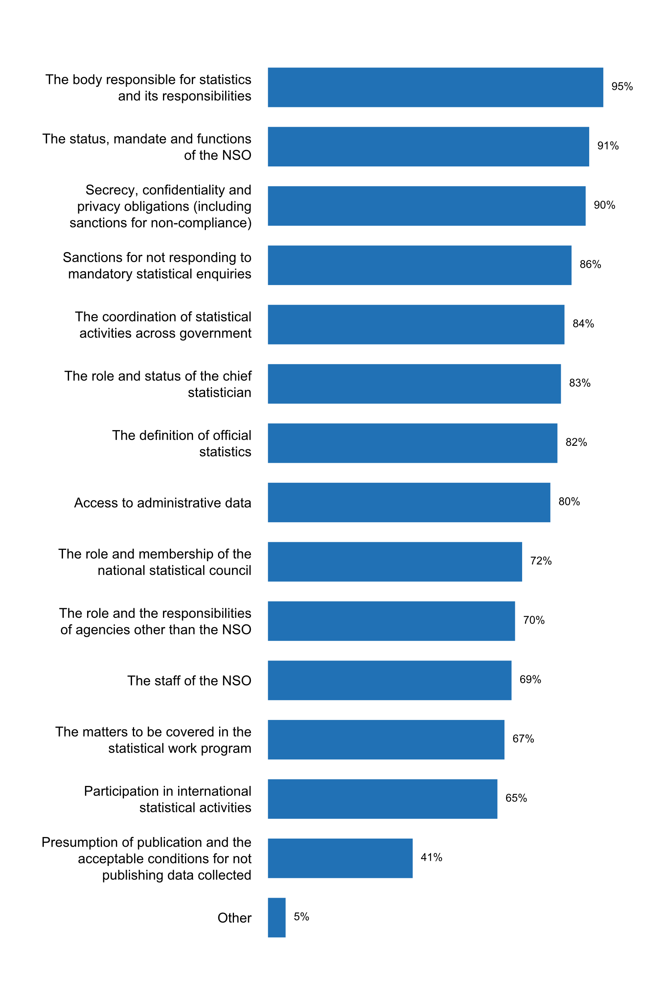

Figure 39. Aspects covered by statistical regulations   
(e.g. Statistical law, presidential decrees)

In terms of the **coverage of the statistical regulations beyond the NSO**, only 52 percent of respondents indicated that the law covers the role and responsibilities **of statistical services in line ministries**, and only 44 percent mentioned the **statistical services in the Central Bank**. Also about 2 in every 5 respondents mentioned that statistical laws cover the role and responsibilities of the **custodians of administrative data**, and a similar proportion of countries mentioned the **statistical offices at the sub-national level**. On the other hand, cases where statistical laws cover roles and responsibilities **statistical research and training centers, private institutions, chambers of commerce or other business networks, or trade unions**, are the exception rather than the common practice.

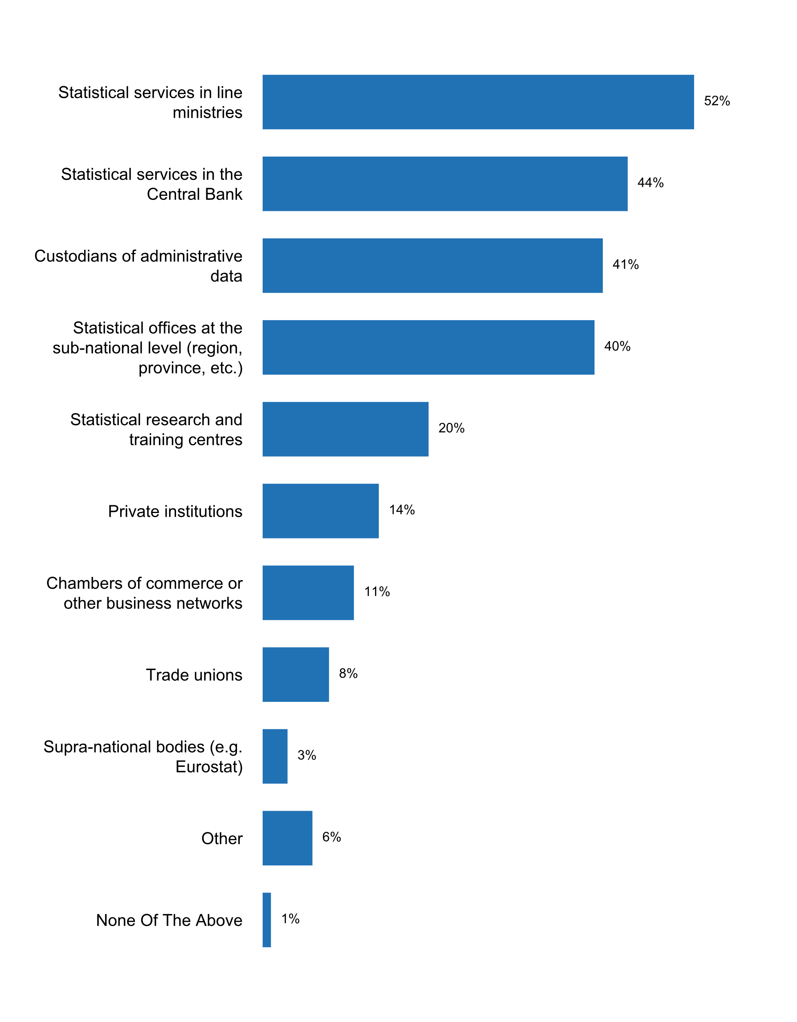

Figure 40. Agencies other than NSO whose role and responsibilities   
are covered by the statistical law

In most cases, the 2018 Questionnaire shows that the **head of the national statistical office** reports to the Ministry of planning or development (24 percent of the respondents); the Prime Minister, chancellor or President (22 percent); the Ministry of Finance or Comptroller general (13 percent); and Ministry of Economic Affairs, Industry or Trade (11 percent). It is worth noting that only about 5 percent of respondents indicate that the head of the national statistical office reports to the parliament or congress of the country.

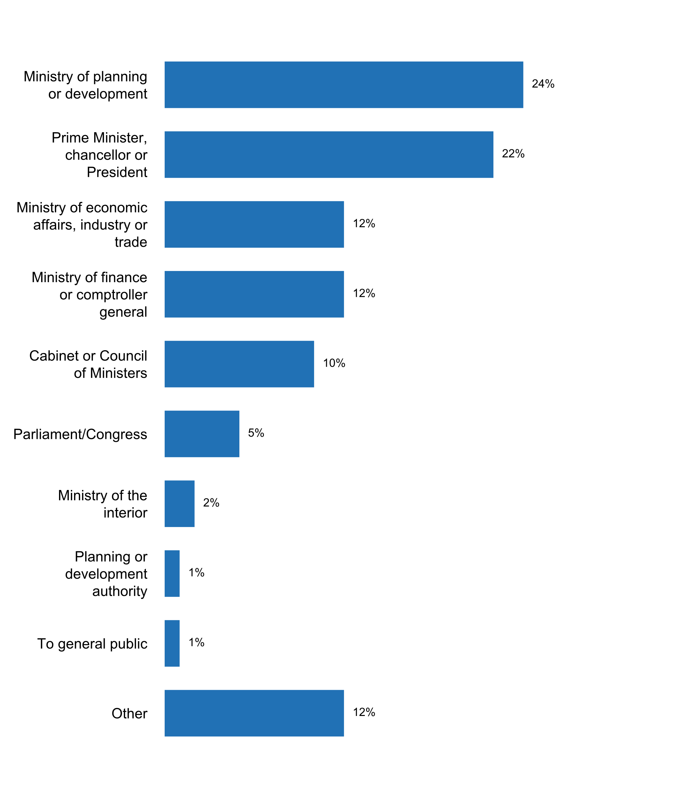

Figure 41. Person or office within the government to which the head of the NSO reports

According to the results of the questionnaire, Freedom of Information or Access to Information laws exist in 82 percent of the countries. However, the national statistical system is not covered in only 73 percent of countries. In addition, 78 percent of the respondents confirmed that regulations affecting the functioning of the national statistical office are published on the their website.

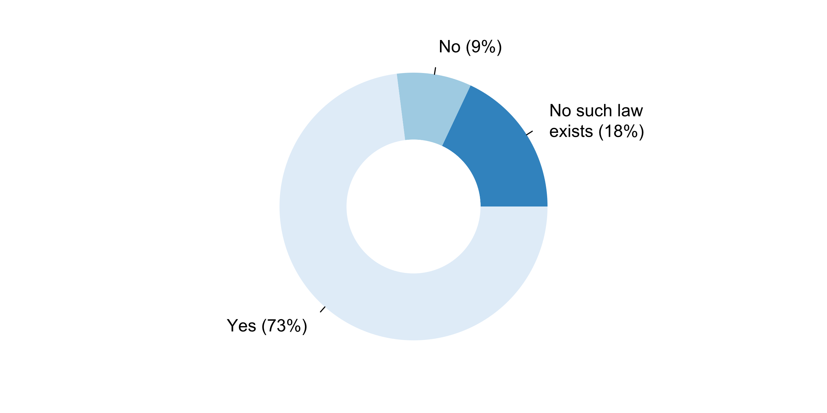

Figure 42. Existence of a Freedom of Information or Access to Information law covering the NSS







*Challenges in the implementation of Principle 7*

In general, for Principle 7, main challenges identified by respondents (question 7.7) included:

**Principle 8: National Coordination**

“Coordination among statistical agencies within countries is essential to achieve consistency and efficiency in the statistical system ”

Ninety-one out of the 93 national statistical offices reported that at least one other agency in their country produces official statistics on behalf of the government. The two other agencies most frequently identified as producers of official statistics were the statistical services of the Central Bank (90 percent) and the statistical services in line ministries (86 percent). Statistical offices at the sub-national level also have responsibilities in the production of official statistics on behalf of the government in about half of the countries that responded to the questionnaire (47 percent). In addition, public research institutes and statistical research and training centers are producers of official statistics in 24 and 20 percent of the respondents, respectively. Finally, it is worth noting that one of the two respondents that did not identify another agency that produces official statistics in addition to the national statistical office, their statistical law does allow for other institutions to produce official statistics upon request.



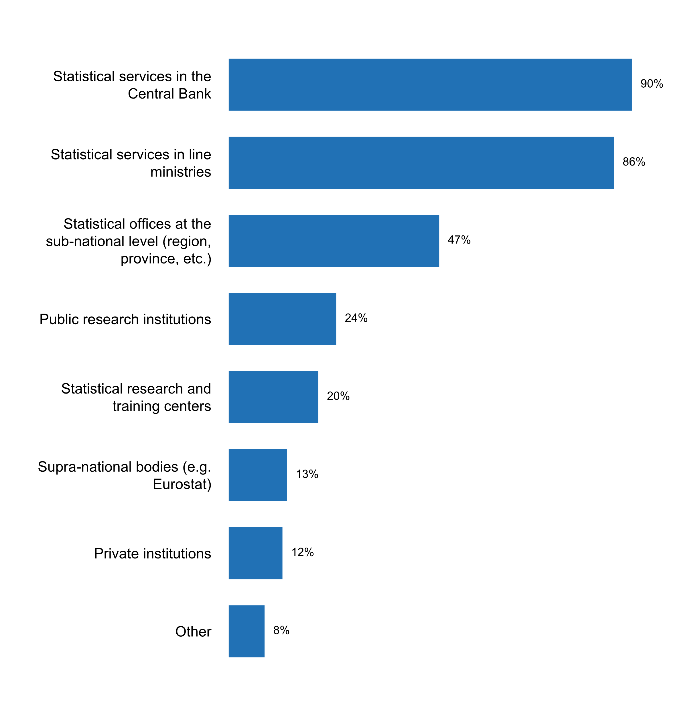

Figure 43. Agencies other than the NSO which produce official statistics on behalf of the government

With respect to the coordination of the production of statistics among members of the National Statistical System, almost 9 in every 10 countries indicated that this is done by meeting in statistical committees, councils, etc. In particular, more than 90 percent of the respondents indicated that producers of official statistics have met at least once during the last five years with 75 percent meeting twice or more per year and 12 percent meeting annually.

Also, most of the respondents (76 and 78 percent, respectively) indicated that they engage in sharing of information and databases or that they sign memorandums of understanding between agencies for the coordination of production of official statistics. The development of joint training programmes is also a relatively frequent mechanism of coordination (63 percent), while little more than half of respondents mentioned the preparation of an annual or multi-annual consolidated program of statistical activities in the country as well as the monitoring of work duplication between agencies. It is as well encouraging to note that 45 percent of the countries report joint data collection initiatives. However, in terms of resource integration, only 24 percent of countries report the exchange of staff between agencies, and only 18 percent report the sharing of budgetary resources between statistical agencies.

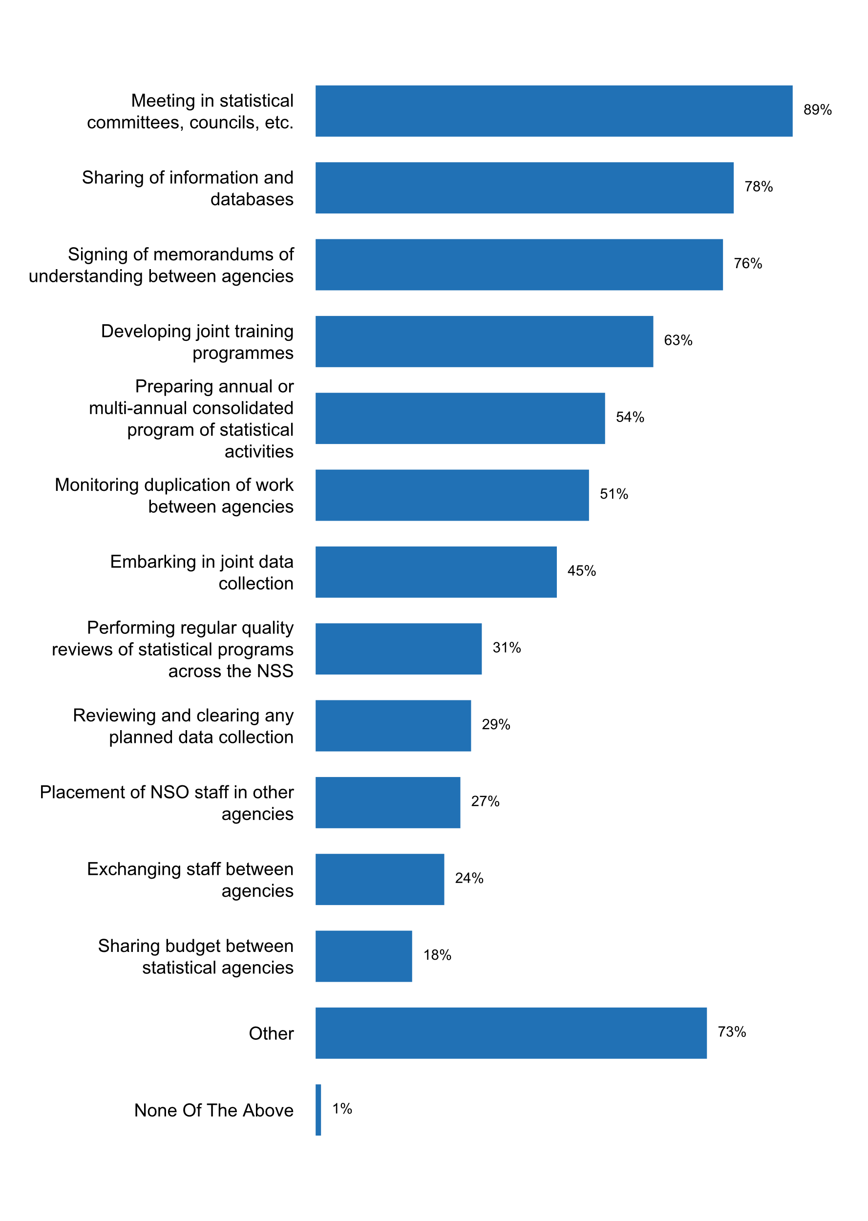

Figure 44. Activities currently being implemented for coordinating the NSS



Based on the results, in countries where national statistical systems have different data producers, only 38 percent reported having a central data portal where the official statistical data are published. For the 62 percent that reported not having a central hub, many stated lack of resources and coordination amongst agencies as main reasons/challenges. It may also be worth noting that although a central data portal doesn’t exist, some respondents mentioned providing direct links to dissemination platform of the other agencies.

Coordination of data dissemination practices among members of the National Statistical System is also crucial to achieve consistency the data that is available to users, as well as efficiency in the development and maintenance of dissemination channels. However, only few countries report specific coordination efforts in this regard. For instance, less than one third of the countries report the existence of a unified release calendar across the National Statistical System, and only one in every five respondents indicated the adoption of standardized metadata structures for data dissemination. Similarly, only about one third of respondents indicated the existence of a central data portal where different members of the NSS publish official statistical data for their country.

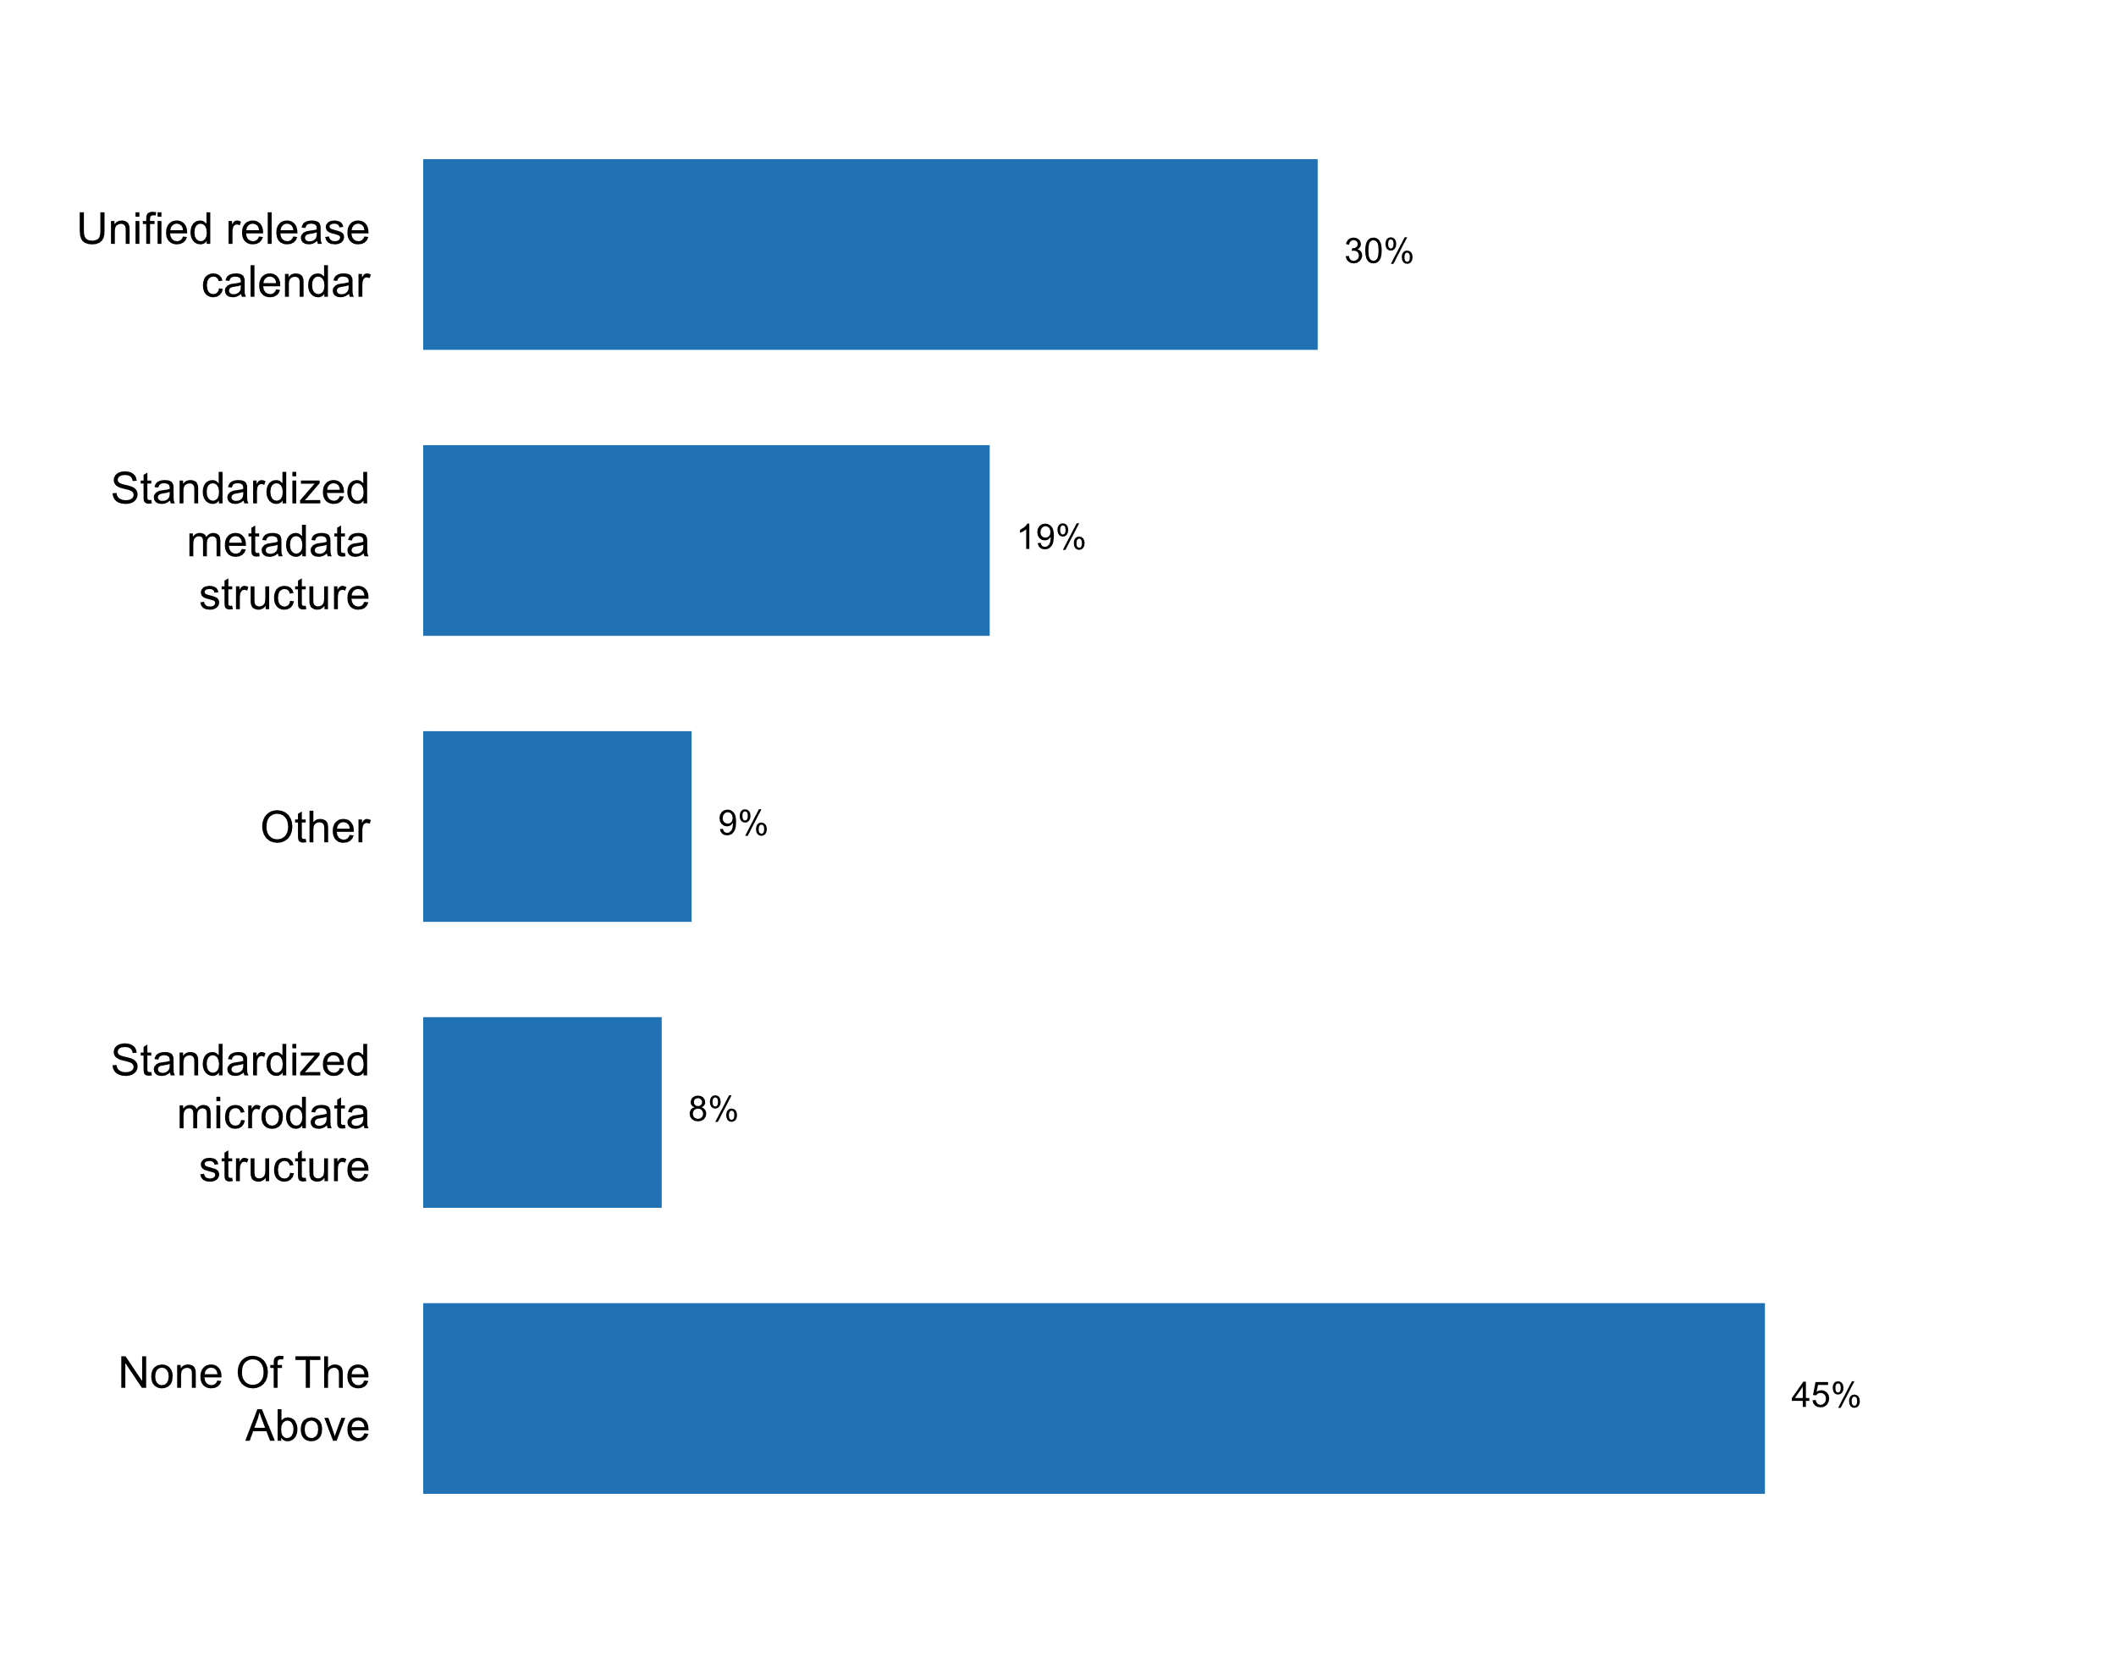

Figure 45. Means employed for coordination of data dissemination across the NSS

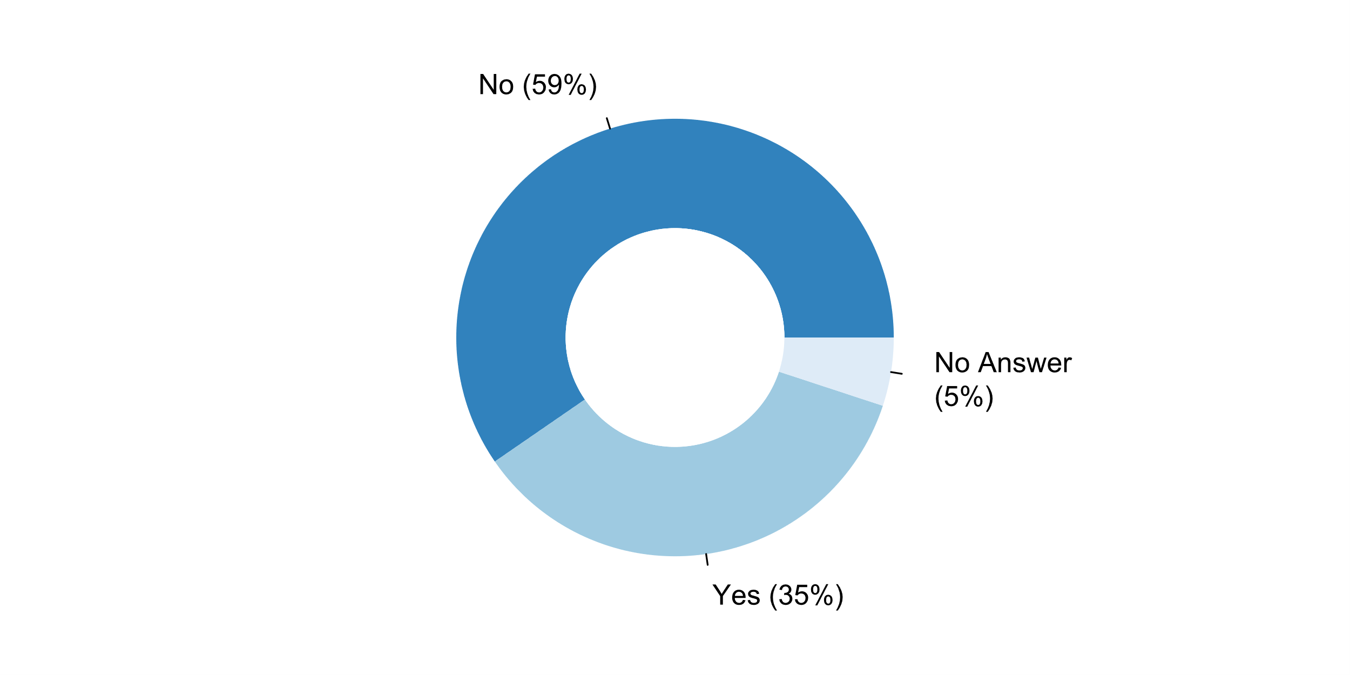

Figure 46. Existence of a central data portal where different members   
of the NSS publish official statistical data

*Challenges in the implementation of Principle 8*

In general, for Principle 8, main challenges identified by respondents (question 8.6) included:

**Principle 9: Use of International Standards**

“The use by statistical agencies in each country of international concepts, classifications and methods promotes the consistency and efficiency of statistical systems at all official levels.”

Statistical standards and classifications are often updated to reflect structural changes in the social, economic, and environmental systems measured by official statistics, as well as to incorporate the latest advances in statistical methodology and respond to the growing needs of data users. Whereas National Statistical Offices deal with a vast body of detailed statistical standards and classifications in their day-to-day operations, the 2018 Questionnaire on the implementation of the Fundamental Principles of Official Statistics examined the status of implementation of a few of them, which are deemed to be part of a core set of international standards.

The System of National Accounts (SNA) is at the core of official economic statistics, providing the conceptual and methodological framework for understanding the economic structure of a country and monitor its economic activity and interlinkages with the global economy. In order keep up to date with economic reality and user needs, the System of National Accounts has been regularly updated, and with its latest two versions being the 2008 SNA and the 1993 SNA. In this connection, 71 percent of the countries indicated that they currently use latest version (either the 2008 SNA, or the European version based on it, the ESA 10). However, 20 percent of the responding countries indicated that they still apply the 1993 SNA.



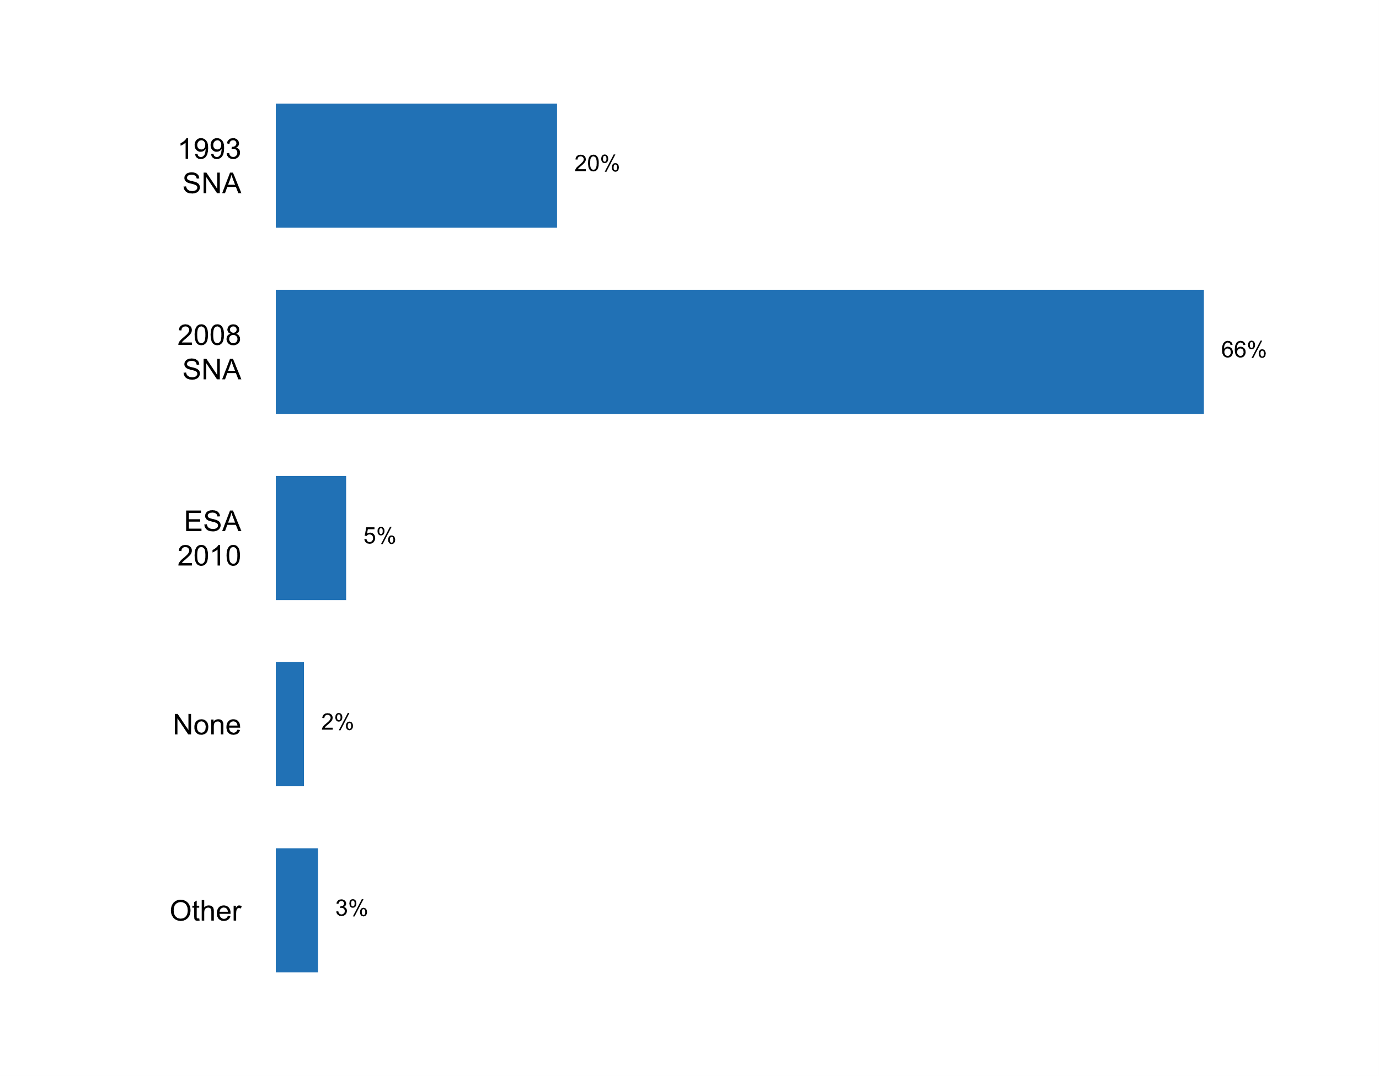

Figure 47. SNA version currently in use

Population and housing censuses are one of the primary sources of data needed for formulating, implementing and monitoring policies and programmes aimed at inclusive socioeconomic development and environmental sustainability. Moreover, they are key source of information for supplying disaggregated data needed for assessing the situation of people by income, sex, age, race, ethnicity, migratory status, disability and geographic location, or other characteristics. Since 1958, the United Nations has issued a series of principles and recommendations for population and housing censuses, which have evolved over time in response to the latest practices and national needs. The last two global Principles and Recommendations for Population and Housing Censuses were published in 2008 (Revision 2) and in 2017 (Revision 3) in preparation for the 2010 and the 2020 World Population and Housing Census Programmes, respectively. In this regard, the 2018 Questionnaire on the implementation of the UNFPOS showed that only 3 percent of the countries are not implementing the Principles and Recommendations for Population and Housing Censuses in their latest census programme. Seventy-two are implementing it fully, while 25 percent are implementing them partially.



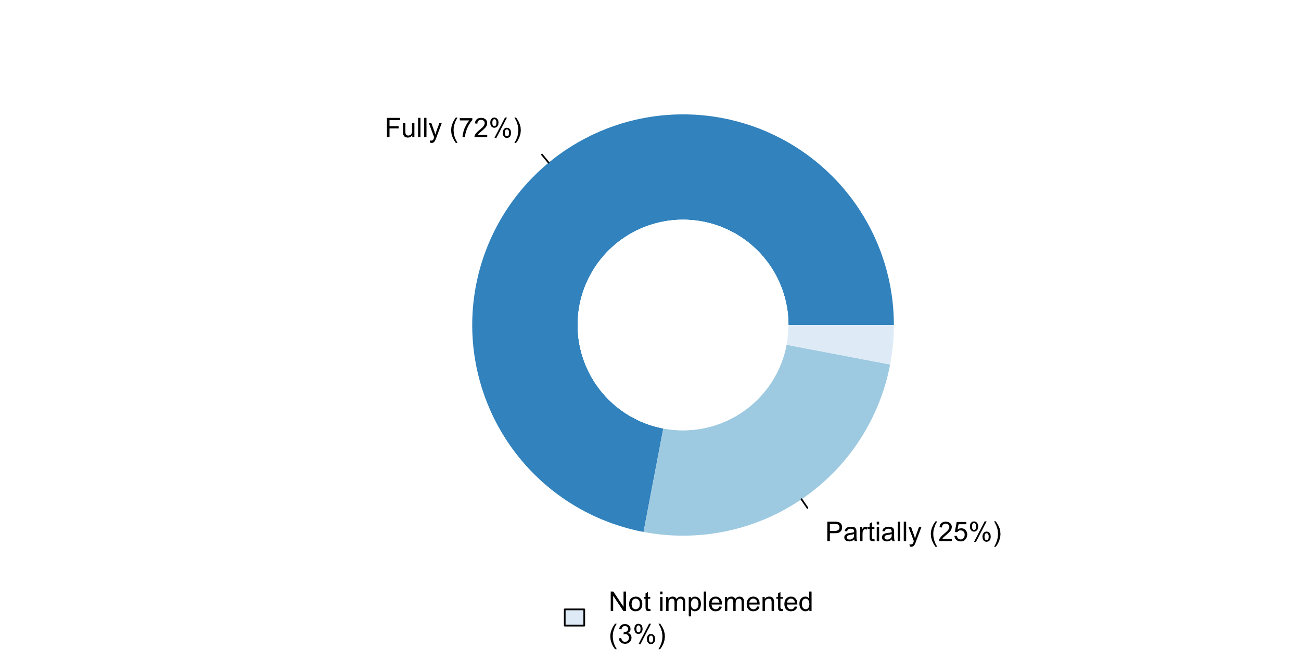

Figure 48. Implementation of Principles and Recommendations for Population and Housing Censuses in latest census programme (Rev. 3 for census undertaken after 2015 or Rev. 2 for census undertaken before 2015)

Official statistics on time-use are an important tool for exploring a wide range of policy concerns, including assessing quality of life or general well-being, analysing division of labour between women and men, improving estimates of all forms of work (paid and unpaid) and estimating household production and its contribution to GDP. The International Classification of Activities for Time-Use Statistics 2016 (ICATUS 2016), endorsed by the UN Statistical Commission in March 2017, provides a set of activity categories that can be utilized in producing meaningful statistics in relation to the broad range of objectives of national time-use studies as well as cross-national and cross-temporal comparative studies on time use. The 2018 Questionnaire on the implementation of UNFPOS shows that 35 percent of the countries do not yet use ICATUS 2016 in collecting and analysing time-use data. Nineteen percent of the national statistical offices use it to guide the collection of time-use data, while 18 percent use it for the dissemination of time-use statistics, regardless of the type of instruments used for data collection, and 14 percent use it as the basis for national classifications of activities for time-use statistics.



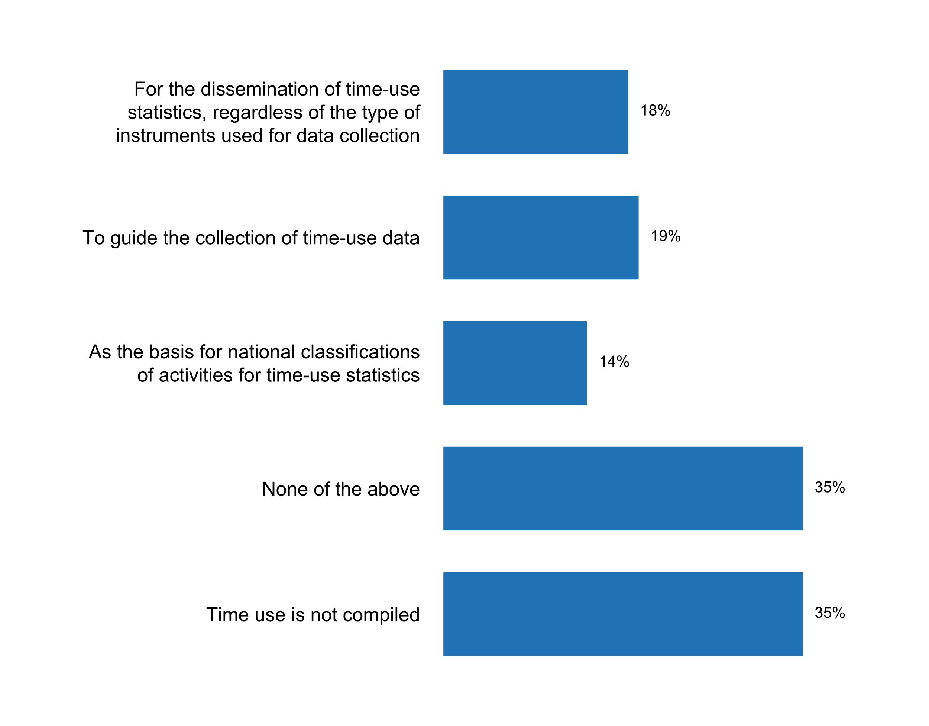

Figure 49. Use of the International Classification of Activities for Time Use Statistics 2016 (ICATUS 2016)

The System of Environmental-Economic Accounting (SEEA) is a framework of internationally agreed standard concepts, definitions, classifications, accounting rules and methodologies for producing internationally comparable statistics and accounts that provide a comprehensive view of the interrelationships between the economy and the environment. With respect to the implementation of SEEA by national statistical systems, the results of the 2018 Questionnaire on the implementation of the UNFPOS show that almost one half of respondents (46 percent) have compiled and published at least one Environmental-Economic Account (EEA). Eight percent have compiled but not yet published at least one EEA, and 15 percent have not compiled but have a started or planned a programme. On the other hand, 31 percent of the countries indicated that they do not have a programme on EEA in place at the moment.



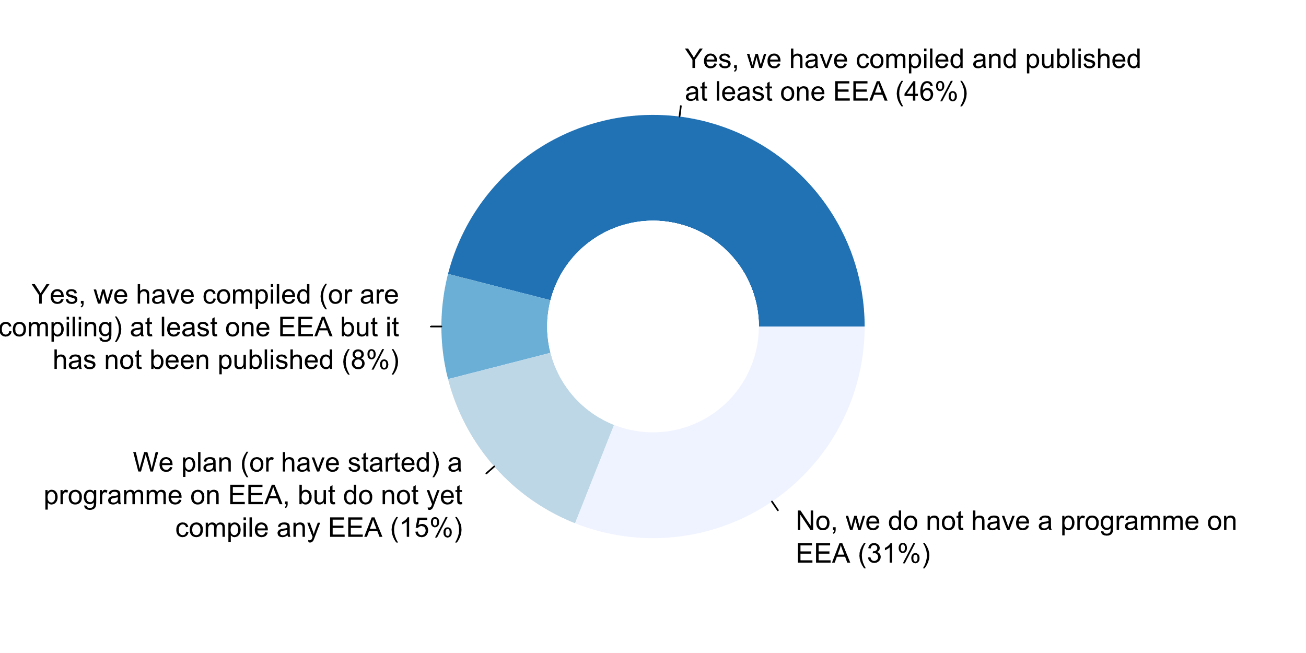

Figure 50. Existence of a programme on Environmental Economic Accounts

The official statistics community has increasingly adopted the Statistical Data and Metadata Exchange (SDMX) standard to support the exchange and dissemination of statistical data and metadata among international organisations and their member countries. Several versions of the technical specifications have been released since 2004, with the latest consolidated version (SDMX 2.1) published in 2013. According to the 2018 Questionnaire on the implementation of the UNFPOS, 71 percent of the respondents stated that they use SDMX, although almost one-half of these respondents do it only partially (i.e., only in some statistical domains or data sets). Still, 27 percent of countries do not report the use of SDMX in their exchange of statistical data and metadata, while 2 percent did know if SDMX was currently being used in their country. At the regional, SDMX is being used at least partially by 94 percent of European countries and 77 percent of countries in the Americas; in contrast, more than one-half of respondents in Asia (54 percent) and 2 in every five countries in Africa report that they are not using SDMX at the moment.

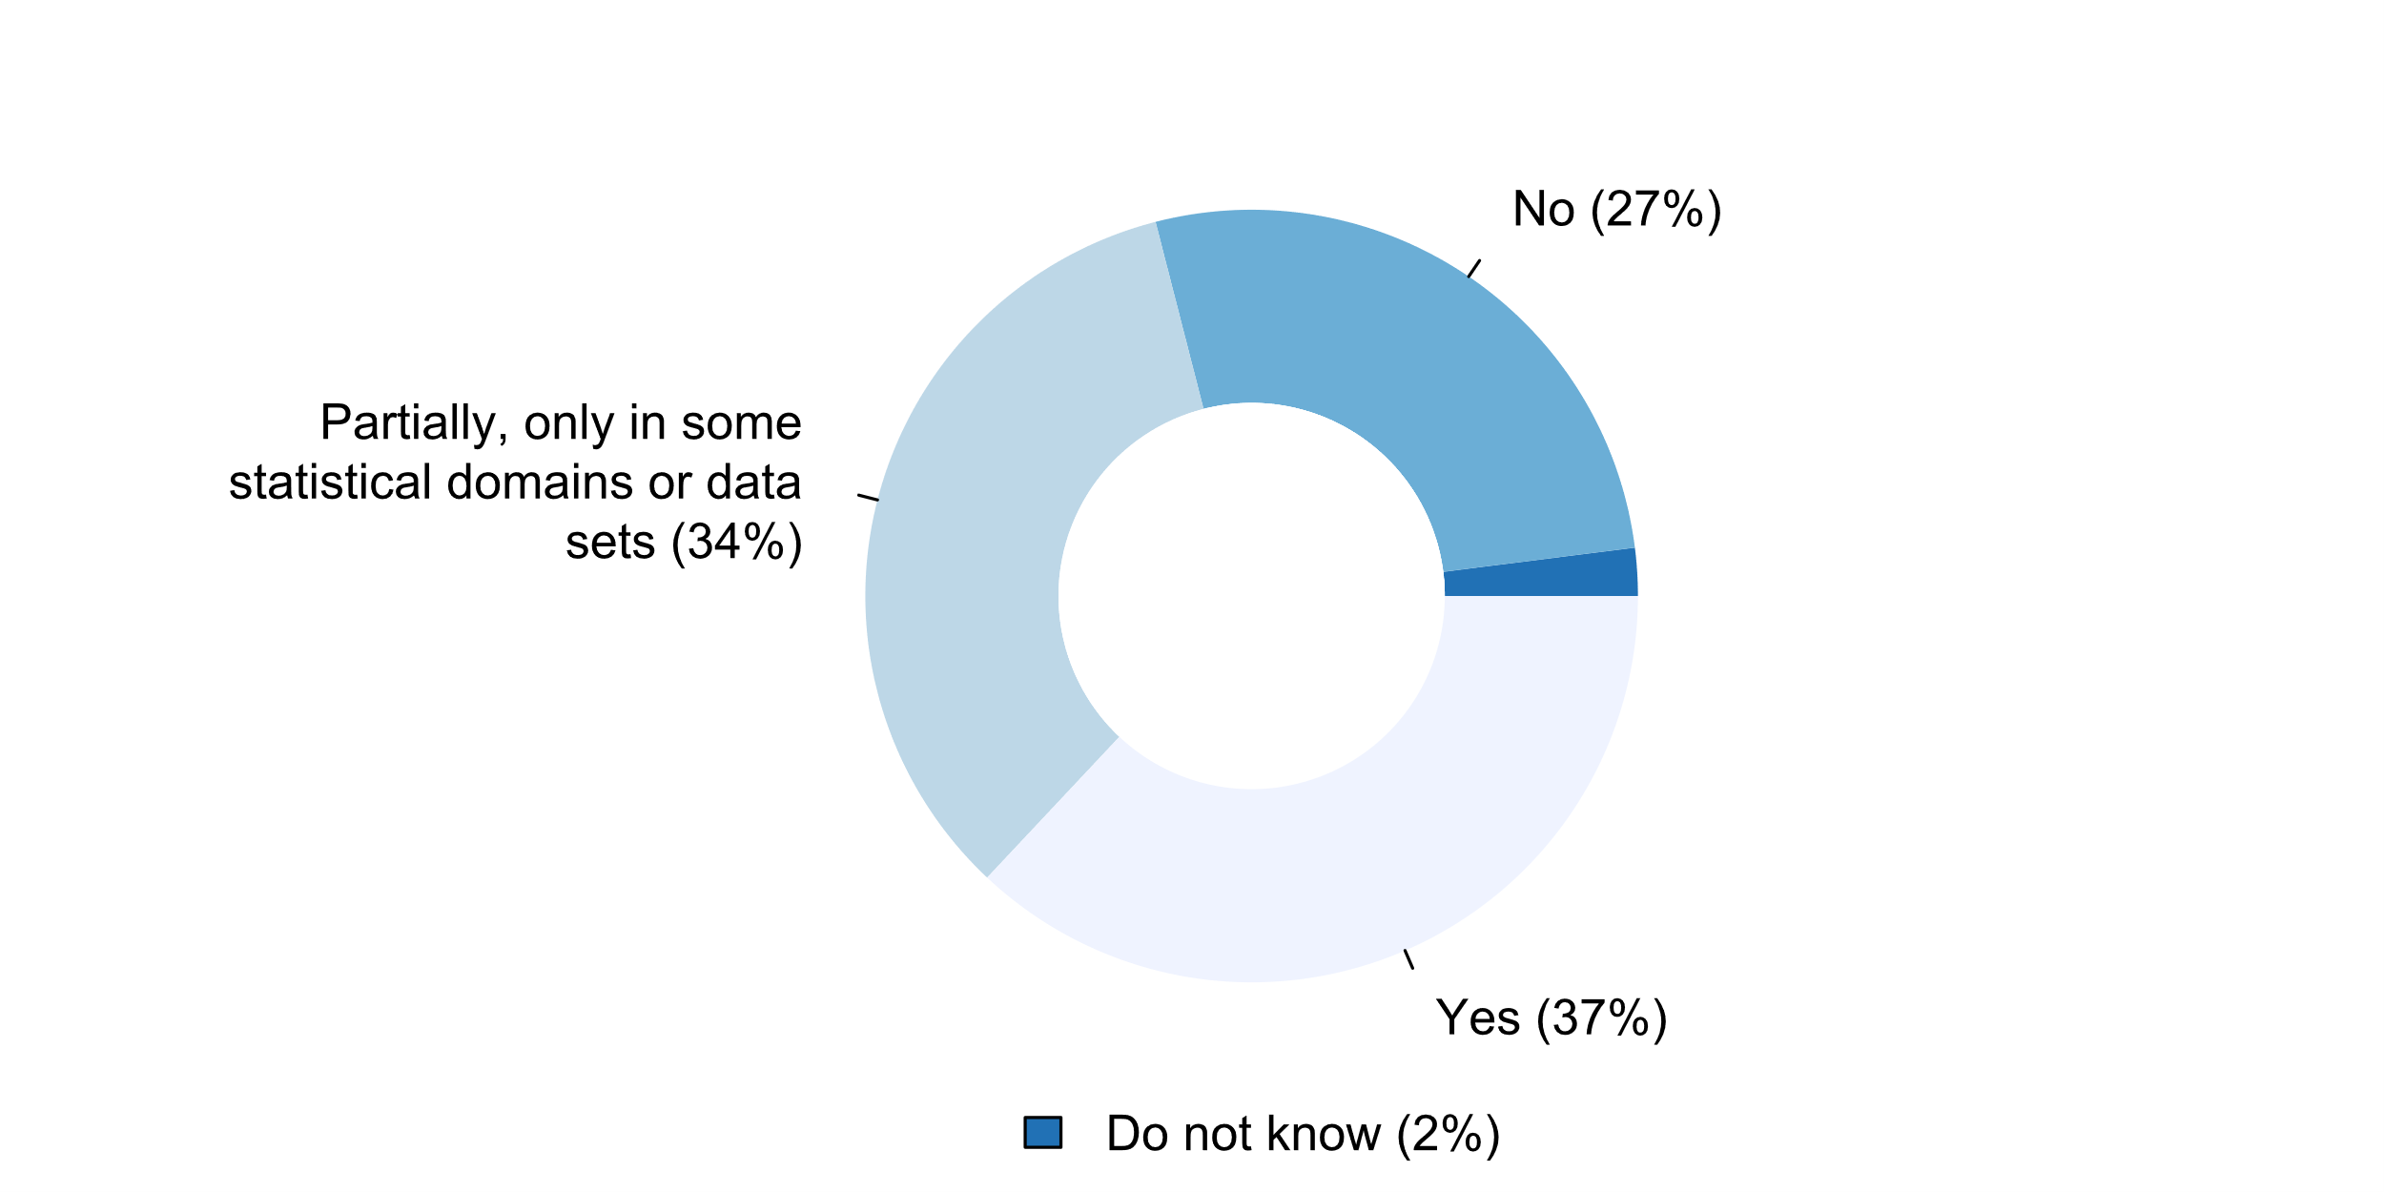

Figure 51. SDMX currently being used

*Challenges in the implementation of Principle 9*

In general, for Principle 9, main challenges identified by respondents (question 9.6) included:

**Principle 10: International Cooperation**

“Bilateral and multilateral cooperation in statistics contributes to the improvement of systems of official statistics in all countries.”

All respondents reported being engaged in international cooperation activities. Approximately 96 percent participate in international working groups, and 92 percent are in working groups at the regional level. Most national statistical offices also engage in technical cooperation activities (89 percent) and in training of statistical personnel through international cooperation (also 89 percent). Seventy-three percent participate in peer reviews and/or external evaluations, and 47 percent report the use of twinning (peer to peer collaboration) arrangements with international partners.



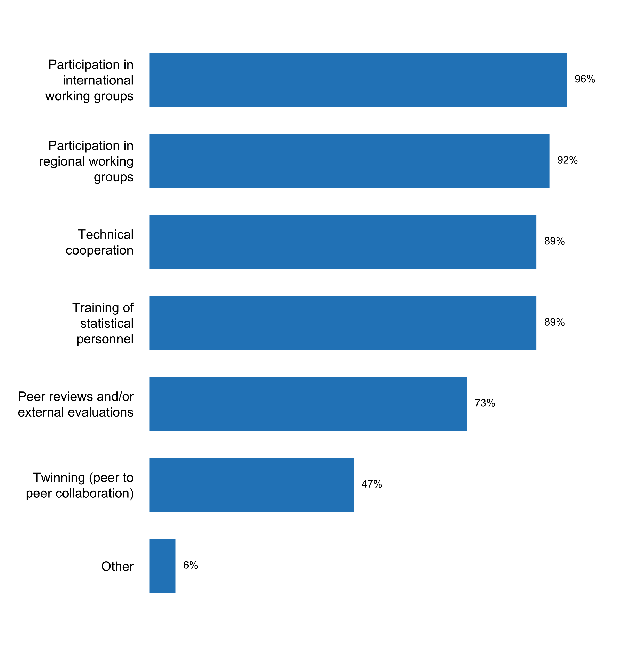

Figure 52. Types of international cooperation activities the NSS engages in

Moreover, most of the respondents (65 percent) receive support from donors and just a little over half of them (53 percent) stated that there is a donor coordination mechanism in place or a basket fund for statistics.

Figure 53. Existence of donor coordination mechanisms or basket funds   
for statistics (among countries receiving support from donors)

*Question 10.4*

Sixty percent of the national statistical offices participate in or contribute to entities or partnerships whose purpose is to promote open data.

|  |  |  |  |
| --- | --- | --- | --- |
| 10.4 | Does the NSO participate in or contribute to any organization or partnership whose purpose is to promote open data? (single) | No. | % |
|  | Yes | 56 | 60.2 |
|  | No | 37 | 39.8 |

*Challenges in the implementation of Principle 10*

In general, for Principle 10, main challenges identified by respondents (question 10.5) included:

1. **Open Data**
2. **Implementation of the Fundamental Principles: challenges and opportunities (Part 11 questions/answers)**
3. **Concluding remarks**
4. **Annex with questionnaire results (table format)- *only the mandatory and additional questions included in the report***

1. This Friends of Chair Group was mandated by the Statistical Commission at its 48th session in March 2017 (Decision 48/107). The Friends of the Chair Group on the Fundamental Principles of Official Statistics was constituted in February 2018, comprising senior statisticians from 11 countries (Argentina, Australia, Egypt, Italy, Jordan, Malaysia, Mauritius, New Zealand, Poland, Suriname, and the United Kingdom of Great Britain and Northern Ireland) and seven international agencies and organizations as observers. New Zealand is Chair of the Group, with the Statistics Division acting as secretariat.
2. See <https://unstats.un.org/unsd/dnss/gp/FP-New-E.pdf>
3. See Report of the Secretary-General on Implementation of the Fundamental Principles of Official Statistics (E/CN.3/2004/21) and (E/CN.3/2013/3) available at <http://unstats.un.org/unsd/dnss/gp/globreview.aspx> and <https://unstats.un.org/unsd/statcom/44th-session/documents/doc13/2013-3-FundamentalPrinciples-E.pdf> respectively. See also the background document with further information on the 2012 questionnaire results which accompanies E/CN.3/2013/3 available at: <https://unstats.un.org/unsd/statcom/doc13/BG-FP.pdf>.
4. In the case of Europe, some respondents also noted that their statistical law or legal framework makes reference to the European Statistics Code of Practice.
5. In approximately 78 percent of those countries that publish it, the release calendar covers a time span of 4 to 12 months. However, the calendar is adjusted at least once a year in almost half of the countries that have one.
6. The 2012 questionnaire yielded contradictory results regarding pre-release, with eighty percent stating statistics were made available to all users at the same time and then two-thirds also confirming that government departments were given access to statistics prior to release.